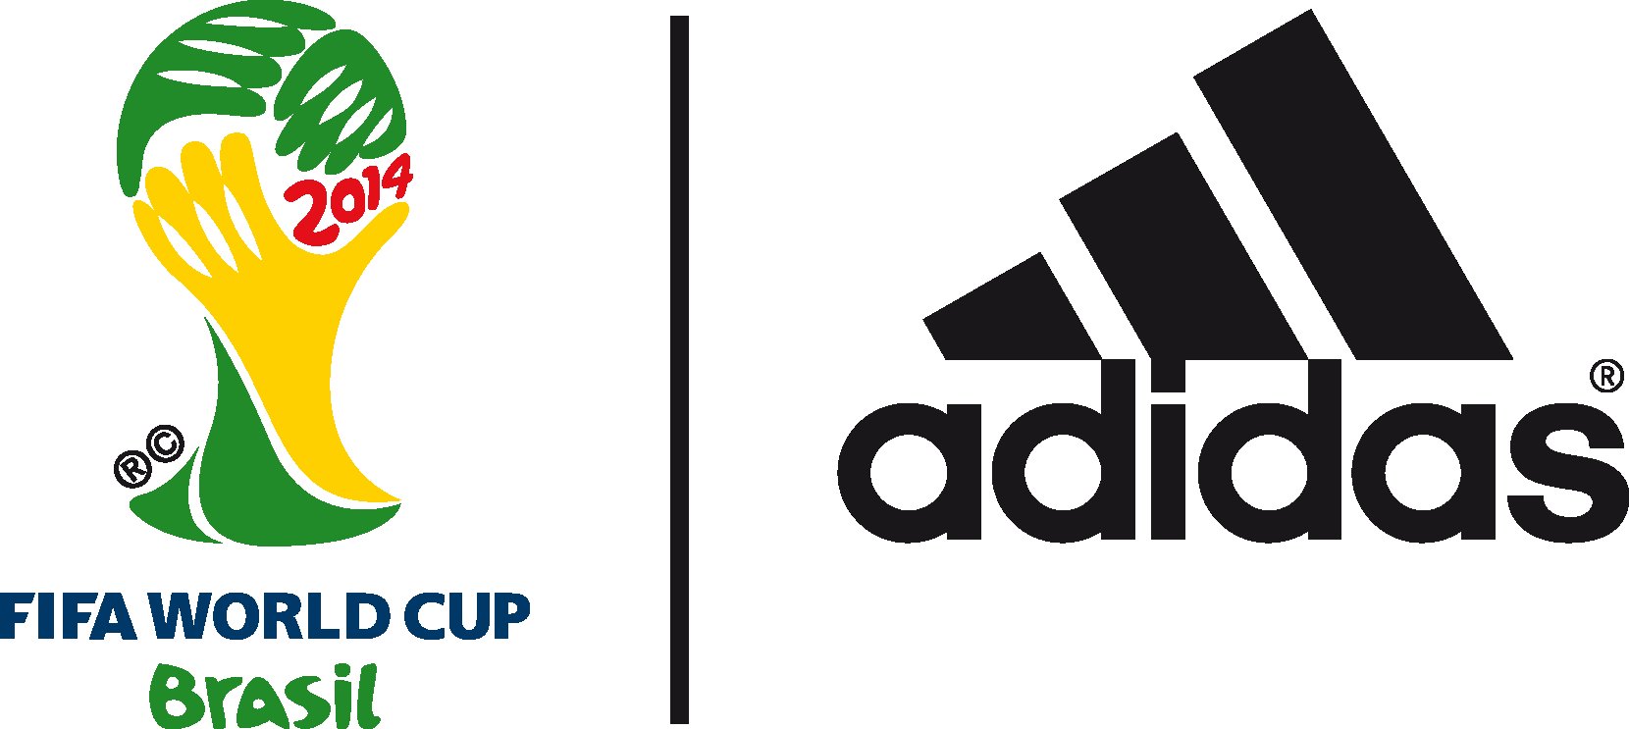

adidas most talked about brand during 2014 FIFA World Cup BrazilTM

With two teams in the final, adidas cement their brand dominance at the 2014 FIFA World Cup BrazilTM

9th July 2014 –Rio de Janeiro – Today sees two adidas teams reach the FIFA World Cup Final for the first time since 1990. With adidas-sponsored sides Argentina and Germany making the Final once again, the World’s leading football brand has cemented its success story at the 2014 FIFA World Cup BrazilTM.

As well as domination on the pitch, adidas is the most talked about brand at the World Cup 2014 across all major social media channels. The adidas campaign, #allin or nothing, is represented strongly across Twitter, YouTube, Facebook, Instagram and Tumblr; posting a combination of planned, anticipated and reactive content for the duration of the five week event. One result is an increase of 4,865,502* followers across all platforms, more than any other sports brand. adidas also brought the 2014 FIFA World Cup BrazilTM Official Match Ball, Brazuca, to life with the @Brazuca handle, acquiring over 2.751 million followers during the tournament (currently over 3.25 million followers) and becoming the fastest growing profile of the FIFA World Cup. It has also shown strong results across the “Team Messi” platforms - focused on their hero asset, Leo Messi** who makes the final for the first time.

Throughout the FIFA World Cup adidas has created a real time tactical campaign focusing on share of voice and reactive moments and the results show that it has the fastest growing community (across sports brands) throughout the tournament, showing a 54.7% (1,962,206 mentions)*** share of voice across all key platforms in the tournament 20% higher than the nearest sports brand competitor. This includes 651.720 mentions (33,160 on 09.07.2014) of #allin or nothing on Twitter, more than twice as much than any other brand during the tournament.

Above and beyond the social focus of the campaign, adidas also boasts the highest scoring boot of the tournament (the adidas adizero f50) with 46 goals to date. It also has three of the top scorers in the tournament wearing the adidas adizero f50 boot (Rodriguez 6, Müller 5 and Messi 4), and sponsorship of both teams in the Final.

Tom Ramsden, Global Brand Marketing Director, adidas football said ‘It is fantastic to have two teams in the World Cup Final. Throughout the tournament our goal has been to be the most talked about brand of the World Cup and engage with people all over the world. Having two teams in the Final and, of course, Leo Messi; we are in a great position to tell our #allin or nothing story. ‘

Further reactive and proactive content is planned by adidas around the World Cup Final which will see the brand further extend its dominance.

Join the adidas football conversation at www.facebook.com/adidasfootball or on Twitter: @adidasfootball #allin or nothing or @brazuca.

***
- END -

For further media information please visit http://news.adidas.com/GLOBAL/PERFORMANCE/FOOTBALL or contact:

Robert Hughes  adidas Senior Global Football PR Manager  Email: robert.hughes@adidas.com  Tel: +49/9132/84-6856 | Alan McGarrie  adidas Global Football PR Manager  Email: alan.mcgarrie@adidas.com  Tel: +49/9132/84-4686
Notes to editors:
*stats taken from simply measured (20:30 09.07.2014)
** https://www.facebook.com/TeamMessi
100K new followers on Twitter (since 1st June 2014)
*** all stats taken from Sysomos (stats taken 20:30 09.07.2014)

About adidas Football
adidas is the global leader in football. It is the official sponsor / official supplier partner of the most important football tournaments in the world, such as the FIFA World Cup™, the FIFA Confederations Cup, the UEFA Champions League, the UEFA Europa League and the UEFA European Championships. adidas also sponsors some of the world’s top clubs including Real Madrid, FC Bayern Munich, AC Milan, Flamengo and Chelsea. Some of the world’s best players also on the adidas roster are Leo Messi, Gareth Bale, Mesut Özil, Dani Alves, Oscar, Xavi, Karim Benzema and Bastian Schweinsteiger.

***

