adidas Outdoor footwear news spring/summer ‘15

In spring/summer ’15, adidas Outdoor will relaunch terrex. Besides established key products, the terrex range will be completed with several new versatile and lightweight styles. They are made without compromise, with the finest materials and always with the purpose of supporting athletes. The new terrex range is made for athletes with unlimited imagination, who want to constantly redefine their limits and set new targets – no matter how they explore the outdoors: biking, climbing, running or flying.

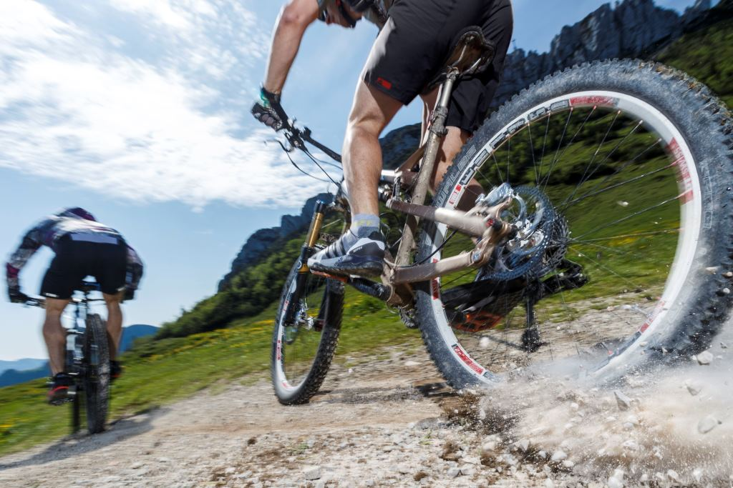

terrex Boost

The terrex Boost is a lightweight mountain running shoe featuring the revolutionary cushioning technology BOOST™. It provides more energy return than any other cushioning material in the industry, which makes it an ideal shoe for long-distance mountain runs. The other big advantage of the terrex Boost is its Continental® rubber outsole. It generates excellent grip even at the highest speeds – on dry as well as on wet ground.

Features & Benefits:

- Upper: speed-lacing construction for fast and snug lacing
- Torsion: Torsion bar / PRO-MODERATOR™ for midfoot stability
- Midsole: Boost™ offers endless energy in the mountains and high adaptability on rocky surfaces
- Outsole: Continental® rubber for excellent grip
- High adaptability on rocky surfaces and a low-to-the-ground feel
- Sock-like fit

Colors men: black/solar red // grey/black/yellow
Weight: 330g (size UK 8 1/2)

Colors women: grey/black/flash pink // clay/black/flash orange
Weight: 280g (size UK 5 1/2)

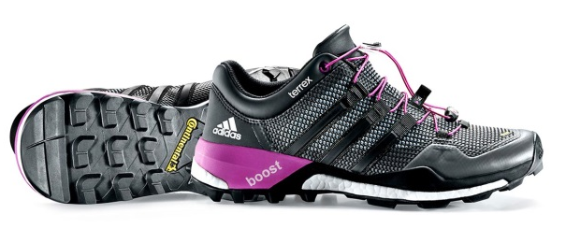
Price: € 160 (RRP)

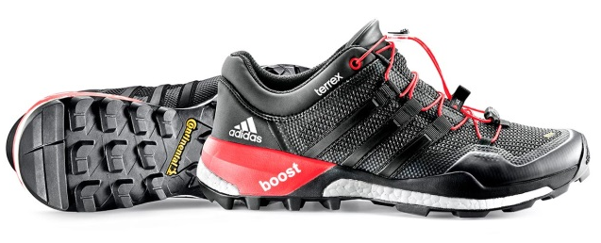

terrex Scope High

This lightweight high-cut alpine approach shoe with ankle protection offers a GORE-TEX® membrane and ADIPRENE® heel cushioning and features a STEALTH rubber outsole for unbeatable grip and control on wet and rocky terrain. It is the ideal shoe for technical via ferrata and longer approaches with small climbing and scrambling in between.

Features & Benefits

- Waterproof and breathable GORE-TEX® membrane (100% PES)
- Sockliner made of molded Ortholite®
- Torsion: PRO-MODERATOR™ for midfoot stability
- Midsole: ADIPRENE® insert for comfort and shock absorption
- Outsole: approach-specific outsole featuring STEALTH® rubber for unbeatable grip; the climbing zone in the toe area and dynamic lugs offer optimal grip on rock contact; the sharp heel step guarantees safe descent
- Upper: Different materials from the toe area up to the leg, firm to soft and supportive to comfortable, increase functionality. Soft stone guard seals up the leg, offers more comfort and keeps stones out; lacing all the way up from the toe area for a snug fit

Colors men: black/white/solar red // bright royal/black/collegiate navy
Weight: 520g (size UK 8.5)

Price: € 190 (RRP)

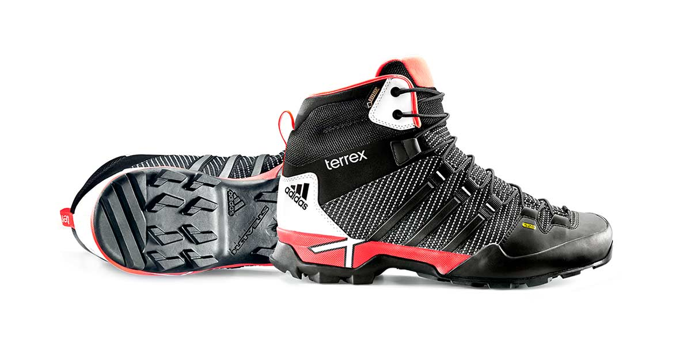

terrex Trail Cross

Together with our athletes, the adidas designers have developed this versatile shoe for hiking and biking technical trails. It combines hiking traction with pedaling power through a STEALTH® rubber outsole with unbeatable grip.

Features & Benefits

- STEALTH® rubber outsole for unbeatable grip
- Outsole: 3 outsole zones; pedal zone in the middle combined with a hiking zone in the front and a descending zone in the heel
- Midsole: The EVA foam from the heel up to the midfoot is protected with PRO-MODERTORTM which offers additional support and stability in the midfoot and prevents the EVA from getting harmed through rock contact
- Upper: The lateral side features highly abrasion-resistant materials; for functionality and breathability on the medial side, the Stripes are perforated; asymmetrical lacing prevents the medial side from getting harmed through cranks; lace bungee prevents the lace from getting caught in cranks;

Weight: 435g (UK 8.5)

Colors: collegiate navy/black/clear onix // white/black/grey

Prize: € 130 (RRP)

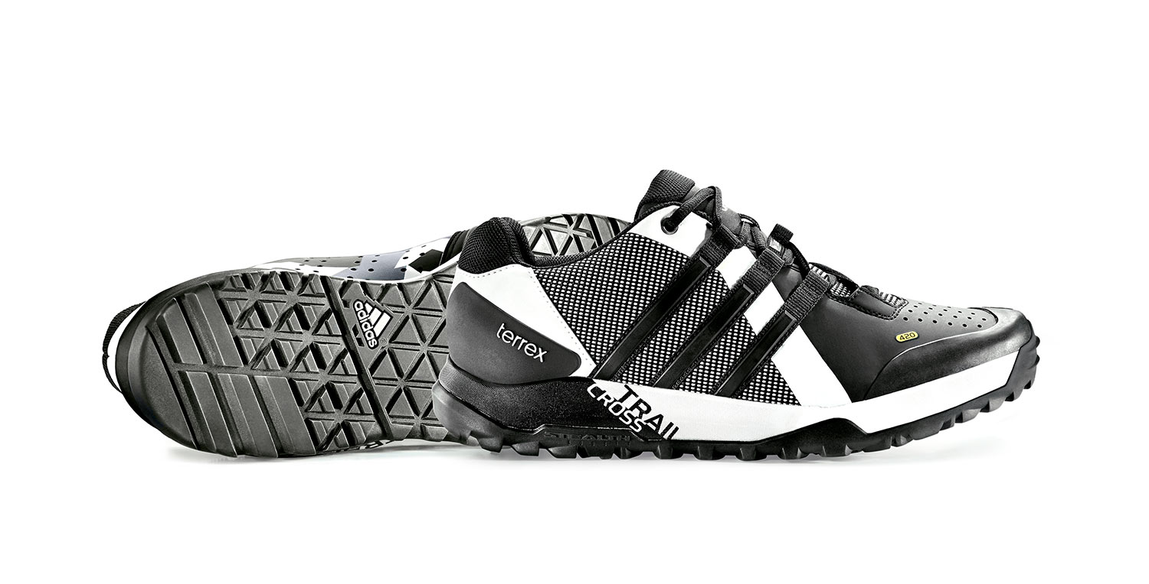

terrex Fast R Mid GTX

Since its introduction in spring/summer 2013, the terrex Fast R has become one of our most successful terrex shoes. It is the ideal shoe for moving fast in the mountains. In 2015, the light, athletic mid-cut shoe gets some small but important updates such as a snug-fitting neoprene heel.
Despite its low weight, the terrex Fast R Mid GTX offers great stability and reliability, which makes controlled climbs and descents possible at high speed. The FORMOTION™ unit in the heel and the Continental™ rubber outsole guarantee additional control and the necessary grip on dry and wet surfaces.

- Waterproof GORE-TEX® membrane
- Continental™ rubber outsole for excellent grip on dry and wet surfaces
- Molded Ortholite® sockliner for pleasant foot climate and comfort
- FORMOTION™ unit for enhanced motion control and downhill comfort
- Upper: neoprene collar for comfort and protection
- Midsole: full forefoot ADIPRENE®+ for forefoot propulsion and efficiency
- Speed lacing

Colors men: collegiate navy/black/clear onix // white/black/grey
Weight: 425g (UK 8.5)

Colors women: night flash/black/flash pink
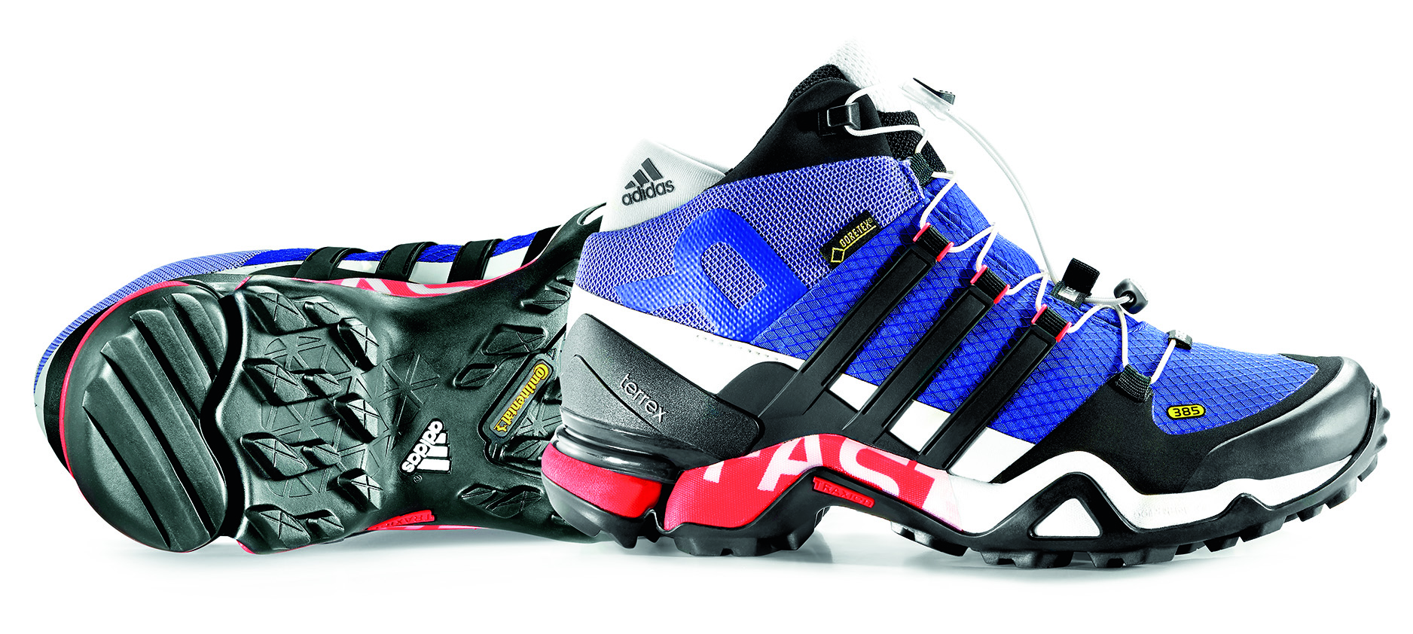
Weight: 385g (UK 5.5)

Price: € 180 (RRP)

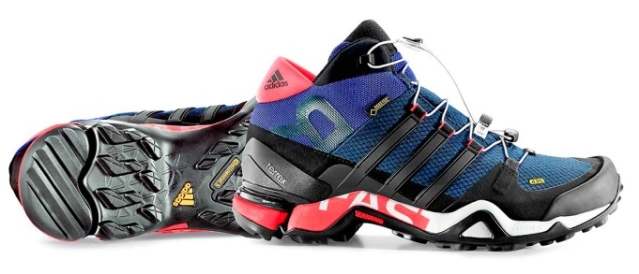

***

More information at
www.adidas.com/outdoor/
www.facebook.com/adidasoutdoor
www.instagram.com/adidasoutdoor
www.youtube.com/adidasoutdoortv

Lena Hackforth
Global PR & Social Media Manager adidas Outdoor
+49 9132 84 4380
+49 160 884 4380 (mobile)
lena.hackforth@adidas.com

