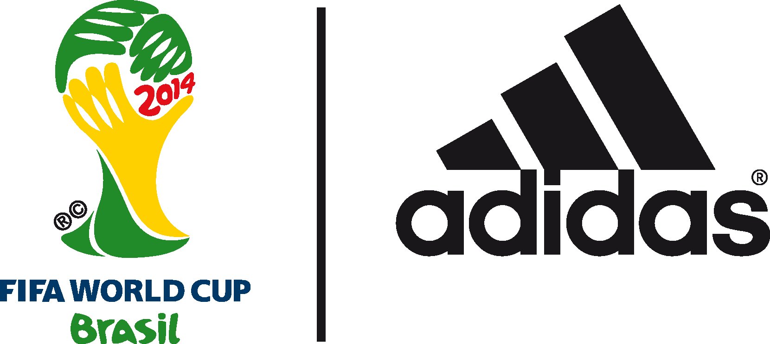

adidas adizero f50 leading the way as top scoring football boot of the 2014 FIFA World Cup Brazil™

Boot of choice for James Rodriguez, Messi and Müller setting the pace in Brazil with 42 goals

2nd July 2014 – Herzogenaurach/ Rio de Janeiro – With the quarter finals of the 2014 FIFA World Cup Brazil™ now decided, the stats reveal that the adidas adizero f50 is currently the top scoring football boot at the tournament with 42 goals scored by players wearing it. The adizero f50 is the boot of choice for an incredible six of the tournament’s top nine goalscorers. This includes World Cup sensation and adidas Golden Boot leader James Rodriguez of Colombia with five goals, with adidas stars Leo Messi (four), Thomas Müller (four), Robin van Persie, Arjen Robben and Karim Benzema (all three) also competing to be top goalscorer.

James Rodriguez has taken the tournament by storm, with three Man of the Match displays and two assists to accompany his five goals. This has come from 15 shots on goal, with an impressive 14 on target.

But it is not just in the goals department that the adizero f50 players are setting the pace. Arjen Robben has been responsible for the most dribbles into the area during the tournament (10), Leo Messi has delivered the most balls into the area (21), while Karim Benzema has had the most shots on target (19).

Join the adidas football conversation at www.facebook.com/adidasfootball or on Twitter: @adidasfootball.

***
- END -

For further media information please visit http://news.adidas.com/GLOBAL/PERFORMANCE/FOOTBALL or contact:

Robert Hughes  adidas Senior Global Football PR Manager  Email: robert.hughes@adidas.com  Tel: +49/9132/84-6856 | Alan McGarrie  adidas Global Football PR Manager  Email: alan.mcgarrie@adidas.com  Tel: +49/9132/84-4686
Notes to editors:
About adidas Football
adidas is the global leader in football. It is the official sponsor / official supplier partner of the most important football tournaments in the world, such as the FIFA World Cup™, the FIFA Confederations Cup, the UEFA Champions League, the UEFA Europa League and the UEFA European Championships. adidas also sponsors some of the world’s top clubs including Real Madrid, FC Bayern Munich, AC Milan, Flamengo and Chelsea. Some of the world’s best players also on the adidas roster are Leo Messi, Gareth Bale, Mesut Özil, Dani Alves, Oscar, Xavi, Karim Benzema and Bastian Schweinsteiger.

***

