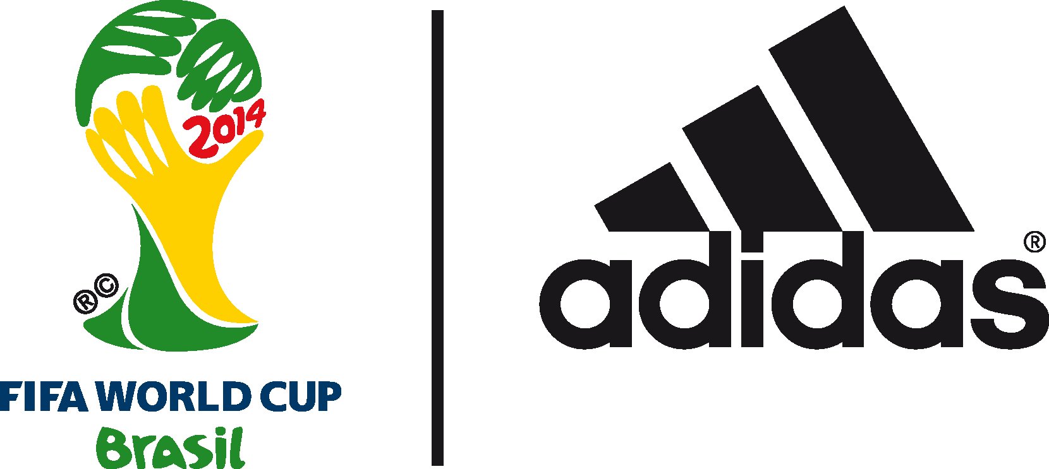

Kaka to feature in adidas show at the
2014 FIFA World Cup BrazilTM

Brazilian World Cup winner to star in The Dugout ahead of Brazil v Chile match

28th June 2014 – Herzogenaurach/ Rio de Janeiro – On the day the knockout stages of the 2014 FIFA World Cup BrazilTM begins, adidas is inviting you to join its latest World Cup show – The Dugout, streamed on YouTube.

Taking place at 1100 (BRT) at the Brazil Clube Regatas Flamengo, Gavea, the fourth in a series of adidas Dugout shows in Rio will feature Brazilian legend and former World Cup winner Kaka. The show will see Kaka taken on an aerial tour of Rio, speaking with him about Brazil, his career highlights and life outside football against a backdrop of the Maracanã, Sugarloaf Mountain and Rio’s beaches.

To watch The Dugout live go to the adidas YouTube page from 1100 BRT today (28th June).

Hosted by KICKTV hosts Layla Anna-Lee and Hugh Wizzy, The Dugout will bring an audience of millions of football fans closer than ever before to adidas footballers and legends, providing debate, views and reactions to all the action in Brazil on and off the field. The series of six shows will be broadcast over the course of the tournament, with a final show to take place on the eve of the 2014 FIFA World Cup™ Final, 12 July.

The show will also see another episode of the adidas miCoach Smart Ball Power Challenge. The Smart Ball houses a sensor package which helps measure the speed, curve, trajectory and spin of the ball and the challenge will see the cast from Dude Perfect and STR Skill School compete to beat Patrick Vieira’s benchmark speed of 111kph.

Brazilian World Cup winner Kaka said, “Witnessing the World Cup in my home country has so far been an incredible experience for me – the atmosphere has been electric in the stadiums and the cities. I’m really looking forward to the knockout stages and it is great that adidas is giving fans the inside view of the tournament with these shows.”

The show airs on YouTube and adidas social channels at 1100 (BRT) ahead of the tournament’s second round knockout stages. To watch go to https://www.youtube.com/watch?v=Y7DTE2GNZZ8

Join the adidas football conversation at www.facebook.com/adidasfootball or on Twitter: @adidasfootball.

***
- END -

For further media information please visit http://news.adidas.com/GLOBAL/PERFORMANCE/FOOTBALL or contact:

Robert Hughes  adidas Senior Global Football PR Manager  Email: robert.hughes@adidas.com  Tel: +49/9132/84-6856 | Alan McGarrie  adidas Global Football PR Manager  Email: alan.mcgarrie@adidas.com  Tel: +49/9132/84-4686
Notes to editors:
About adidas Football
adidas is the global leader in football. It is the official sponsor / official supplier partner of the most important football tournaments in the world, such as the FIFA World Cup™, the FIFA Confederations Cup, the UEFA Champions League, the UEFA Europa League and the UEFA European Championships. adidas also sponsors some of the world’s top clubs including Real Madrid, FC Bayern Munich, AC Milan, Flamengo and Chelsea. Some of the world’s best players also on the adidas roster are Leo Messi, Gareth Bale, Mesut Özil, Dani Alves, Oscar, Xavi, Karim Benzema and Bastian Schweinsteiger.

Broadcast dates and YouTube video URLs

The Dugout - 28th June
VIDEOURL: https://www.youtube.com/watch?v=Y7DTE2GNZZ8

The Dugout – 3rd July
VIDEO URL: https://www.youtube.com/watch?v=GWJP4dd4Alg

The Dugout - 12th July
VIDEO URL: https://www.youtube.com/watch?v=PNgG5wtBZdI

***

