Cavani Ready to Rewrite History for Uruguay

Uruguay striker Edinson Cavani stands in the shadow of his nation’s history in a picture created by adidas

14th June, Herzogenaurach / Montevideo: Few countries have a football heritage as strong as Uruguay’s. Striker Edinson Cavani is ready to bring glory back to the tournament’s first winner.

Uruguay has had some great football legends and champions over the years. Edinson Cavani, unfazed by his country’s past, is ready to write a new chapter in his country’s history at the World Cup in Brazil. The weight of history on his shoulders has been brought to life in this inspiring photo from adidas.

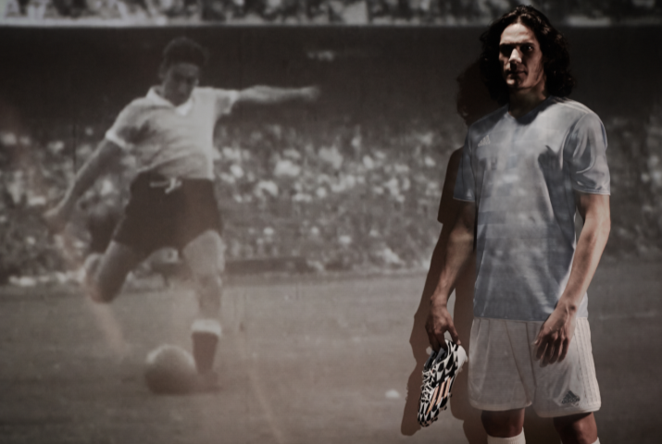
The photograph depicts Cavani, ready for action with his adidas boots at hand, standing in the shadow of Uruguay winning the first World Cup. Cavani is on a personal mission to ensure history repeats itself in Brazil. The image, part of the adidas all in or nothing FIFA World Cup™ campaign, represents the huge weight of expectation that the world’s best players will have to overcome to succeed in Brazil.

The all in or nothing campaign from adidas is about challenging the world’s best footballers to seize their opportunity at the World Cup™. It is a provocative and bold campaign that celebrates the players able to defy the pressure of expectation and step-up on the world’s biggest stage.

Commenting on the image, Cavani said, “The World Cup is where legends are made. Like the great players that went before me, I am ready to go all in to win the World Cup for Uruguay again”.

Caption- ‘Cavani stands in the shadow of legends. Uruguay striker Edinson Cavani prepares to write his own history in a picture created by adidas.’

------ENDS-------

For further media information please visit http://news.adidas.com/GLOBAL/home/FIFA-WORLD-CUP-2014 or contact:

Robert Hughes  adidas Senior Global Football PR Manager  Email: robert.hughes@adidas.com  Tel: +49/9132/84-6856 | Alan McGarrie  adidas Global Football PR Manager  Email: alan.mcgarrie@adidas.com  Tel: +49/9132/84-4686

