World Cup winner Cafu is joined by Yohan Blake and Warren Weir at the adidas Dugout

Two time World Cup winner joined by Jamaican sprinters at live streamed adidas event

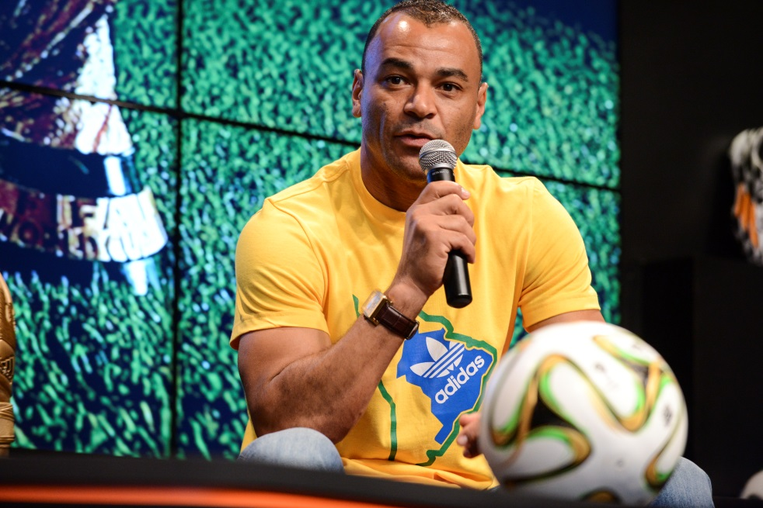

13th June 2014 – Rio de Janeiro – Cafu talked football and World Cup predictions with the Jamaican sprinting duo as part of a new initiative set up by adidas designed for football fans from around the world to get involved in the action, by submitting questions for guests on adidas social platforms. The unique platform includes a series of exclusive and interactive shows throughout the 2014 FIFA World Cup Brazil™, and has already featured other big names including Patrick Vieira and Fernando Hierro.

Speaking on the live show in Rio after Brazil’s victory over Croatia, Cafu said, “The atmosphere in the stadium was fantastic. The fans were behind the team from the beginning, there was a big vibration, a lot of passion and love. Even when Brazil was down 1-0 to Croatia the fans were behind the team and that’s what we want to see throughout the World Cup. What was big for Brazil was Oscar’s performance. He played very well, got the third goal and showed how to play football.”

The innovative shows will bring an audience of millions of football fans closer than ever before to adidas star footballers and legends, providing debate, views and reactions to all the action in Brazil on and off the field.

The next show, which airs live on 27th June at 1100 (BRT) on YouTube and adidas social channels, will feature Brazilian duo Kaká and Lucas Moura. To watch go to https://www.youtube.com/watch?v=16CpPZ206Bc.

Join the adidas football conversation at www.facebook.com/adidasfootball or on Twitter: @adidasfootball.

***
- END -

For further media information please visit http://news.adidas.com/GLOBAL/PERFORMANCE/FOOTBALL or contact:

Robert Hughes  adidas Senior Global Football PR Manager  Email: robert.hughes@adidas.com  Tel: +49/9132/84-6856 | Alan McGarrie  adidas Global Football PR Manager  Email: alan.mcgarrie@adidas.com  Tel: +49/9132/84-4686
Notes to editors:
About adidas Football
adidas is the global leader in football. It is the official sponsor / official supplier partner of the most important football tournaments in the world, such as the FIFA World Cup™, the FIFA Confederations Cup, the UEFA Champions League, the UEFA Europa League and the UEFA European Championships. adidas also sponsors some of the world’s top clubs including Real Madrid, FC Bayern Munich, AC Milan, Flamengo and Chelsea. Some of the world’s best players also on the adidas roster are Leo Messi, Gareth Bale, Mesut Özil, Dani Alves, Oscar, Xavi, Karim Benzema and Bastian Schweinsteiger.

Broadcast dates and YouTube video URLs
The Dugout - 27th June
VIDEO URL: https://www.youtube.com/watch?v=16CpPZ206Bc

The Dugout - 28th June
VIDEOURL: https://www.youtube.com/watch?v=Y7DTE2GNZZ8

The Dugout – 3rd July
VIDEO URL: https://www.youtube.com/watch?v=GWJP4dd4Alg

The Dugout - 12th July
VIDEO URL: https://www.youtube.com/watch?v=PNgG5wtBZdI

***

