adidas introduces the new kit of the Bosnia and Herzegovina Football Federation

Herzogenaurach / Sarajevo, 3rd June 2014 — adidas today is proud to present the new official Bosnia and Herzegovina Football Federation home and away kits to be worn by the team during the upcoming 2014 FIFA World Cup Brazil™. This summer’s tournament will mark Bosnia’s first ever appearance in a major tournament as an independent nation.

The new kits will be worn for the first time on June 3rd in Chicago when the team take on fellow adidas federation Mexico in a friendly match.
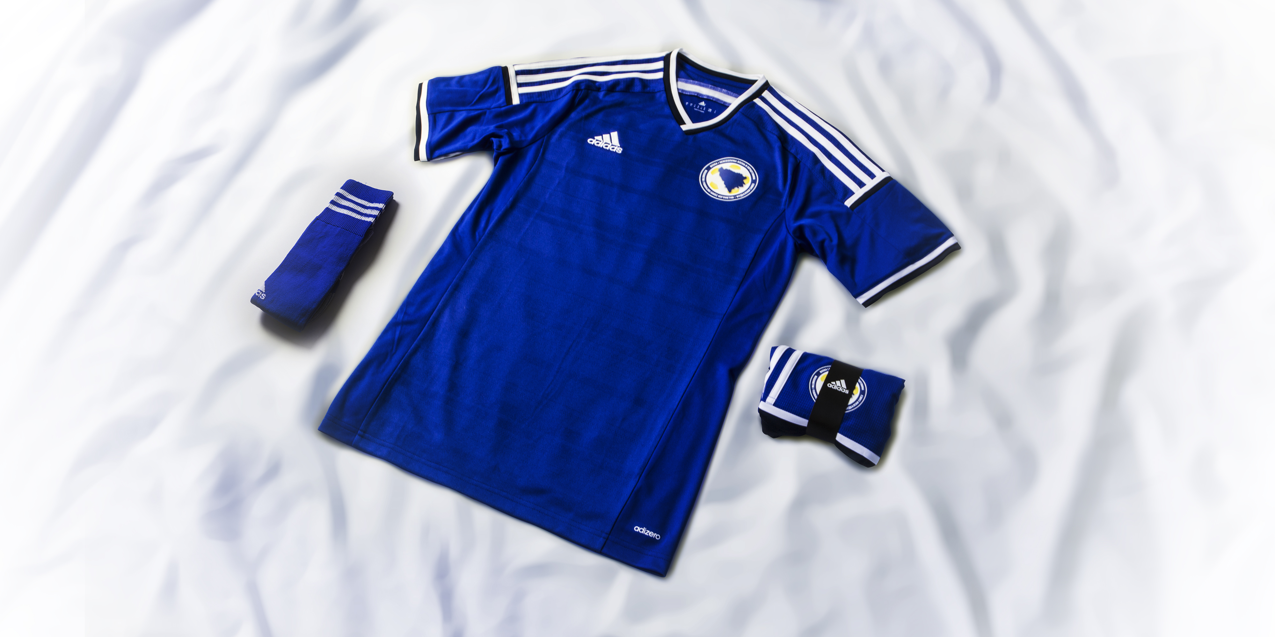

The bold blue and white colouring of the kit is a continuation of the symbolic and traditional colours of Bosnia and Herzegovina. The home kit is blue with white trim while the away kit is white with blue trim. The bold and imposing design on both kits reflects the pride and commitment of the Bosnian people whilst representing on the field the passion and emotion they feel towards their country.

The home kit incorporates adizero technology which provides added ventilation to the players, helping them stay dry during the 90 minutes of the match and truly acting like a second skin. The away jersey is equipped with climacool, which ensures proper ventilation and will help to keep players cool even during heat in Brazil.

adidas already possesses close links with Bosnian football, with existing sponsorship deals with high profile Bosnian players including; Edin Džeko of Manchester City, Miralem Pjanić of Roma, Senad Lulić of Lazio and national team captain Emir Spahić of Bayer Leverkusen.

Manchester City striker and Vice-captain Edin Džeko, stated, “It is so important that at our first ever tournament, we have a kit that can truly inspire us. Through its bold design, this fully encapsulates the passion and commitment behind the people of our nation. I hope we can deliver this summer and make them proud.”

The new official Bosnia and Herzegovina Football Federation home and away kits are available now to purchase globally in selected adidas retail outlets, associated stockists and via www.adidas.com/worldcup. Join the adidas football conversation at www.facebook.com/adidasfootball or on Twitter: @adidasfootball #allin or nothing.

***

For further media information please visit http://news.adidas.com/GLOBAL/PERFORMANCE/FOOTBALL or contact:

Robert Hughes  adidas Senior Global Football PR Manager  Email: robert.hughes@adidas.com  Tel: +49/9132/84-6856 | Alan McGarrie  adidas Global Football PR Manager  Email: alan.mcgarrie@adidas.com  Tel: +49/9132/84-4686

Notes to editors:

About adidas Football
adidas is the global leader in football. It is the official sponsor / official supplier partner of the most important football tournaments in the world, such as the FIFA World Cup™, the FIFA Confederations Cup, the UEFA Champions League, the UEFA Europa League and the UEFA European Championships. adidas sponsors some of the top football federations in world football including Spain, Argentina, Germany, Japan, Russia, Colombia, Bosnia and Herzegovina & Mexico. adidas also sponsors some of the world’s top clubs including Real Madrid, FC Bayern Munich, AC Milan, Flamengo and Chelsea. Some of the world’s best players also on the adidas roster are Leo Messi, Gareth Bale, Mesut Özil, Dani Alves, Oscar, Xavi, Karim Benzema and Bastian Schweinsteiger.

