EMBARGOED UNTIL 1000HRS CET Saturday 24 May

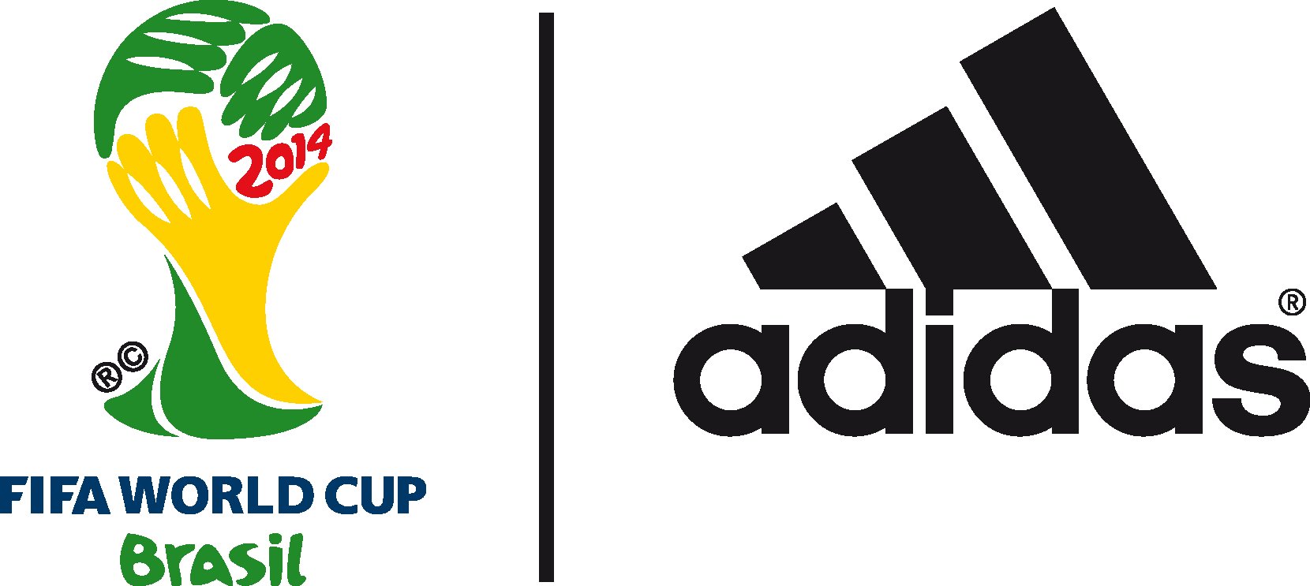

adidas launch 2014 FIFA World Cup Brazil™ advert

Stars of world football prove that you have to go
“all in or nothing” to succeed on the biggest stage

24th May 2014 – Herzogenaurach, Germany – adidas has released its official advert for the 2014 FIFA World Cup Brazil™, starring some of the world's best football players including Leo Messi, Dani Alves, Luis Suárez, Robin van Persie, Bastian Schweinsteiger, and Xavi. The advert, known as “Leo Messi’s World Cup Dream”, officially marks the start of the adidas "#allin or nothing" 2014 FIFA World Cup Brazil™ campaign.

“Leo Messi’s World Cup Dream”, directed by City of God director Fernando Meirelles, co-directed by Cassiano Prado, and featuring an exclusive track by Kanye West can be viewed here: http://youtu.be/jR1XQsCiAKE

The advert, which airs on TV screens around the world at half time during tonight’s UEFA Champions League Final, asserts there is only one way to live and play if you want to lift the trophy in Brazil: all in or nothing.

The film begins with Leo Messi asleep and vividly dreaming of the extreme lengths his fellow star footballers are going to in their preparation for the 2014 FIFA World Cup Brazil™. This includes introduction of the Battle Pack boots, adidas’ official footwear collection for the tournament. Attention then turns to cutting edge football action on the field of play, with leading adidas players going “all in”, showing off extraordinary skills and ultimately succeeding in an epic battle of wills on the pitch. Players, fans, managers and nations all join together in their desire for the ultimate prize, before Messi awakes knowing it is time to go ‘all in or nothing’ for 2014 FIFA World Cup Brazil™.

As the advert comes to an end, the viewer will be presented with the same choice as Leo Messi. The final screen of the ad on TV and YouTube will offer a stark and binary choice; an “all in” button, alongside a “nothing” button. Clicking “all in” will connect the user to everything adidas has to offer for the 2014 FIFA World Cup by following all adidas football handles on Twitter. Clicking “nothing” ensures the user is shut out and has no adidas communication for the summer tournament.

Tom Ramsden, Global Brand Marketing Director, adidas football, said: “This advert presents the "#allin or nothing" attitude by showcasing the dedication and commitment required to winning this great tournament. Giving anything less than everything will not win the World Cup. At adidas, we believe the only way to play sport, unlock your potential and get the most out of the biggest event in sport is to be “all in”. We are incredibly proud of this film and the entire 'all in or nothing' campaign. By bringing together the creative powers of Fernando (Meirelles), Cassiano (Prado) and Kanye; and combining them with the best players in the world, we present a unique, fresh and authentic view of the World Cup that only adidas can deliver.”

“Leo Messi’s World Cup Dream” debuts on television during half time of tonight’s UEFA Champions League Final and can be viewed here: http://youtu.be/jR1XQsCiAKE. For more information on the adidas 2014 FIFA World Cup Brazil™ campaign visit www.adidas.com/worldcup or join the conversation on Twitter @adidasfootball #allin or nothing.

***
- END -

For further media information please visit http://news.adidas.com/GLOBAL/PERFORMANCE/FOOTBALL or contact:

Robert Hughes  adidas Senior Global Football PR Manager  Email: robert.hughes@adidas.com  Tel: +49/9132/84-6856 | Alan McGarrie  adidas Global Football PR Manager  Email: alan.mcgarrie@adidas.com  Tel: +49/9132/84-4686
Notes to editors:
About adidas Football
adidas is the global leader in football. It is the official sponsor / official supplier partner of the most important football tournaments in the world, such as the FIFA World Cup™, the FIFA Confederations Cup, the UEFA Champions League, the UEFA Europa League and the UEFA European Championships. adidas also sponsors some of the world’s top clubs including Real Madrid, FC Bayern Munich, AC Milan, Flamengo and Chelsea. Some of the world’s best players also on the adidas roster are Leo Messi, Gareth Bale, Mesut Özil, Dani Alves, Oscar, Xavi, Karim Benzema and Bastian Schweinsteiger.

***

