adidas and Chelsea Football Club launch 2014/15 away shirt

New yellow shirt pays tribute to iconic away kits from the club’s illustrious past

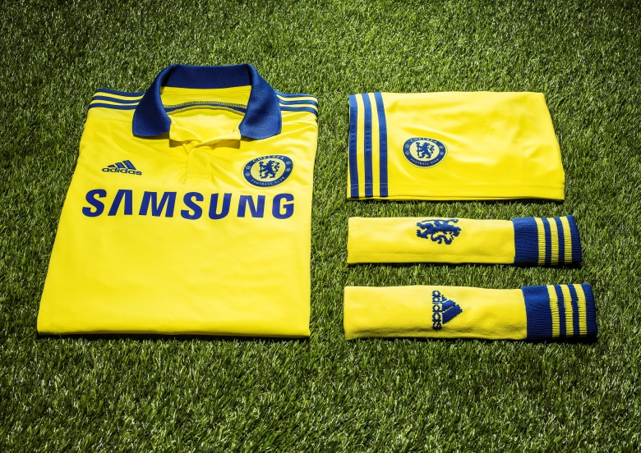

London/Herzogenaurach, 21st of May 2014 – Following on from the hugely successful Forever Blue campaign which launched the new 2014/15 home shirt in April, adidas and Chelsea Football Club have today revealed the new look away shirt, inspired by famous yellow kits from the club's past.

Fans of all ages will have great memories of Chelsea in a yellow away strip, from its first outings with the likes of Peter Osgood in the 1960s and 1970s, through unforgettable moments with Clive Walker in the 1980s, Gianfranco Zola in the 1990s up to Frank Lampard’s memorable winner in the FA Cup final of 2009.

The new shirt will be the lightest Chelsea away shirt ever produced, featuring the latest in adiZero lightweight technology and a polo collar which pays tribute to the retro designs, as well as an iconic blue stripe across the back which contrasts the two traditional Chelsea colours.

The new kit is available to order now at www.chelseafc.com/foreverblue, ahead of its arrival in stores on 4 June 2014.

***
For more information on adidas football, please visit www.adidas.com/football or follow the conversation @adidasUK #allinCFC

For further media information please visit http://news.adidas.com/GLOBAL/PERFORMANCE/FOOTBALL or contact:

Robert Hughes  adidas Senior Global Football PR Manager  Email: robert.hughes@adidas.com  Tel: +49/9132/84-6856 | Alan McGarrie  adidas Global Football PR Manager  Email: alan.mcgarrie@adidas.com  Tel: +49/9132/84-4686
Notes to editors:
About Chelsea Football Club

Chelsea Football Club is one of the world’s top football clubs. UEFA Champions League winners in 2012, Chelsea FC followed that success by lifting the UEFA Europa League trophy in 2013. Founded in 1905, Chelsea is London’s most central football club, based at the iconic 42,000-capacity Stamford Bridge stadium.

Nicknamed ‘The Blues’, Chelsea are three-time English Premier League champions and have also lifted the FA Cup seven times, the Football League Cup four times, the UEFA Cup Winners’ Cup twice, the UEFA Super Cup once and the Football League Championship once, in 1955. The Europa League triumph saw Chelsea become the first English club to win all three major UEFA competitions, and the first club ever to hold both the Champions League and Europa League at the same time.

About adidas Football
adidas is the global leader in football. It is the official sponsor / official supplier partner of the most important football tournaments in the world, such as the FIFA World Cup™, the FIFA Confederations Cup, the UEFA Champions League, the UEFA Europa League and the UEFA European Championships. adidas also sponsors some of the world’s top clubs including Real Madrid, FC Bayern Munich, AC Milan, Flamengo and Chelsea. Some of the world’s best players also on the adidas roster are Leo Messi, Gareth Bale, Mesut Özil, Dani Alves, Oscar, Xavi, Karim Benzema and Bastian Schweinsteiger.

Additionally, the Chelsea Foundation boasts one of the most extensive community initiatives in sport, working in 29 countries around the world, helping improve the lives of more than 700,000 children and young people each year.

