EMBARGOED UNTIL 1200HRS CET MONDAY 19th MAY
adidas unveils Predator Zones goalkeeper gloves ahead of 2014 FIFA World Cup Brazil™

Herzogenaurach, 19th May – adidas has introduced the all-new adidas Predator Zones goalkeeping gloves range for the 2014 FIFA World Cup Brazil™. Designed in partnership with some of the world’s best goalkeepers, the new range of adidas goalkeeping gloves are perfectly suited to the needs of the modern goalkeeper. The gloves feature the distinctive black and white design pattern of the adidas Battle Pack boots which will be worn by adidas players at this summer’s tournament in Brazil.

Working with leading goalkeepers including Manuel Neuer, Iker Casillas and Petr Cech, adidas identified an innovative three zones concept aimed at covering each key attribute in the life of a goalkeeper. These three zones are a punching zone, designed to give the goalkeeper maximum force, while still maintaining the flexibility required; a grip zone, the most important area which uses a latex mixture unique to adidas to deliver the best grip possible in the key areas of the glove; and an abrasion zone, which is designed to protect the palm from damage, ensuring strength as well as the flexibility that goalkeepers need from their gloves.

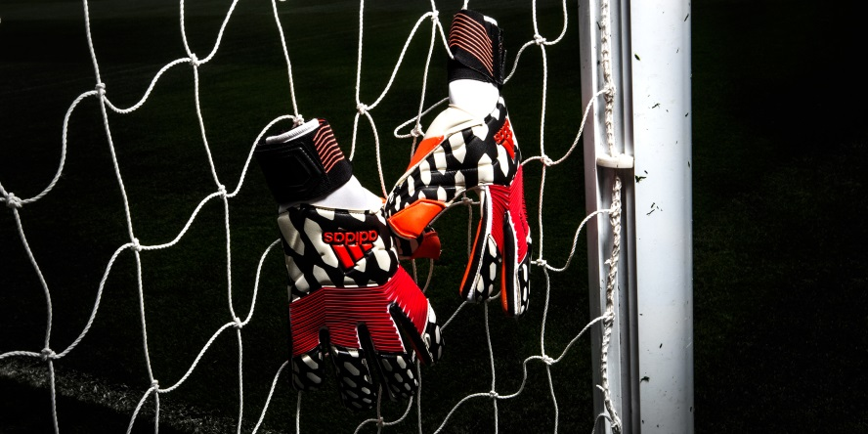

The adidas Predator Zones will be launched with a black and white colourway for the Predator Zones Pro™ range, in line with the design and colour of the adidas Battle Pack boots. The grip zone and punching zone are coloured red to highlight the two most important zones. The gloves will be worn for the first time by Iker Casillas during the UEFA Champions League Final. They will then be worn by all adidas goalkeepers throughout the 2014 FIFA World Cup Brazil™. The return to classic black and white colourways ties in to the wider adidas “All in or Nothing” 2014 FIFA World Cup Brazil™ campaign. The black and white design represents the stark choice that players are forced to make on the field in Brazil, the choice to go all in or achieve nothing.

Spanish captain Iker Casillas said, “What makes these gloves special is that we, the goalkeepers, have been involved in the design of the gloves at every stage. We were sent a blank glove to mark the areas that were most important to us, so the three zones have been designed with our needs in mind. I am going into the world’s greatest tournament, knowing I am equipped with the best possible gloves. That makes a huge difference.”

Frank Weigl, adidas Senior Product Manager, Football Hardware said, “By working alongside goalkeepers we were able to identify the key areas of gloves according to the players who are ultimately going to wear the product in major tournaments. The adidas Predator Zones have gone through an extensive period of on-field testing with amateur and professional goalkeepers across the globe. Through the rounds of testing we managed to perfect a cutting edge design which suited exactly what goalkeepers look for in their gloves. We are confident adidas Predator Zones will be a great success at the 2014 FIFA World Cup Brazil™ and beyond.”

The Predator Zones gloves will also be available to customise at miadidas.com from June 2nd 2014.

Join the adidas football conversation at www.facebook.com/adidasfootball or on Twitter: @adidasfootball.

***
- END -

For further media information please visit http://news.adidas.com/GLOBAL/PERFORMANCE/FOOTBALL or contact:

Robert Hughes  adidas Senior Global Football PR Manager  Email: robert.hughes@adidas.com  Tel: +49/9132/84-6856 | Alan McGarrie  adidas Global Football PR Manager  Email: alan.mcgarrie@adidas.com  Tel: +49/9132/84-4686
Notes to editors:
About adidas Football
adidas is the global leader in football. It is the official sponsor / official supplier partner of the most important football tournaments in the world, such as the FIFA World Cup™, the FIFA Confederations Cup, the UEFA Champions League, the UEFA Europa League and the UEFA European Championships. adidas also sponsors some of the world’s top clubs including Real Madrid, FC Bayern Munich, AC Milan, Flamengo and Chelsea. Some of the world’s best players also on the adidas roster are Leo Messi, Gareth Bale, Mesut Özil, Dani Alves, Oscar, Xavi, Karim Benzema and Bastian Schweinsteiger.

***

