adidas “brazucam” gives fans a unique view of the 2014 FIFA World Cup Brazil™

Online documentary series celebrates football around the world, as seen from the eyes of @brazuca

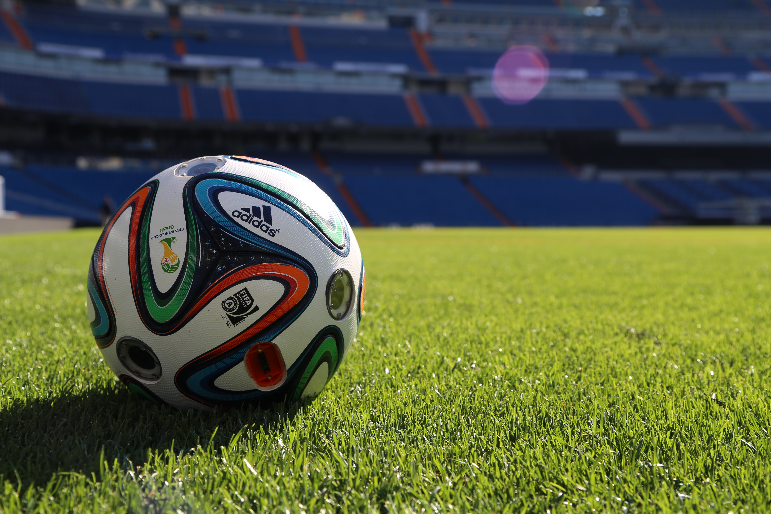
Herzogenaurach, Monday 31st March 2014 – adidas is kicking off a weekly series of online documentary-style films to excite football fans as the 2014 FIFA World Cup Brazil™ gets closer. The story will be played out from the perspective of @brazuca; the first ever twitter account for a FIFA World Cup™ Official Match Ball.

The films entitled ‘brazuca around the world’ were shot via ‘brazucam’, unique technology that allows the ball to experience the world from a whole new angle. ‘brazucam’ is a customized brazuca Official Match Ball featuring six HD cameras that capture 360° views of the action. The product features custom-made image stabilization software at the cutting edge of innovation.

The films will follow the journey of @brazuca, as it makes its way through countries including Spain, Germany, England, Russia, Japan, the USA and Mexico, getting closer to Brazil and all the while capturing the athletes and enthusiasts playing their beloved sport, from a ball’s-eye-view. For the next 7 weeks, one film per week will be released via the adidas Football YouTube channel (www.youtube.com/adidasfootballtv) and on twitter via @brazuca.

The forthcoming video series will feature stars such as Xavi Hernandez, Dani Alves, Cristian Tello, Bastian Schweinsteiger, Manuel Neuer, Philipp Lahm and David Villa, as the films introduce the ‘all or nothing’ journey around the world and showcase brazucam’s technology. Next week, the global tour will officially begin with a behind-the-scenes training session featuring current FIFA World Cup™ holders Spain.

‘brazuca around the world’ follows on from the ‘i am brazuca’ interactive film which launched in December 2013 as part of the unveiling of the brazuca ball. ‘i am brazuca’ teased the concept of this latest campaign, allowing viewers to pause the interactive film, dive into it and take a 360° degree exploration of the scene. Both elements are part of adidas’ ‘all in or nothing’ FIFA World Cup™ campaign.

From Monday 7th April, a digital platform located on www.adidas.com/brazucajourney will offer an enhanced experience for fans following the journey by offering the opportunity to access a unique 360° image gallery and the chance to win signed product from the various players starring in the video series.

Fans can watch the first episode of ‘brazuca around the world’ by clicking on http://youtu.be/eDQQc5vKHhs, or to follow each stage of the global journey follow @brazuca on twitter or visit the adidas football YouTube page: www.youtube.com/adidasfootballtv.

- END -

For further media information please visit http://news.adidas.com/GLOBAL/PERFORMANCE/FOOTBALL or contact:

Robert Hughes  adidas Senior Global Football PR Manager  Email: robert.hughes@adidas.com  Tel: +49/9132/84-6856 | Alan McGarrie  adidas Global Football PR Manager  Email: alan.mcgarrie@adidas.com  Tel: +49/9132/84-4686
Notes to editors:
About adidas Football
adidas is the global leader in football. It is the official sponsor / official supplier partner of the most important football tournaments in the world, such as the FIFA World Cup™, the FIFA Confederations Cup, the UEFA Champions League, the UEFA Europa League and the UEFA European Championships. adidas also sponsors some of the world’s top clubs including Real Madrid, FC Bayern Munich, AC Milan, Flamengo and Chelsea. Some of the world’s best players also on the adidas roster are Leo Messi, Gareth Bale, Mesut Özil, Dani Alves, Oscar, Xavi, Karim Benzema and Bastian Schweinsteiger.

