The Earth Pack rumbles from the Brazilian jungle

New adidas boot collection inspired by the rainforests of Brazil
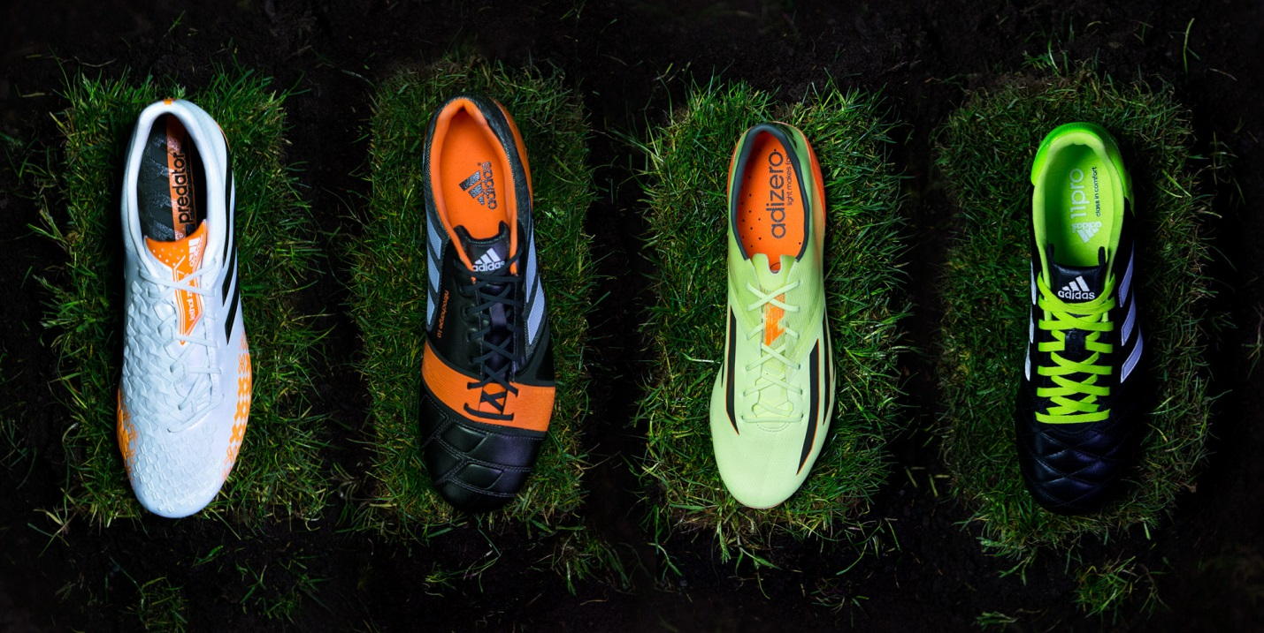

Herzogenaurach, Monday 24th March – adidas is proud to unveil the Earth Pack: a new series of football boots inspired by the Brazilian rainforest.

The country of Brazil is famous for its diverse rainforest and the city of Manaus in the centre of the Brazilian jungle will play host to some key fixtures during this summer’s 2014 FIFA World Cup Brazil™.

The Earth Pack is a collection of uniquely designed boots for each of the four main silos: adizero™ f50, predator®, nitrocharge™ and 11pro.

adizero™ f50
The adizero™ f50, worn by players such as Gareth Bale and Luis Suarez, enables players to be as fast as possible on the football field. The Glow / Earth Green / Solar Zest coloured Earth Pack adizero™ f50 boasts SPEEDTRAXION, an enhanced, high speed stud alignment for maximum acceleration and pinpoint changes of direction, and SPEEDFOIL, a revolutionary material that combines lightweight, softness and durability for a comfortable, yet locked down heel fit.
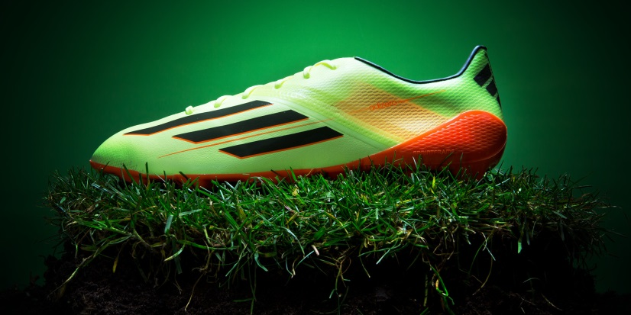
adidas Earth Pack adizero™ f50

nitrocharge™
nitrocharge™, the energy-retaining football boot designed for ‘The Engine’ as worn by Dani Alves and Javi Martinez, comes in an Earth Green / Running White / Solar Zest colourway. Its unique and highly elastic ENERGYSLING™ around the forefoot supports sidecut and precision turn movements to sharpen reactions on the pitch, and ENERGYPULSE™ spring technology provides high energy push-offs and long lasting energy return when sprinting.
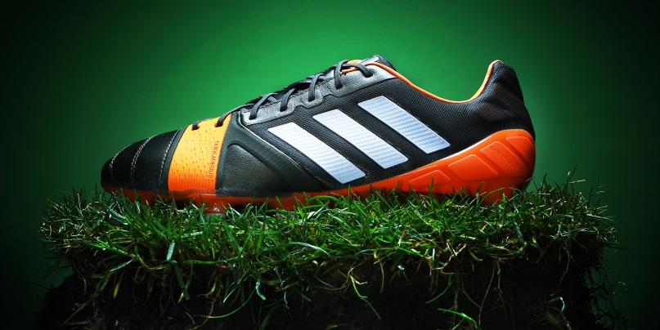
adidas Earth Pack nitrocharge™

predator® Lethal Zones
The Earth Pack predator® Lethal Zones favoured by the likes of Oscar and Mesut Ozil boasts a Running White / Earth Green / Solar Zest colourway. Designed with five distinctive 'Lethal Zones' of technology to deliver outstanding ball control, touch, accuracy and power, the boot is made to master every aspect of performance.
adidas Earth Pack predator® Lethal Zones

11pro
With a Black / Running White / Solar Slime colourway the Earth Pack 11pro has a classic look favoured by star players such as Philipp Lahm and Frank Lampard. With its premium, ultra-soft and ultra-light Taurus leather providing excellent fit, performance, comfort and ball-feel allied to an enhanced outsole with comfort frame for better pressure distribution, as well as optimised stud placement for maximum grip and acceleration, the 11pro remains the boot of choice for the complete footballer.
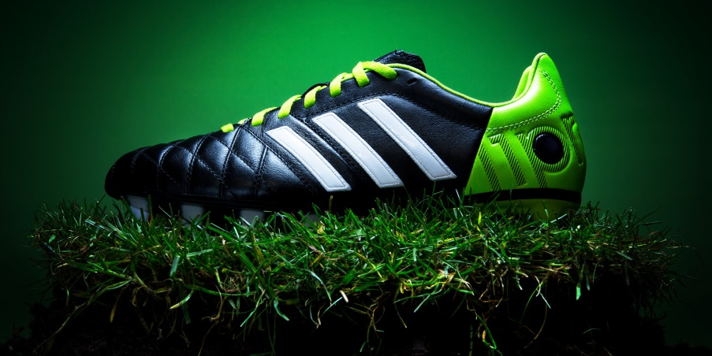
adidas Earth Pack 11pro

The most exciting professional players in the world will wear the new adidas Earth Pack boots onfield from April 1st onwards, with the boots available to purchase on the same day at adidas own-retail outlets as well as specialist stores worldwide. For further information please visit adidas.com/football or go to facebook.com/adidasfootball or @adidasfootball on twitter to join the conversation. #all-in-or-nothing

- END -

For further media information please visit http://news.adidas.com/GLOBAL/PERFORMANCE/FOOTBALL or contact:

Robert Hughes  adidas Senior Global Football PR Manager  Email: robert.hughes@adidas.com  Tel: +49/9132/84-6856 | Alan McGarrie  adidas Global Football PR Manager  Email: alan.mcgarrie@adidas.com  Tel: +49/9132/84-4686
Notes to editors:
About adidas Football
adidas is the global leader in football. It is the official sponsor / official supplier partner of the most important football tournaments in the world, such as the FIFA World Cup™, the FIFA Confederations Cup, the UEFA Champions League, the UEFA Europa League and the UEFA European Championships. adidas also sponsors some of the world’s top clubs including Real Madrid, FC Bayern Munich, AC Milan, Flamengo and Chelsea. Some of the world’s best players also on the adidas roster are Leo Messi, Gareth Bale, Mesut Özil, Dani Alves, Oscar, Xavi, Karim Benzema and Bastian Schweinsteiger.

