adidas Climachill
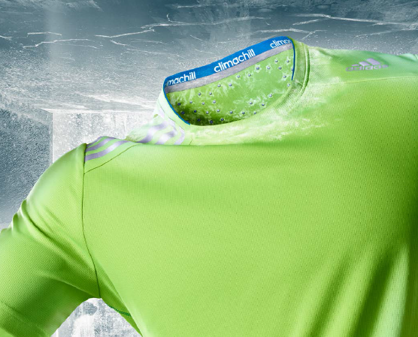
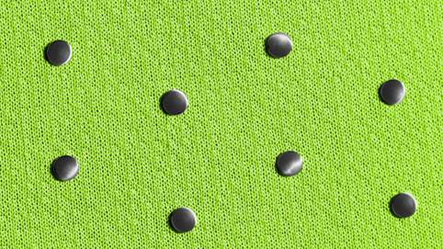
Fact Sheet

adidas introduces Climachill, a revolution in active cooling apparel technology. At the intersection of science and passion, Climachill is designed to raise performance levels by lowering body temperatures to their optimum levels. The technology provides an instant cooling sensation so athletes can train harder, run longer, retain focus and compete and the highest level.

 | GROUNDBREAKING CLIMATE CONTROL | - 3D aluminium cooling spheres are strategically located on the back, neck and forearms to correspond with the warmest area of the body and cool skin down upon contact  - Flat SubZero yarn allows it to cover more surface area on your skin, enabling it to transfer more heat away from your body  - Titanium in the threads gives a cooling sensation to the skin upon contact
SUPERIOR BREATHABILITY |  | The micro fiber fabric outer layer of this apparel is by far more breathable than anything we’ve ever created, moving excess moisture away from your skin. The light and breathable fibers maximize air permeability like an open mesh, allowing for maximum ventilation and evaporation.
PRODUCT AVAILABILITY | Climachill pieces – including running, training and tennis tees, tanks and shorts – are available now from $40 to $60 on adidas.com in select retailers nationwide.

