Flamengo celebrates the spirit of Carnaval
Launch of the new Flamengo adidas away jersey for 2014 season

Rio de Janeiro / Herzogenaurach, 28th February, 2014 – adidas is proud to unveil the new Flamengo away kit for the 2014 season, which features an iconic design to coincide with the most famous festival in the world – Rio de Janeiro´s Carnaval.

Carnaval kicks off this weekend (Friday 28th February) and Flamengo’s home city of Rio de Janeiro will become the party capital of the world to millions of Brazilians, cariocas (inhabitants of Rio) and tourists who will flock to the city to celebrate.
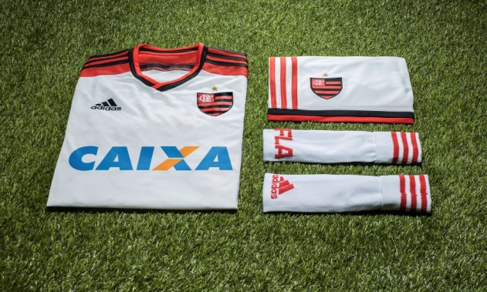
The new CR Flamengo Away Kit for the 2014 season

adidas pays tribute to this celebration and the heritage of Flamengo with an all-white away kit, with white being one of the official colours of Rio de Janeiro. The sleeves and trim on the shorts carry the iconic adidas three stripes in the famous black and red of Flamengo, and the crest on the front is visible in club’s shield proudly displayed on the chest.

The 2014 shirt is the lightest adidas club kit ever, ensuring maximum performance for the players. Speed, endurance and comfort will also be increased with TechFit™ technology which stabilises and focuses muscles to generate explosive acceleration and deliver maximum power output.

Last but not least, the shirts also feature adidas ClimaCool™ technology, a mixture of heat and moisture controlling materials, ventilation channels and 3D fabrics, which improve air flow to the skin in the key heat zones.

The adidas Flamengo away kit is available from Tuesday 11th March for purchase in selected adidas retail outlets, associated stockists and via www.adidas.com/football. Join the adidas football conversation at www.facebook.com/adidasfootball or on Twitter: @adidasfootball.
- END -

For further media information please visit http://news.adidas.com/GLOBAL/PERFORMANCE/FOOTBALL or contact:

Robert Hughes  adidas Senior Global Football PR Manager  Email: robert.hughes@adidas.com  Tel: +49/9132/84-6856 | Alan McGarrie  adidas Global Football PR Manager  Email: alan.mcgarrie@adidas.com  Tel: +49/9132/84-4686
Notes to editors:
About adidas Football
adidas is the global leader in football. It is the official sponsor / official supplier partner of the most important football tournaments in the world, such as the FIFA World Cup™, the FIFA Confederations Cup, the UEFA Champions League, the UEFA Europa League and the UEFA European Championships. adidas also sponsors some of the world’s top clubs including Real Madrid, FC Bayern Munich, AC Milan, Flamengo and Chelsea. Some of the world’s best players also on the adidas roster are Leo Messi, Gareth Bale, Mesut Özil, Dani Alves, Oscar, Xavi, Karim Benzema and Bastian Schweinsteiger.

