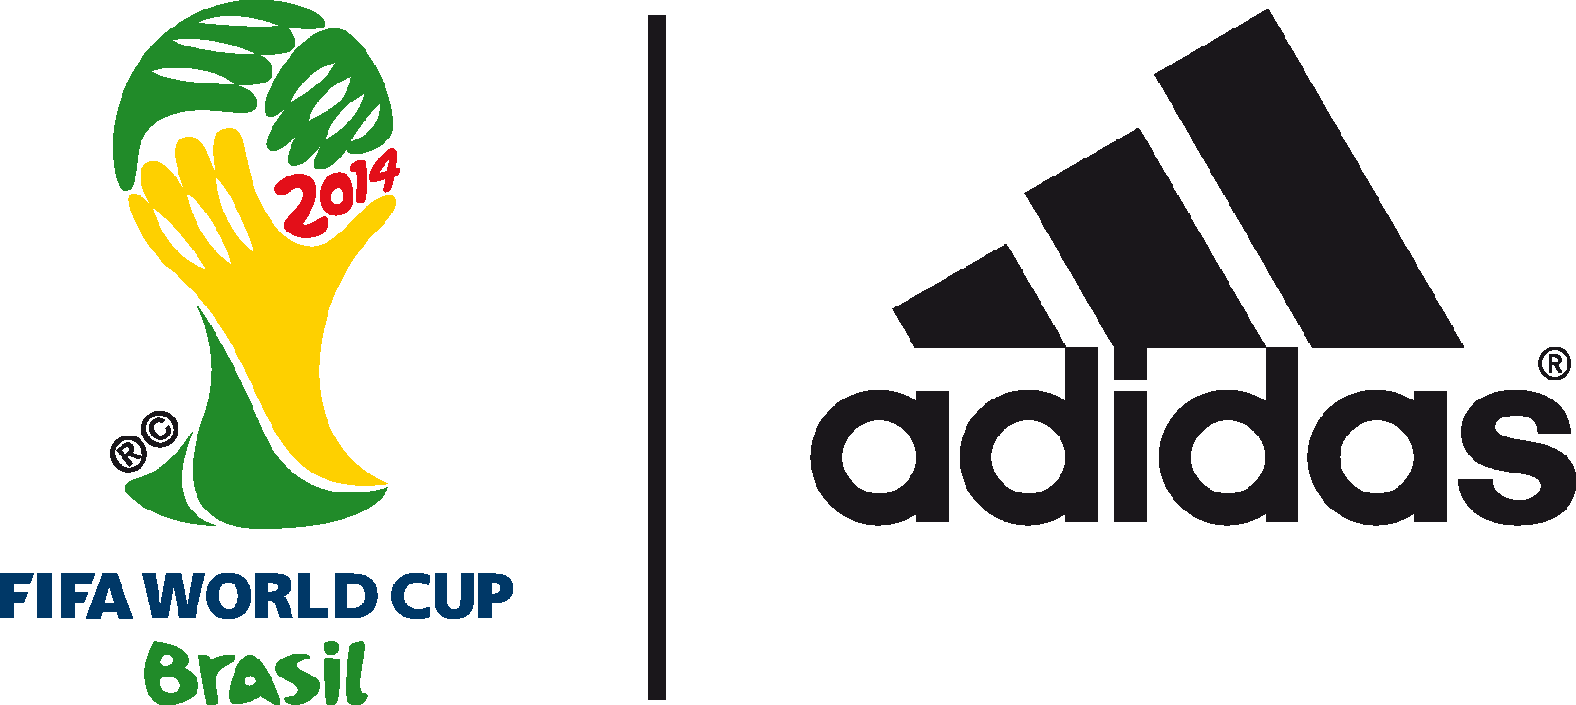

UNIQUE, STAR-STUDDED rio REVEAL SEES adidas’ brazuca FIFA world cup™ ball LAUCHED IN DRAMATIC STYLE

Spectacular 3D projection lights up iconic Parque Lage in celebration of 2014 FIFA World Cup™ in Brazil

Rio de Janeiro / Herzogenaurach, 4th December 2013 – adidas last night unveiled brazuca, the official 2014 FIFA World CupBrazil™ match ball, with a spectacular 3D light projection event held at iconic Brazilian location Parque Lage in Rio de Janeiro. Current national team striker Fred, former FIFA World Cup™ winner Cafu and Flamengo forward Hernane revealed the ball to VIP guests, as adidas kicked off the countdown to next summer’s tournament with a bold and unexpected launch event for the FIFA World Cup™ ball. The unique and stunning show took the audience on an epic journey showcasing FIFA World Cup™ balls from previous tournaments before finally revealing brazuca to the world for the first time.
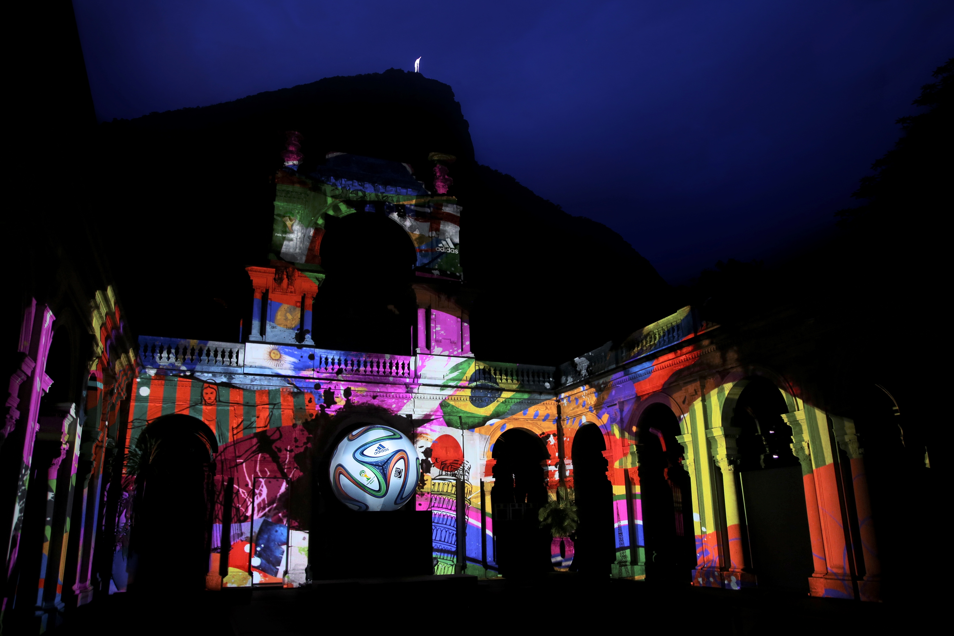

An array of Brazilian football talent as well as famous faces from the country’s sports and entertainment world were in attendance at the star-studded event. Former Samba heroes Edmundo and Roger joined Cafu as they mingled with the next generation of Brazilian football stars, including the gifted 17 year-old Fluminense midfielder Robert. Other famous faces on the guest list included Dutch football legend Clarence Seedorf, tennis player and Brazilian No.1 Thomaz Bellucci and synchronized swimmers and TV hosts Bia and Branca Feres. Popular Brazilian music artists DJ Nepal and DJ Zeh Pretim provided the sets for the night.

The start of the stunning 3D projection was inspired by the wild surroundings of Parque Lage before introducing the stories behind the different national kits worn by adidas-sponsored teams in the upcoming tournament. The focus then switched to previous FIFA World Cup™ balls before the final reveal of brazuca, introducing the technical changes and creative inspirations as well as the launch of @brazuca on Twitter, bringing the ball to life for the first time ever through social media.

The @brazuca Twitter account will enable fans to track the build-up to the FIFA World Cup™ through the eyes of the ball as it travels the world and offers insiders’ perspective on the game and popular culture. brazuca will visit footballing nations, meet players and celebrities, and take part in major cultural events before landing in Brazil for the first game in June, and will be tweeting all the way.

brazuca was named back in September 2012 following a public vote in Brazil involving 1 million football fans and the design reflects the way “brazuca” is used to describe national pride in the Brazilian way of life. The colours and ribbon design also symbolise the multi-coloured bracelets worn in the country as well reflecting the emotions and pride associated with football in Brazil while the new structural innovation of the ball is now made up of six identical panels.

The launch of brazuca marks the next phase of adidas’ “all in or Nothing” 2014 FIFA World Cup campaign, following the launch of seven national federation FIFA World Cup™ kits and the Samba Collection, a Brazilian-themed football boot collection. The FIFA World Cup™ tournament is the world’s largest football event and the ultimate platform for the adidas state-of-the-art apparel, hardware and footwear.

brazuca is available to purchase globally from today (December 4th) in selected adidas retail outlets, associated stockists and via www.adidas.com/worldcup. Join the adidas football conversation at www.facebook.com/adidasfootball or on Twitter: @adidasfootball & @brazuca.

- END -

For further media information please visit http://news.adidas.com/GLOBAL/PERFORMANCE/FOOTBALL or contact:

Robert Hughes  adidas Global Football PR Manager  Email: robert.hughes@adidas.com  Tel: +49/9132/84-6856 | Alan McGarrie  adidas Global Football PR Manager  Email: alan.mcgarrie@adidas.com  Tel: +49/9132/84-4686
Notes to editors:
About adidas Football
adidas is the global leader in football. It is the official sponsor / official supplier partner of the most important football tournaments in the world, such as the FIFA World Cup™, the FIFA Confederations Cup, the UEFA Champions League, the UEFA Europa League and the UEFA European Championships. adidas also sponsors some of the world’s top clubs including Real Madrid, FC Bayern Munich, AC Milan, Flamengo and Chelsea. Some of the world’s best players also on the adidas roster are Leo Messi, Gareth Bale, Mesut Özil, Dani Alves, Oscar, Xavi, Karim Benzema and Bastian Schweinsteiger.

