adidas reveal Yohji Yamamoto adizero f50

Fashion meets football with limited edition boot
inspired by Japanese culture
Herzogenaurach, Friday 25th October 2013 – adidas have teamed up with award-winning Japanese fashion designer Yohji Yamamoto, the man behind the adidas Y-3 fashion brand, to launch the limited edition Yohji Yamamoto adizero f50 boot.

The collaboration between adidas and the well-known designer marks the latest in a line of special edition football boots, following on from the successful release of the White Copa Mundial & “Enlightened” reflective football boots in recent weeks.

Only 2,000 pairs of the visually striking f50s will be available globally and the boots are sure to excite fans when they go on sale from this coming Monday (28th October).

The front of the boot displays a pair of imperial lion-dogs who, in ancient times, guarded the emperors of Japan who used to live on sacred ground. This traditional design has been placed in the context of Japan’s modern sci-fi culture creating a spiritual connection between the past and the future. The result is an unexpected design that draws inspiration from the fashion world in order to make a bold statement on the football field.
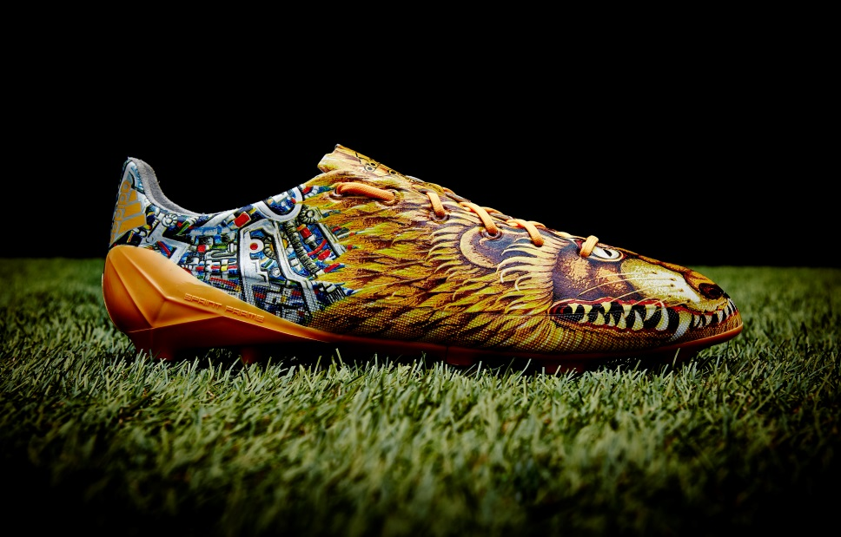
Yohji Yamamoto adizero f50

Yohji Yamamoto explained: “My inspiration is a mixture of ancient traditions and modern sci-fi from Japanese culture… I hope the inspiration of the boot harmonises the players and gives them extra confidence to express themselves without any fear. People should feel free to express themselves. Just follow your own instinct.”

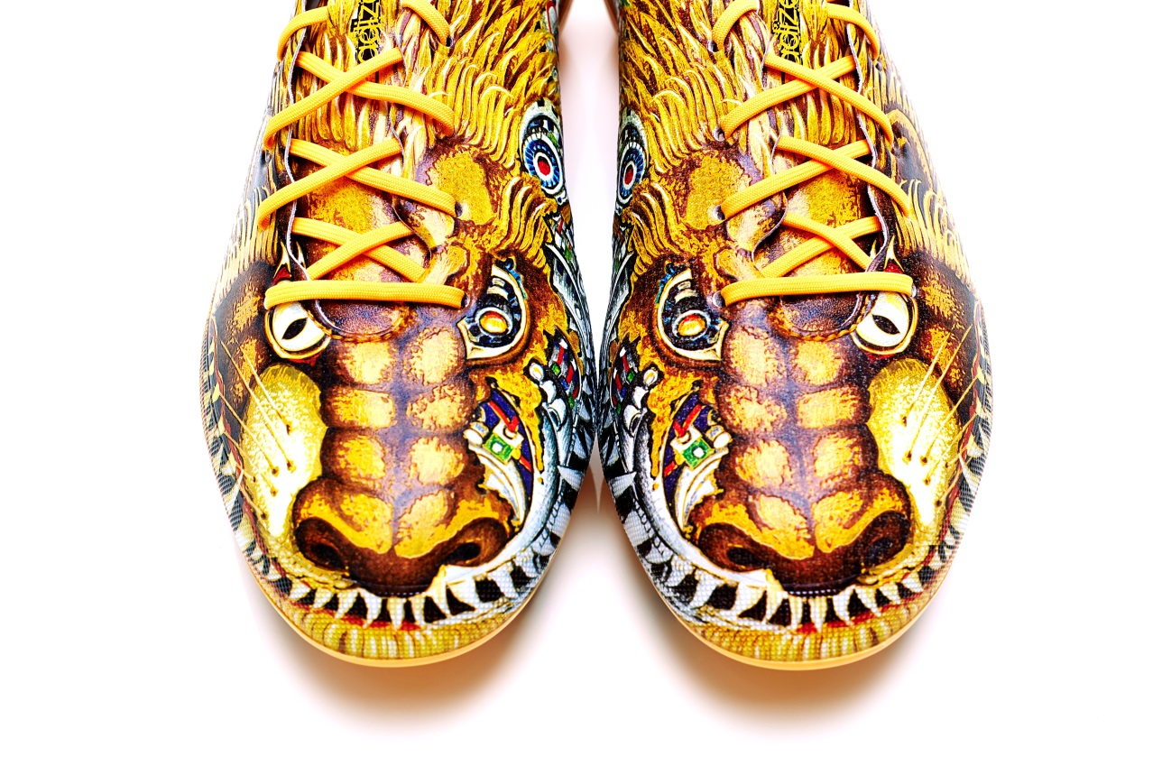
Yohji Yamamoto adizero f50

The Yamamoto f50 uses the same technology as the current adizero f50 range and enables players to be faster than ever before. Precision engineering has played an integral role in every aspect of the boot design and at only 165g is one of the lightest shoes on the market.

The Yohji Yamamoto adizero f50 is available from Monday 28th October for purchase in selected adidas retail outlets, associated stockists and via www.adidas.com/football. Join the adidas football conversation at www.facebook.com/adidasfootball or on Twitter: @adidasfootball.

- END -

For further media information please visit http://news.adidas.com/GLOBAL/PERFORMANCE/FOOTBALL or contact:

Robert Hughes  adidas Senior Global Football PR Manager  Email: robert.hughes@adidas.com  Tel: +49/9132/84-6856 | Alan McGarrie  adidas Global Football PR Manager  Email: alan.mcgarrie@adidas.com  Tel: +49/9132/84-4686
Notes to editors:
About adidas Football
adidas is the global leader in football. It is the official sponsor / official supplier partner of the most important football tournaments in the world, such as the FIFA World Cup™, the FIFA Confederations Cup, the UEFA Champions League, the UEFA Europa League and the UEFA European Championships. adidas also sponsors some of the world’s top clubs including Real Madrid, FC Bayern Munich, AC Milan, Flamengo and Chelsea. Some of the world’s best players also on the adidas roster are Leo Messi, Gareth Bale, Mesut Özil, Dani Alves, Oscar, Xavi, Karim Benzema and Bastian Schweinsteiger.

