ADIDAS ENLIGHTEN THE FIELD OF PLAY

adidas introduce reflective technology during the
UEFA Champions League

Herzogenaurach, Tuesday 22nd October 2013 – adidas will light up the UEFA Champions League with its reflective exposure innovation for boots that captures and bounces off the light of floodlights and cameras to stun defenders and opposition. This is the first time reflective exposure has been used on one of the world’s biggest football stages and adidas continue to lead from the front when taking football boot technology to the next level.

‘The Enlightened Pack’ takes the customisation capabilities on the miadidas web site to new heights, with fans now able to opt for a ‘reflective exposure’ material on their boots and laces to bring the iconic three stripes to life on the pitch. The customisations will be available across all four adidas football footwear silos: adizero f50; predator; nitrocharge and 11pro.

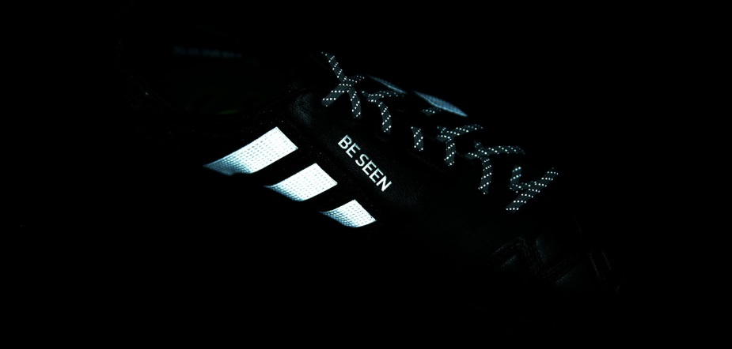
‘The Enlightened Pack’

Europe’s top players will debut the reflective technology in a one off appearance during the forthcoming UEFA Champions League matches set to take place tonight and tomorrow (22nd / 23rd October). adidas first used reflective technology in their sports footwear in 2012 when launching the adidas adizero Smoke “Spotlight” colourway in American Football.

Football fans will now be able to apply the ‘reflective exposure’ to their customised miadidas boots online whilst selected retailers will also be selling boots with the treatment on high streets around the world.

The Enlightened Pack is available from today (Tuesday 22nd October) for purchase in selected adidas retail outlets, associated stockists and via www.adidas.com/go/enlightened. Join the adidas football conversation at www.facebook.com/adidasfootball or on Twitter: @adidasfootball.

- END -

For further media information please visit http://news.adidas.com/GLOBAL/PERFORMANCE/FOOTBALL or contact:

Robert Hughes  adidas Senior Global Football PR Manager  Email: robert.hughes@adidas.com  Tel: +49/9132/84-6856 | Alan McGarrie  adidas Global Football PR Manager  Email: alan.mcgarrie@adidas.com  Tel: +49/9132/84-4686
Notes to editors:
About adidas Football
adidas is the global leader in football. It is the official sponsor / official supplier partner of the most important football tournaments in the world, such as the FIFA World Cup™, the FIFA Confederations Cup, the UEFA Champions League, the UEFA Europa League and the UEFA European Championships. adidas also sponsors some of the world’s top clubs including Real Madrid, FC Bayern Munich, AC Milan, Flamengo and Chelsea. Some of the world’s best players also on the adidas roster are Leo Messi, Gareth Bale, Mesut Özil, Dani Alves, Oscar, Xavi, Karim Benzema and Bastian Schweinsteiger.

