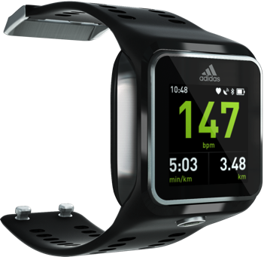
MICOACH SMART RUN – Fact Sheet

The miCoach SMART RUN is the most advanced and intuitive wrist based running device on the market. For the first time, runners will be able to track their runs using GPS mapping, monitor their heart rate off their wrist, listen to their favorite music and get real-time coaching – all in a simple color touch screen running watch.

KEY FEATURES INCLUDE:
- Real-time continuous heart rate measurement from the wrist
- GPS for pace, distance and route logging
- Built-in accelerometer for stride rate measurement
- WLAN sync with miCoach platform for training planning and history/lifetime stats tracking
- TFT LCD color screen
- Intuitive touch screen navigation
- Bluetooth® audio for music and coaching
- Customizable training data screens
- Strength and flexibility coaching videos
- Watch and timer function
- Manual and automatic laps
- Over the air feature updates
- 4GB data memory for music and workouts

TECHNICAL SPECS:
Materials: Soft touch silicon strap, stainless steel bezel, buckle and detailing, magnesium backplate
Display: 1.45” full color transflective TFT LCD, 184px x 184px with capacitive touch
Sensors: GPS, accelerometer, Mio continuous optical heart rate
Software Platform: Android Jelly Bean 4.1.1
Battery: 410mAh lithium ion, charging time ~ max 4 hrs
Usage: Training mode (1 sec. data and music) ~4hrs
Marathon mode (5sec data) ~8hrs
Casual mode (watch only) ~14 days
Data Memory: 4GB (3GB dedicated to music)
RF Protocol: Bluetooth® 4.0, WLAN
Weight: 2.8 ounces
Size: Width 48.4mm, height 15.6mm, length (w/strap) 263.1mm

For further media information please visit adidas NewsStream

