adidas release limited edition of
World’s most popular football boot

White Copa Mundial set to start footwear frenzy

Herzogenaurach, Monday 30th September 2013 – adidas is proud to unveil a limited edition version of their most famous football boot to date: the iconic Copa Mundial.

Released in 1982, the Copa Mundial is the best-selling boot in football history and has been worn by some of the all-time greats including Franz Beckenbauer, Michel Platini, Zico & Karl-Heinz Rummenigge. Since then it has been sold over 10 million times and was actually the last revolutionary product innovation created by sporting goods legend and founder of the adidas brand Adi Dassler. He had been personally involved in the early development of the original Copa Mundial before he passed away in 1978.

adidas will release a limited number of pairs of the special White Copa Mundial available to footballers globally and they are sure to become a collector’s item when they go on sale tomorrow (Tuesday 1st October).
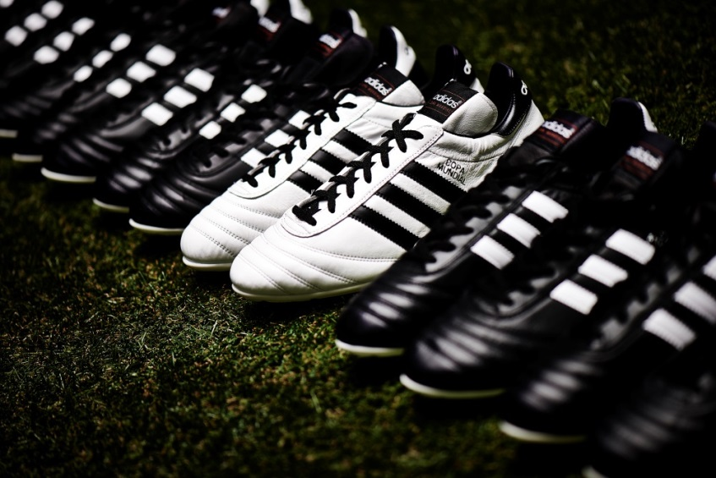
adidas White Copa Mundial

Going through very slight changes since the boot was designed for the 1982 FIFA World Cup™ in Spain, the Copa continues to be made in Scheinfeld, close to adidas HQ in Germany. It boasts a kangaroo leather upper and additional leather provided on the heel, intended to improve durability and stability.

The new boot maintains the same qualities and feel of the traditional version but the colour way has been reversed with white being the prominent colour launching the boot into the modern game.

The White Copa Mundial is available from tomorrow (Tuesday 1st October) for purchase in selected adidas retail outlets, associated stockists and via www.adidas.com/football. Join the adidas football conversation at www.facebook.com/adidasfootball or on Twitter: @adidasfootball.

- END -

For further media information please visit http://news.adidas.com/GLOBAL/PERFORMANCE/FOOTBALL or contact:

Robert Hughes  adidas Global Football PR Manager  Email: robert.hughes@adidas.com  Tel: +49/9132/84-6856 | Alan McGarrie  adidas Global Football PR Manager  Email: alan.mcgarrie@adidas.com  Tel: +49/9132/84-4686
Notes to editors:
About adidas Football
adidas is the global leader in football. It is the official sponsor / official supplier partner of the most important football tournaments in the world, such as the FIFA World Cup™, the FIFA Confederations Cup, the UEFA Champions League, the UEFA Europa League and the UEFA European Championships. adidas also sponsors some of the world’s top clubs including Real Madrid, FC Bayern Munich, AC Milan, Flamengo and Chelsea. Some of the world’s best players also on the adidas roster are Leo Messi, Gareth Bale, Mesut Özil, Dani Alves, Oscar, Xavi, Karim Benzema and Bastian Schweinsteiger.

