FW13 D Rose 4 Apparel Collection – Men’s Basketball

This season, adidas and Derrick Rose launch the new D Rose signature collection. adidas worked side-by-side with Derrick on the collection’s materials, textures and colors to represent his different on and off-court personalities. The collection features adidas’ most premium products, such as fleece sweatshirts/pant, tees, shorts, hats and socks.

D ROSE CITY FULL ZIP
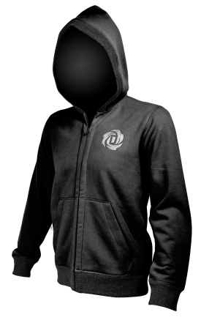
- Heavyweight textured fleece material hand-picked by D Rose to add richness, style and ultimate comfort
- Features matching hood and cuff trim with tonal color and stylish material contrast
- Reflective zipper pocket with D Rose logo add unique style element and functional pocket
Product Rollout:

Colorway Article Release
Black G87126 10/01/13
Medium Grey Heather F47484 10/01/13
Blast Blue F47485 10/01/13
Night Blue F47486 10/01/13

Price: $80

D ROSE SWEAT PANT
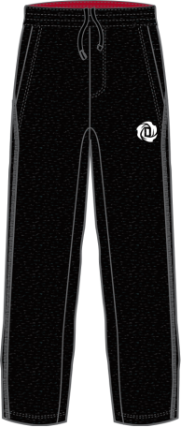
- Heavyweight textured fleece pant combines style with warmth and comfort, features a premium satin stich D Rose logo
- Diagonal fabric highlight and tones are inspired by high-end suit and tie details
Product Rollout:

Colorway Article Release
Black D82336 10/1/13
Tech Grey F12 G92690 10/1/13

Price: $70

D ROSE DOWN JACKET
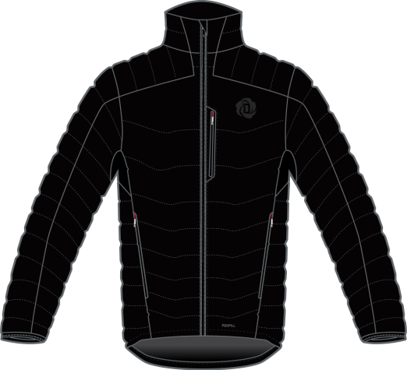
- Premium goose down jacket for optimal warmth in the cold Chicago winters
- Stretch fabric under arms for added mobility and breathability

Product Rollout:

Colorway Article Release
Black D84760 11/1/13

Price: $225

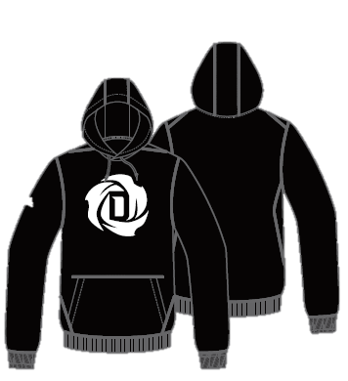
D ROSE LOGO HOODY

- Premium fleece classic pullover hoody features a large D Rose logo on the front for a proud style statement
- Modern seam placement for increased comfort and fit for on and off-court

Product Rollout:

Colorway Article Release
Black D84760 11/1/13
Grey D84761 11/1/13
Light Scarlet D84762 11/1/13

Price: $75

D ROSE CREW NECK SWEATSHIRT
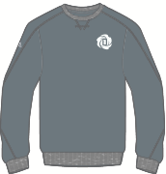
- Heavyweight tonal fleece crew neck inspired by retro gym sweatshirts
- Satin stich D Rose logo on the chest and reflective adidas logo on the arm provide sharp style contrast on classic sweatshirt

Product Rollout:

Colorway Article Release
Tech Grey/White G85702 10/1/13
Black/White G84350 10/1/13

Price: $70

D ROSE LOGO TEE
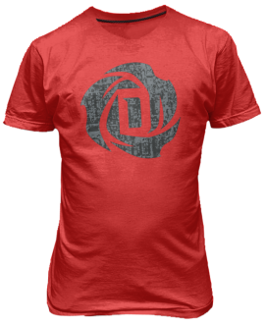
- This fitted cotton/polyester blend was hand-picked by D Rose for its style and comfort
- D Rose logo front and center with a texturized satellite map print of Chicago
Product Rollout:

Colorway Article Release
Light Scarlet G85707 10/1/13
White G84352 10/1/13
Black G75213 10/1/13
Aluminum 2 G85708 10/1/13
Blast Blue D79836 10/1/13
Ray Purple D79838 11/1/13
Clear Green D79837 11/1/13
Night Blue D82335 11/1/13

Price: $30

D ROSE TECH SHORT

- The most premium of the D Rose shorts features a woven base with satin stitched D Rose logo, reflective adidas logo and reflective side seam taping
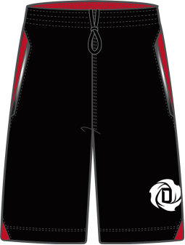
- Built for performance with circle cut side perforations and a slimmer fit for maneuverability on the court
Product Rollout:

Colorway Article Release
Black / Light Scarlet F46780 10/1/13
Light Grey / Tech Grey F46781 10/1/13

Price: $60

D ROSE CITY SHORT
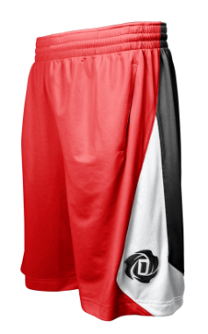
- Heavyweight knit short featuring a panel texturized with the Chicago satellite map print
- Uses the same design pattern and style to hook up with each colorway of the D Rose 4 signature shoe

Product Rollout:

Colorway Article Release
Light Scarlet F46785 10/1/13
Black / Light Scarlet F46782 10/1/13
Blast Blue / Electricity F46786 10/1/13
Aluminum / Light Scarlet F46783 10/1/13
Prism Mint / Black F46787 11/1/13
Night Blue / Pop F46788 11/1/13
Ray Purple / Blast Purple F46789 11/1/13
Black / Pop F46784 11/1/13

Price: $45

D ROSE DIAMOND SHORT

- Heavyweight textured knit short featuring diamond shaped panels and
D Rose logo
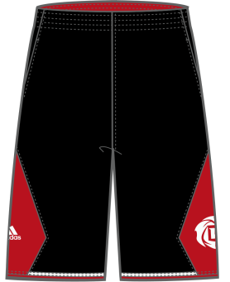

Product Rollout:

Colorway Article Release
Black / Light Scarlet / White D80707 08/1/13
Blast Blue / Black / Vivid Yellow D82133 08/1/13
Tech Grey / Black / Light Scarlet D82134 08/1/13
Collegiate Royal / Black / White D82135 08/1/13
Black / White / Black D82136 08/1/13
Light Scarlet / Black / White D82137 08/1/13
White / Black / White D82138 08/1/13

Price: $38

D ROSE SNAPBACK CAP
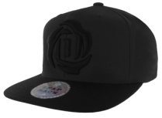
- Designed to meet Derrick’s demand for stylish and comfortable headwear
- Features premium stitched D Rose logo and colors to hook with the D Rose signature shoe
Product Rollout:

Colorway Article Release
Black / Black 5129196 10/10/13
Black / Light Scarlet 5129197 10/10/13
Camo / Black 5129199 10/10/13
Blast Blue/Heather Grey/Electricity 5129428 10/10/13
Collegiate Purple/Electricity/White 5129429 11/21/13

Price: $28

D ROSE CREW SOCK
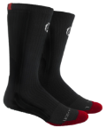
- Designed with the same color blocking of each D Rose 4 colorway
- Features climalite moisture wicking yarns, sculpted cushion foot bed, ribbed leg and D Rose embroidered logo
Product Rollout:

Colorway Article Release
Black/ Light Scarlet / White 5129268 10/10/13
Blast Blue / Electricity / White 5129273 10/10/13
Light Scarlet / Black / White 5129274 10/10/13
Prism Mint / Red Zest / White 5129270 11/07/13
Night Blue/Blast Purple/Pop/Black 5129271 11/14/13
Light Grey / Light Scarlet / White 5129272 11/21/13
Pop / Clear Grey / Black 5129269 12/05/13
Prime Time* 5129453 12/19/13

Price: $15 Crew
*$24 Sublimated Crew

D ROSE BACKPACK
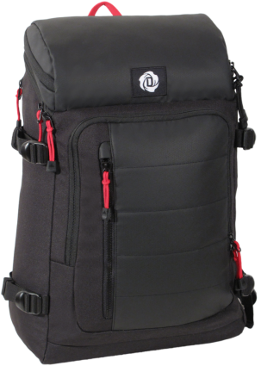
- The first ever D Rose backpack is built with durable materials for function and style
- Features media pockets and two large compartments for maximum storage space

Product Rollout:

Colorway Article Release
Black / Vivid Red 5129238 07/1/13

Price: $80

MORE INFO: For more information, visit news.adidas.com, adidas Basketball Facebook page, www.adidasbasketball.com/thereturn or follow us on twitter and Instagram @adidashoops, #DROSE4

###
Madeline Breskin
adidas Basketball PR
971-234-2220 (o)
971-295-6936 (m)
Madeline.Breskin@adidas.com

