LEO MESSI & ADIDAS CREATE ‘THE NEW SPEED OF LIGHT’

adidas marks latest addition to f50 Messi collection with
cutting-edge LED film

Herzogenaurach, Thursday 1st August 2013 – adidas today revealed the latest iteration of the adizero f50 Messi football boots collection. Messi’s exclusive f50 boots receive their latest treatment with a bold turbo/blast/purple/white colourway. To celebrate the launch the world’s leading football brand has displayed the genius of Leo Messi like you’ve never seen it before. To explore the actions that make him the best in the world, Leo has been fitted up with an innovative LED light suit to help capture his movements, touch and speed in a whole new light.

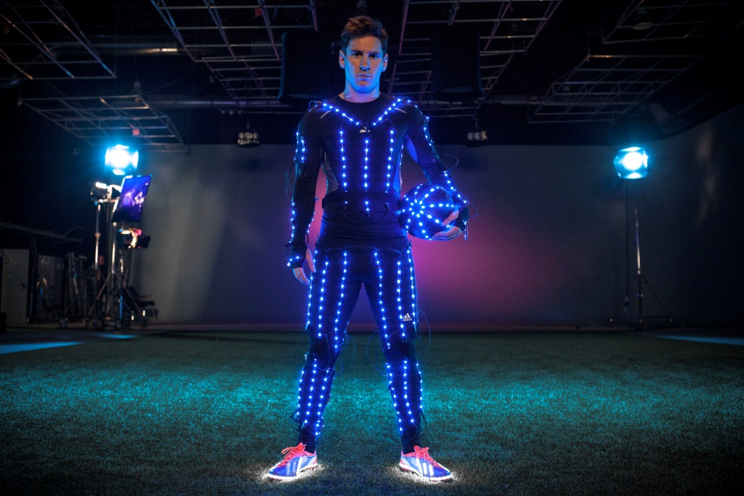
Messi stars in ‘The New Speed of Light’

This film entitled ‘The New Speed of Light’ is a truly unique study of football motion. Created using a bespoke LED suit and a pair of ‘hacked’ adizero f50 Messi boots, it showcases the direction and body movement of the world’s best player. It was shot at 1000 frames per second to create a specially developed visual display that defines the new speed of light.
Filmed in Barcelona by ML studios and directed by Marcus Lyall, the film features a track by Congorock (Ivory – Bloody Beetroots Remix) to compliment the echo effect and concert visual aesthetic of the film.

To watch the new adidas adizero™ Messi f50 ‘The New Speed of Light’ video please click on the following link: http://a.did.as/15aRqDg .

The adizero™ f50 combines revolutionary technologies and precision engineering with every aspect of the boot design based around making the wearer as fast as possible on the football field. At only 165g, the adizero™ f50 is one of the lightest shoes on the market.

The f50 features a range of ground-breaking technologies including:
- Sprintskin – a 1.5mm thick layer made from DUALMAX synthetic with exclusive leather grain optic that allows the boot to be lightweight whilst maintaining a natural feeling between boot and ball
- Sprintweb – the 3D printed texture on the surface of the boot that allows for exceptional ball control at speed and also provides the supple but stable construction
- Sprintframe – a strong but lightweight lower section that offers players a perfectly balanced boot

The new adidas adizero™ f50 Messi boot is available to buy from today (August 1st), please visit the official adidas online-shop www.adidas.com/messi-collection. Join Team Messi at facebook.com/teammessi or join the conversation on Twitter @TeamMessi.

For further information on adidas football and associated products please visit adidas.com/football or go to facebook.com/adidasfootball or @adidasfootball on twitter to join the conversation.

- END -

For further media information please visit http://news.adidas.com/GLOBAL/PERFORMANCE/FOOTBALL or contact:

Robert Hughes  adidas Senior Global Football PR Manager  Email: robert.hughes@adidas.com  Tel: +49/9132/84-6856 | Alan McGarrie  adidas Global Football PR Manager  Email: alan.mcgarrie@adidas.com  Tel: +49/9132/84-4686
Notes to editors:

About adidas Football
adidas is the global leader in football. It is the official sponsor of the most important football tournaments in the world, such as the FIFA World Cup, the FIFA Confederations Cup, the UEFA Champions League, the UEFA Europa League and the UEFA European Championships. adidas also sponsors some of the world’s top clubs including Real Madrid, FC Bayern Munich, AC Milan, Flamengo and Chelsea. Some of the world’s best players are also on the adidas roster with world class individuals such as Leo Messi, Gareth Bale, Dani Alves, Oscar, Xavi, Karim Benzema and Bastian Schweinstegier all sponsored by the German brand.

Marcus Lyall is co-founder and co-director of ML Studio. Originally studying Graphic Design at Central St Martins, Marcus started out making multiscreen slide and film shows in London’s Underground music scene over fifteen years ago.
Since then, he’s worked as a designer, director and animator. His strong interest in experimental filmmaking has led him away from conventional cinema and towards moving images in other contexts, including live events, multimedia and galleries.

ML Studio work with some of the most successful acts in creating unforgettable live events for big audiences. They put music, film, light and stagecraft together to make complex, hard edged, integrated theatrical live shows. The tools of our trade are film making, animation, stage design and the latest display technologies.
But what’s far more important than techniques and technology is imagination. Its imagination laced with a heavy dose of intuition. It’s imagination informed by an understanding of performance and narrative. Imagination inspired by the raw power of music to generate compelling imagery. It is imagination in the service of making live music an unforgettable, visceral experience for audiences.

