EMBARGOED UNTIL WEDNESDAY 3rd JULY 0001hrs CET
ADIDAS SCOUT YOUNG ‘ENGINE’ PLAYERS FROM AROUND THE WORLD TO STAR IN GLOBAL
NITROCHARGE EVENT IN BRAZIL

Young amateur footballers handed surprise trip to Rio
to play lead role in ‘Power Pitch’

Rio de Janeiro / Herzogenaurach, 3rd July 2013 – adidas has scouted a young team of emerging ‘Engine’ players from throughout the world and hosted them in a once in a lifetime, ground-breaking event in Brazil, the home of football and the 2014 FIFA World Cup.

Promoting adidas’ recently launched nitrocharge™ boot, ‘Power Pitch’ is the first event of its kind - where the players’ actions on the pitch translate into powering the lighting around the arena. Each pass, sprint and tackle had an impact on the lighting to show the raw, relentless energy of each player – thus resulting in a mesmerising film showcasing the power and energy of ‘The Engine’ players in action.

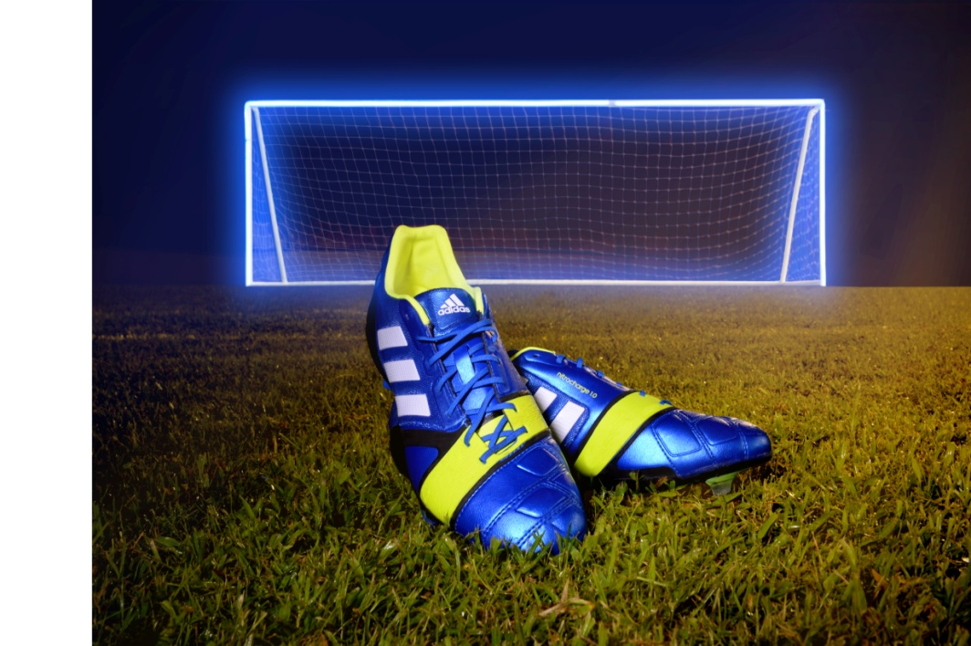
nitrocharge™ Power Pitch

Each player from throughout the World was identified as the type of footballer the nitrocharge™ boots are especially designed for, box-to-box players with relentless energy in the mould of Daniele De Rossi, Ezequiel Lavezzi, Javi Martinez & Dani Alves.

Surprise scouting sessions took place with some of the world’s top football stars including Daniele De Rossi, Patrick Vieira & Jamie Carragher surprising young amateur players from their respective nations. Each ‘Engine Scout’ was briefed to look out for the qualities that best characterise ‘The Engine’ player and selected the winners based on key factors including work rate, pitch coverage and key attacking and defensive actions. The winners were invited to play central roles at the event in Brazil and included youngsters Jerome Martelli-Denton from the UK, Andrea Delianni of Italy, Cyprien Morin of France, Andres Ona Alcocer from Ecuador, Ruben Ramirez of Venezuela and Jae Hoon Lim from South Korea.

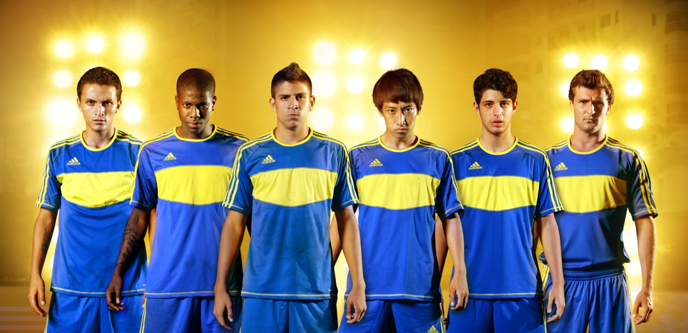
‘The Engine’ players scouted from throughout the World

A cutting-edge film has been produced from the content captured at the ‘Power Pitch’ event and showcases how the relentless qualities and characteristics of ‘The Engine’ player can be transformed into fast-paced, visual energy. State of the art filming techniques were used with customised rigs developed for GoPro cameras and camera drones capturing HD, multi-angle footage to bring the action to life.

nitrocharge™ player Daniele De Rossi said: “Power Pitch is an exciting event that focuses on the idea around ‘The Engine’ player. I was lucky enough to be involved with selecting one of the players and it was an honour to be able to provide a great moment to a young, aspiring footballer. To give Andrea, the player I scouted, the chance to not only go to Brazil – the home of next year’s World Cup – but also to take part in a really cool adidas football event was amazing.”

The visually striking nitrocharge™ boot is an evolution of adidas’ heritage in creating footwear to fit certain player types. The unique positioning of nitrocharge™ has energy retention at its heart and has been designed specifically for ‘The Engine’ player, the archetypical footballer who is always first on the team sheet; the player who powers a team, running and tackling more, relentlessly and ferociously seeking chances from box-to-box over 90 minutes.

'The Engine’ is a player adidas has recognised and actively sought to engage with over the last two years. Now, following a partnership with football statisticians Opta, an algorithm has been developed from which player performances can be analysed to determine how well they suit ‘The Engine’ role.

To buy the new adidas nitrocharge™ boot please visit the official adidas online-shop www.adidas.com/nitrocharge-collection or to join the conversation visit facebook.com/adidasfootball or @adidasfootball #TheEngine on twitter.

- END -

For further media information please visit http://news.adidas.com/GLOBAL/PERFORMANCE/FOOTBALL or contact:

Robert Hughes  adidas Senior Global Football PR Manager  Email: robert.hughes@adidas.com  Tel: +49/9132/84-6856 | Alan McGarrie  adidas Global Football PR Manager  Email: alan.mcgarrie@adidas.com  Tel: +49/9132/84-4686

Note to Editors

About nitrocharge™

The nitrocharge™ boot realises a range of new technologies that when combined will innovate the way ‘Engines’ play the beautiful game:

- The eye catching ENERGYSLING™ arches over the boot and supports sidecut and turn movements to sharpen reactions on the pitch
- The sole plate of the boot contains a zig-zagging ENERGYPULSE™, inspired by spring technology, with high-elastic material at its heart, providing premium energy during the off toe phase of sprinting
- A Protection mesh layer around the foot and Protection pads around the most sensitive tackle zones such as the Achilles tendon also feature in the boot

- Compatible with the adidas miCoach™ SPEED_CELL, players can measure on-pitch performance and focus on improvement over time

About adidas Football
adidas is the global leader in football. It is the official sponsor of the most important football tournaments in the world, such as the FIFA World Cup, the FIFA Confederations Cup, the UEFA Champions League, the UEFA Europa League and the UEFA European Championships. adidas also sponsors some of the world’s top clubs including Real Madrid, FC Bayern Munich, AC Milan, Flamengo and Chelsea. Some of the world’s best players are also on the adidas roster with world class individuals such as Leo Messi, David Beckham, Dani Alves, Oscar, Steven Gerrard, Karim Benzema and Bastian Schweinstegier all sponsored by the German brand.

