

Adidas reveal new Chelsea Football Club away kit for 2013/14
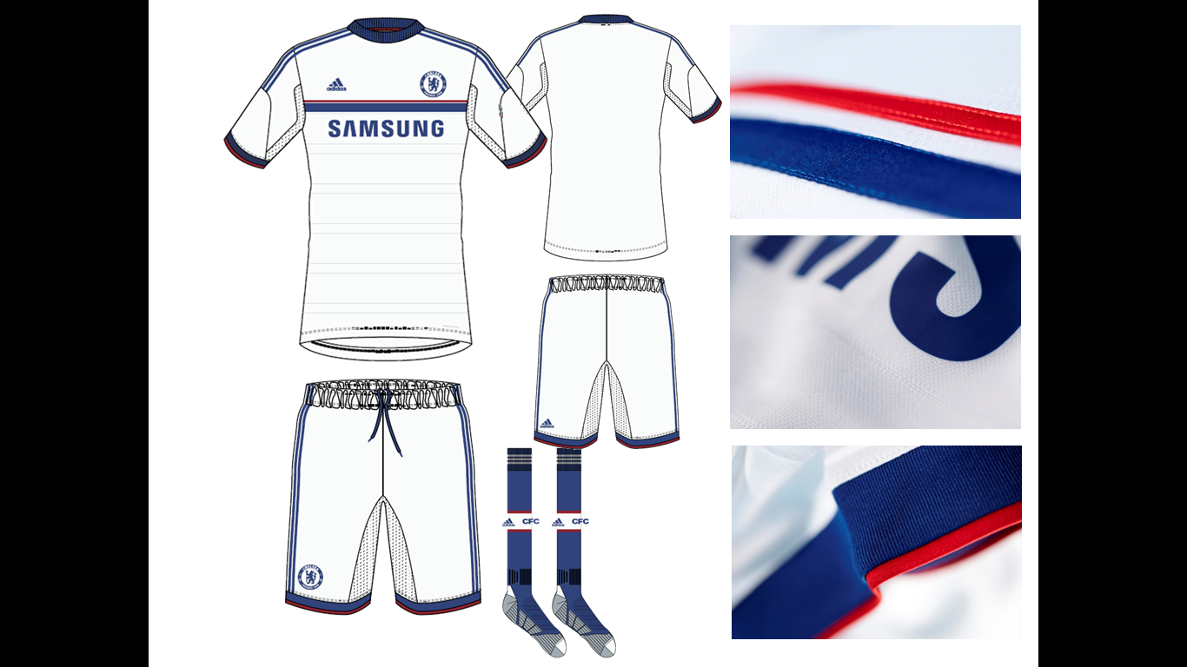

XX May 2013 - adidas and Chelsea FC have today revealed the new away kit for the forthcoming 2013/14 season.
Fresh from the successful launch of the new home shirt through the innovative “It’s blue, what else matters” campaign, adidas have delivered a standout kit to be worn in select away fixtures across the 2013/14 season.
The new design leads with white as the primary colour, the sixth time a Chelsea away kit has featured this colour scheme. The strip is a clear homage to the club's iconic white kits with blue and red trim during the 1960s.
The use of red makes a return with its first appearance on a kit since the 2010/11 season’s home shirt.
The new strip is available now for pre-order and will go on sale July 4, 2013
Technology

The traditionally styled white kit features the latest adidas technologies to ensure that it not only evokes the meaning of being a true blue but gives CFC an edge on the pitch:

Climacool - adidas ClimaCool™ technology provides a mixture of heat and moisture controlling materials, ventilation channels and 3D fabrics to improve air flow to the skin in key heat zones.

Visit www.chelseafc.com/allin for information and to purchase the new CFC away kit.

For further information:

Ben Goldhagen
adidas UK – Press Office
ben.goldhagen@adidas.com
07961 182 501

