**EMBARGOED UNTIL MONDAY 22nd April 1900hrs CET**

**ADIDAS & OPTA UNCOVER NEW**

**BREED OF FOOTBALL PLAYER**

**Mathematical algorithm proves existence of ‘The Engine’**

**Herzogenaurach, Monday 22nd April** – For the last two years adidas have been working behind the scenes to identify a new specific type of football player called ‘The Engine’ and today they are proud to reveal a partnership with leading sports data provider, Opta, who can confirm the existence of this player type through an algorithm summarised by the mathematical equation below:



***‘The Engine Equation’\****

‘The Engine’ is the archetypical box-to-box footballer who covers every blade of grass, seeks goal scoring chances, tracks down his opponent and displays relentless energy from the first minute to the final whistle.

Based on the adidas insight, Opta have helped to reveal the fundamental character of ‘The Engine’ by finding out how to measure and quantify his performances. They have produced a mathematical algorithm which defines the perfect ‘Engine’ player and will be used to track this player’s performance from today onwards. Some of the players believed to fit ‘The Engine’ stereotype are Bayern Munich’s Javi Martinez, FC Barcelona’s Dani Alves, AS Roma’s Daniele De Rossi & Paris Saint Germain’s Ezequiel Lavezzi.

With the help of Opta and their database of statistics and insights, the algorithm will be used to pinpoint ‘The Engine’ performances week in, week out. Certain indicators such as work rate, pitch coverage, and on / off ball statistics will be measured and players will be scored out of 100. adidas & Opta will analyse data from key matches from the UEFA Champions League and the Confederations Cup and highlight ‘The Engine’ players via an index entitled ‘The Engine Scale’ – results will be announced to media and fans through a series of info graphics and other statistic-based imagery as they become available on twitter @adidasfootball #TheEngine.

Ahead of this week’s UEFA Champions League and UEFA Europa League Semi Finals, the algorithm has already focused on several of the world’s top players and has unearthed some stats proving how vital ‘The Engine’ has been during these campaigns. For example, Bayern Munich midfielder Javi Martinez is renowned for his committed style of play and has won on average 2.6 aerial duels per game in the UEFA Champions League this season, more than any other Bayern Munich player.

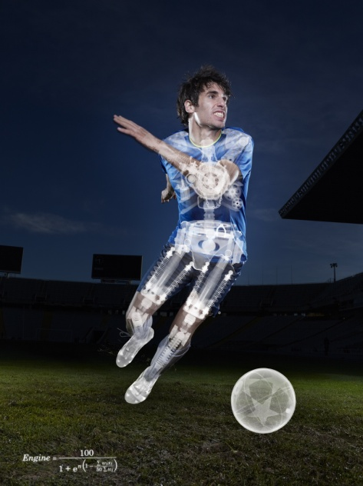 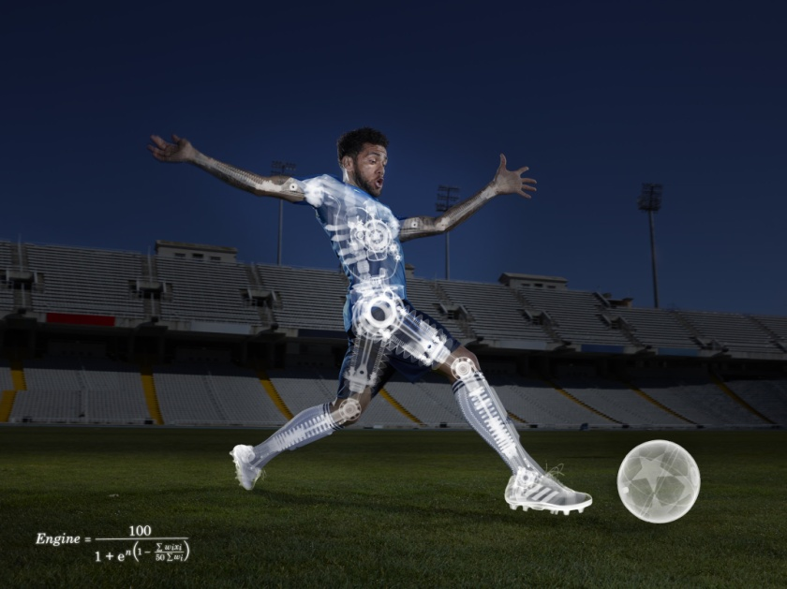

***Bayern Munich’s Javi Martinez and FC Barcelona’s Dani Alves have both been***

***identified by adidas & Opta as ‘The Engine’ players and will meet each other in this week’s***

***UEFA Champions League Semi Final 1st leg***

Claus-Peter Mayer, adidas Vice President Global Sports Marketing Football, said: *“Working with Opta has confirmed that adidas have found ‘The Engine’ footballer. ‘The Engine’ is a player we have been focusing on in recent years in terms of our footwear development and player recruitment, so for the world’s leading data provider to prove this insight through their scientific analysis is a fantastic and exciting development.”*

Aidan Cooney, CEO, Opta commented: *“We are delighted to be working with adidas on confirming the existence of ‘The Engine’ player.  Modern football fans are passionate about comparing, contrasting and analysing their favourite players’ performances. By incorporating Opta’s uniquely detailed data, The Engine Scale can help to contribute to this debate before, during and after the match”.*

For further information please go to **facebook.com/adidasfootball / optasports.com** or **@adidasfootball / @optasuit** on twitter and join the conversation with **#TheEngine**.

**- END -**

**For further information please contact:**

|  |
| --- |
| Alan McGarrie  adidas Global Football PR Manager  Phone: + 49 9132 844686  Email: [alan.mcgarrie@adidas.com](mailto:alan.mcgarrie@adidas.com) |

**Continued.**

**Notes to Editors:**

**Explained: The Engine Equation

$$Engine=\frac{100}{1+e^{n\left(1-\frac{\sum{w_{i}x_{i}}}{50\sum{w_{i}}}\right)}}$$

\***

**Where:**

* n is the number of indicators,
* wi is the weighting for the ith indicator and
* xi is the player score for the ith indicator.

*This equation summarizes the mathematical concept behind the Engine Scale calculation.

**Currently there are n = 4 indicators:**

* x1 = Work Rate
* x2 = Pitch Coverage
* x3 = On the Ball
* x4 = Off the Ball

E.g. if wi ≡ 1

|  |  |  |  |  |
| --- | --- | --- | --- | --- |
| **Work Rate** | **Pitch Coverage** | **On the Ball** | **Off the Ball** | **Engine** |
| 80 | 80 | 80 | 80 | **92** |
| 80 | 50 | 50 | 50 | **65** |
| 50 | 50 | 50 | 50 | **50** |
| 20 | 50 | 50 | 50 | **35** |
| 20 | 20 | 20 | 20 | **8** |

**INDICATORS**

1. **Work Rate**

Work Rate looks at how involved each player is during the course of a match, both overall and how consistent they are.

This is composed of:

* passes
* team passes
* minutes played
* attacking touches
* defensive touches

So, for example, a player that consistently has a high number of touches throughout the match will score better than one who has bursts of high and low involvement (all else being equal).

1. **Pitch Coverage**

Pitch Coverage looks at where the player is involved on the pitch, with a higher score being awarded for a larger area of positions that the player is involved. Again, this is based upon an overall figure for the match and how consistently they are involved all over the pitch.

This is composed of:

* x and y co-ordinates of all player events
* co-ords of attacking events
* co-ords of defensive events
* time

1. **On the Ball**

A player’s On the Ball rating is driven by how successful they were when in possession of the ball. This includes:

* passes
* crosses
* shots
* dribbles
* event co-ordinates

The last is an important point – completing a pass into the opposition’s box will positively affect a players score more than the same pass in their own half. Note that while shots are considered they are relatively infrequent events and considered a minor part of what makes a player an Engine so, while goals will positively impact a player score, it will not make a large difference.

1. **Off the Ball**

Off the Ball is based on how effective players are when out of possession. That is, how often and successfully are they winning the ball back for their team. It includes:

* Tackles
* Interceptions
* Blocks/saves
* Aerials
* Clearances
* event co-ordinates

As with On the Ball, location is factored in to the weight of the events (i.e. a shot blocked in the six-yard box is more important than one from long range).

**About Opta:**

Opta are the world's leading sports data company. They collect, package, analyse and distribute more live data, in more detail, than anyone else.

The level of detail Opta provides allows for more innovative broadcast coverage, more engaging online and print reporting and more intelligent professional analysis.

This high definition data is collected and analysed live by Opta. It is databased and supplied within seconds of the action happening on the pitch. This means it can be used to create an ongoing narrative as the drama unfolds.

As the live data goes into the Opta databases, it adds to the most comprehensive archive of sports data on the planet.

Sports fans across the world can be confident in Opta data. Players and teams are compared using the same global standard, and it is this passion for consistency that has ensured that Opta has become the byword for credibility in the world of sports data.