Embargoed until 9am CET 21/03/13
adidas launches Leo Messi Facebook experience
‘Team Messi’ Facebook Connect application allows fans to star alongside Messi in personalised film

Herzogenaurach, Thursday 21st March 2013 – adidas today unveiled a new, cutting edge Facebook experience, designed to bring Leo Messi’s legion of fans even closer to their hero.

By joining ‘Team Messi’ on Facebook fans will be able to star alongside the world’s best player in an interactive film personalised to the user through Facebook Connect. The innovative application represents a first for a football player, and makes use of pioneering 3D flash technology and filming techniques.

The film is personalised to the user from the opening scene, with fans enjoying a tailored experience determined by their entry to ‘Team Messi’ on Facebook; a first for Facebook Connect. The experience features three interactive moments, each allowing the user to dictate which journey they take through the film with Leo Messi. These moments mark a further technological milestone – adidas being the first brand in the world to use this 3D flash technology online.

Once fans have lived their ‘Team Messi’ experience they can share a short trailer of their film, containing a piece of the personalised content, with their friends on Facebook.

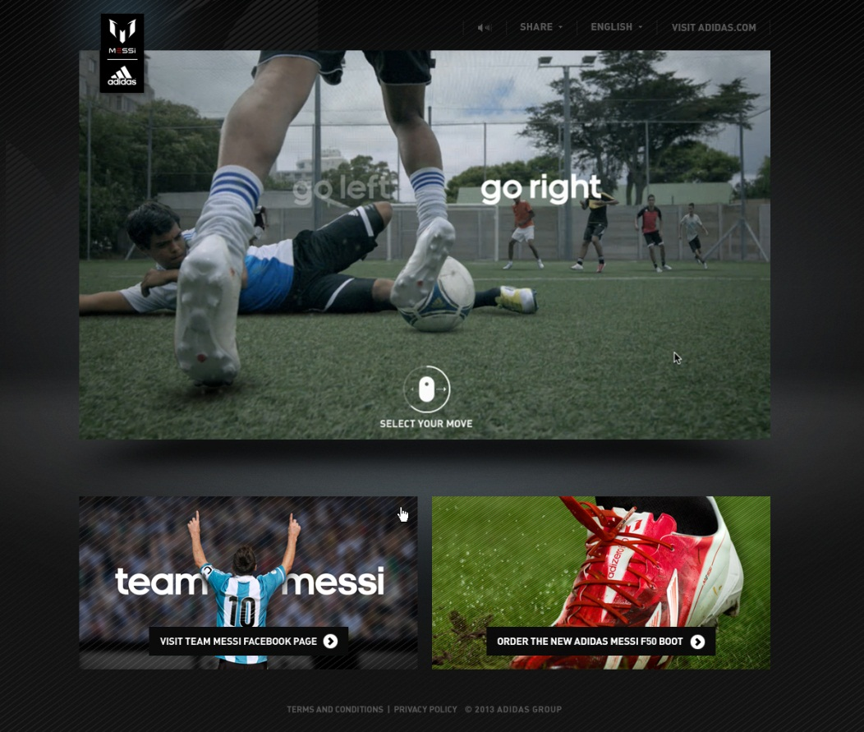
Facebook Connect experience featuring Leo Messi

The film also features a previously unreleased track from Hudson Mohawke, a leading electronic music producer who has worked with the likes of Kanye West, Lunice and Egyptian Hip Hop, both as a solo artist, or as one half of electronic duo TNGHT.

The interactive Facebook Connect experience is part of a wider ‘Team Messi’ campaign to mark the launch of the adidas Messi Collection of boots and apparel, including a signature adizero f50 Messi boot. ‘Team Messi’ celebrates the attributes, behaviour and values that make Leo the most admired and inspiring footballer in the world.

Last week adidas also unveiled the adidas Messi Gallery, a pop-up exhibition in Barcelona housing a series of iconic memorabilia representing Leo Messi’s entire career.

The experience is available on Facebook via http://a.did.as/WJufN0

Join Team Messi at facebook.com/teammessi or join the conversation on Twitter @TeamMessi

For further information on adidas products and services please visit: www.facebook.com/adidasfootball or www.adidasnewsstream.com.

- Ends -

For further information please contact:

Robert Hughes
Senior Global PR Manager Football

Email: Robert.Hughes@adidas.com
Tel: +49-160 884 6856

The content was filmed with a Phantom camera at 1000 frames per second and then digitally remastered using 3D projection mapping to integrate live action footage.

