EMARGOED UNTIL 0900hrs 7th November 2012
adidas Unveil The Next Generation of Speed Boot –
The adizero f50®
The boot that enables players to ‘Find Fast’

Herzogenaurach, December 2012 – adidas are excited to announce the next generation adizero f50® football boot, a boot which enables players to be faster than ever before.

The new adizero f50® is all about precision engineering with every aspect of the boot design based around making the wearer as fast as possible on the football field. At only 165g, the adizero f50® is one of the lightest shoes on the market. They will be released in a new Vivid Yellow / Black / Green Zest colour way allowing wearers to own the spotlight. Football fans will get an early preview of what the boots can do when the world's best player, Leo Messi, exclusively debuts them in the UEFA Champions LeagueTM against Celtic on 7th November.

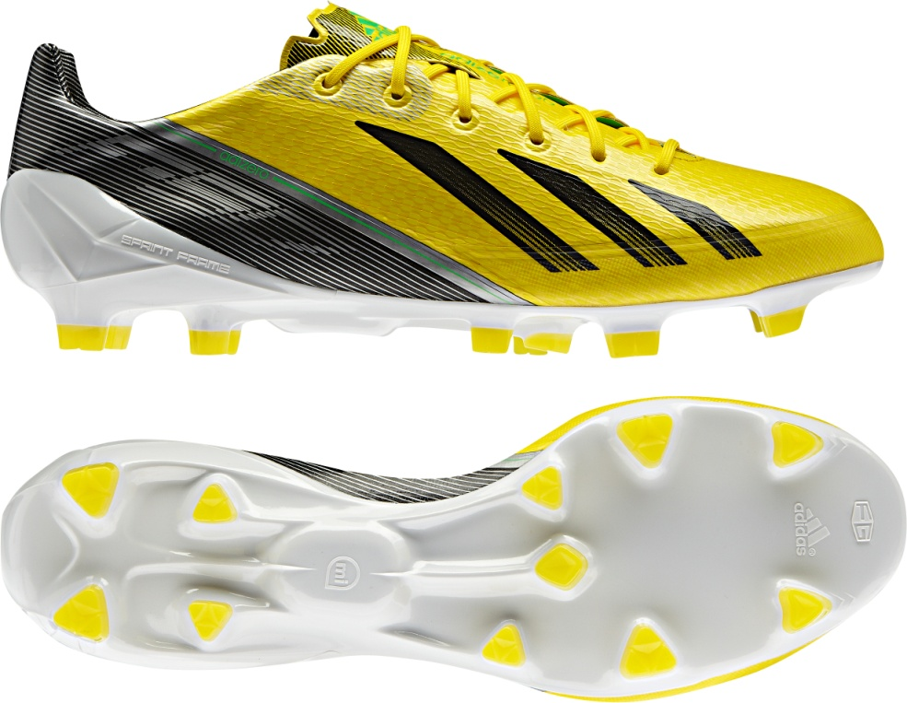
adizero f50®

The new adizero f50® combines revolutionary technologies with cutting edge engineering in order to create the latest incarnation of the hugely successful silo series. Sprintskin is a 1.5mm thick synthetic layer that allows the boot to be lightweight whilst maintaining a natural feeling between boot and ball. Sprintweb is the 3D printed texture on the surface of the boot that allows for exceptional ball control at speed and also provides the supple but stable construction. The final layer of boot construction is the Sprintframe, a strong but lightweight lower section that offers players a perfectly balanced boot.
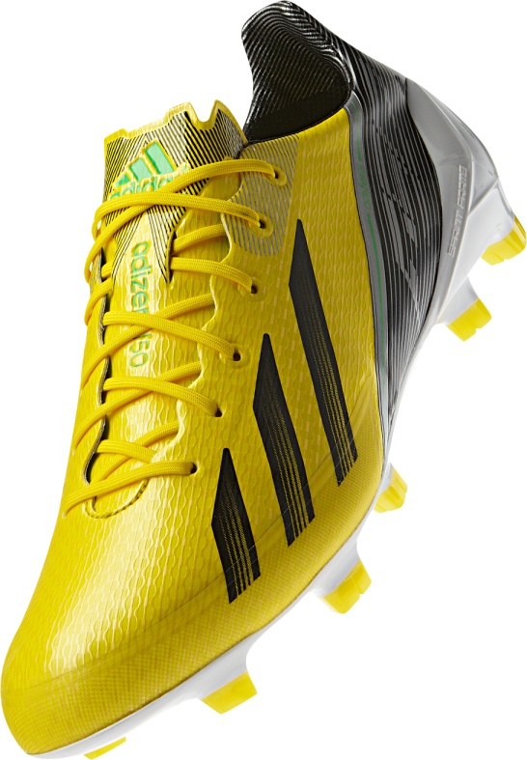
adizero f50®

The next-generation technologies are designed to enable players to ‘Find Fast’, and performance metrics can be tracked, analysed and compared against the best players in the world or with your friends via social media networks using the ground breaking adidas miCoach® capability. The specially designed cavity within the new adizero f50® houses the miCoach Speedcell® which records statistical data such as top speed, distance covered, and active zones. Once the data is captured, it can be wirelessly synced up to an iPhone/iPod or PC/Mac allowing players to analyse their performance, get tips and advice on how to improve, and compare themselves to others.

From mid-November onwards some of the most exciting professional players in the world, including Dani Alves, Karim Benzema, David Silva and David Villa will dominate the game in the boots. The new adizero f50® boots will be available at adidas own-retail outlets as well as specialist stores worldwide from December 2012 in Vivid Yellow / Black / Green Zest. In addition, footballers can download an exclusive mobile app that will unlock unique adidas content, insight into the new boot, and chances to get closer to the brand and its ambassadors. For further information please visit adidas.com/football or go to facebook.com/adidasfootball or @adidasfootball on twitter to join the conversation.

- END –

For further information please contact:
Robert Hughes
adidas Global Football PR Manager
Email: robert.hughes@adidas.com
Tel: +49/9132/84-6856

Alan McGarrie
adidas Global Football PR Manager
Email: alan.mcgarrie@adidas.com
Tel: +49/9132/84-4686

