Europe’s Elite Design Their Own adidas Boots
Stars celebrate the miadidas ‘Next Gen Weekend’ by creating personalised adidas boots

Herzogenaurach, Germany - October 2012 - During the first weekend of November (3rd & 4th), seven adidas footballers including Karim Benzema, Lukas Podolski and Riccardo Montolivo will celebrate the miadidas ‘Next Gen Weekend’ by wearing personalised boots that they have designed on miadidas.com.

The player-designed boots will be road tested during a one off appearance in league matches throughout Europe in order to promote the launch of the website’s new ‘Next Generation Configurator’. miadidas.com is a service allowing footballers to “Create Your Own” design and incorporate colour schemes and personal touches to their boots. The website features new personalisation possibilities and improved functionality meaning that it is easier than ever for ‘designers’ to share their creations on social media.

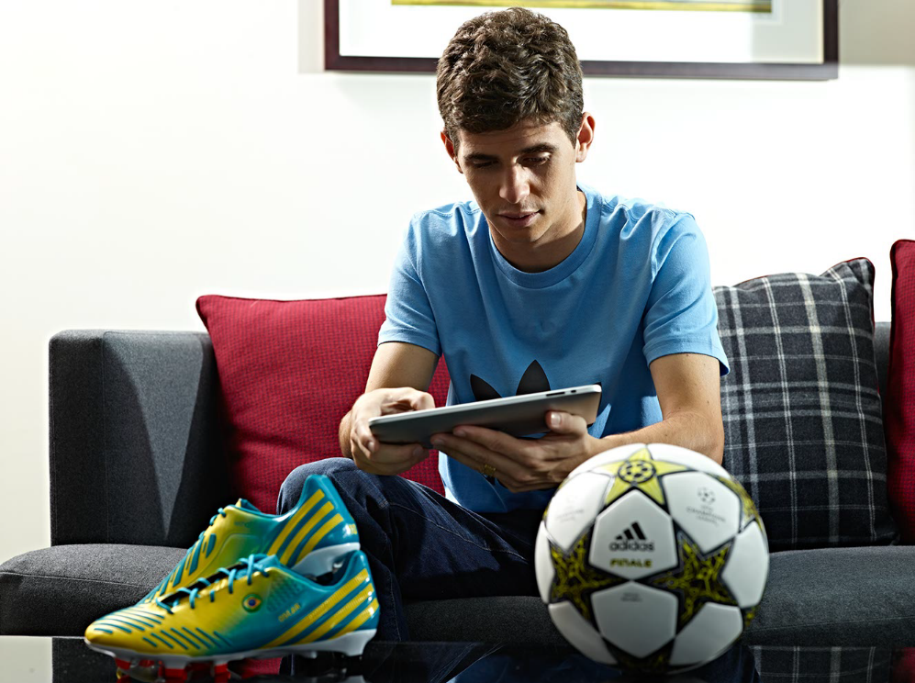
Oscar

Whether it’s the Brazilian inspired predators designed by Oscar or the sleek black / gold f50s favoured by Karim Benzema, the new miadidas configurator has enabled players to create unique designs driven by their personal inspiration and creativity.

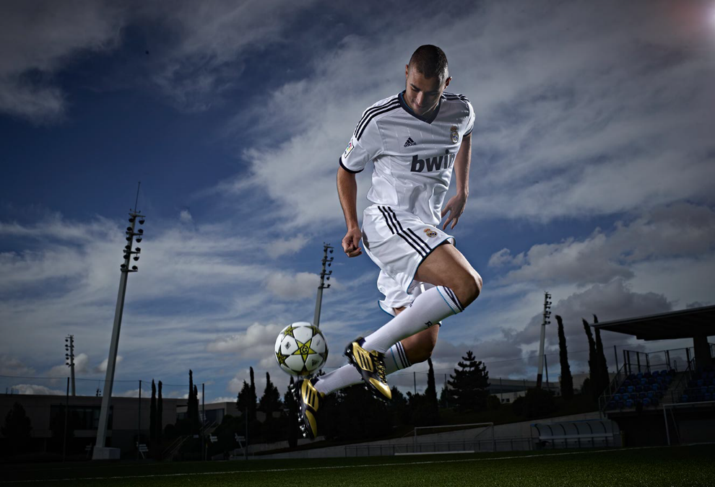
Karim Benzema

In certain countries where the miadidas configurator is available, fans of the best footballer in the world, Leo Messi, have already been getting to grips with the newly launched platform this week as they have entered a competition to design a pair of boots for the player to wear on field in December.

Speaking about the competition earlier this week, Messi said: “In football you express yourself with your feet, which is why I like to feel like I have a connection to my adizero f50s. Knowing that your boots are unique makes you feel special and makes you play with more confidence. I’m excited to see the designs that my fans create for me on the miadidas configurator and I look forward to playing in them.”

The full list of players who will unveil their specially created designs during the miadidas ‘Next Gen Weekend’ on 3rd / 4th November are Karim Benzema (Real Madrid), Fernando Llorente (Athletic Bilbao), Riccardo Montolivo (AC Milan), Thomas Müller (Bayern Munich), Oscar (Chelsea), Lukas Podolski (Arsenal) and Ashley Young (Manchester United).

Football fans are invited to take inspiration from the miadidas ‘Next Gen Weekend’ and create and share their boot designs on miadidas.com. For further information please visit facebook.com/adidasfootball or @adidasfootball #miadidas on twitter to join the conversation.

About miadidas
The newly launched ‘Next Generation Configurator’ on www.miadidas.com is available in the following markets: Austria, Belgium, Denmark, Finland, France, Germany, Italy, Japan, Netherlands, Sweden, Spain, UK & ROI & United States and enables sport and lifestyle enthusiasts to create unique products that reflect their individuality. All three adidas football boot silos are available to customise: predator; f50 & adipure. Designs can be shared amongst consumers through Facebook, Twitter or via e-mail.

- END –

For further information please contact:
Robert Hughes
adidas Global Football PR Manager
Email: robert.hughes@adidas.com
Tel: +49/9132/84-6856

Alan McGarrie
adidas Global Football PR Manager
Email: alan.mcgarrie@adidas.com
Tel: +49/9132/84-4686

