adidas unveil new Chelsea Football Club Third Kit

THE SUN ALWAYS SHINES ON CHELSEA

2012– Just months after basking in Champions League and FA Cup glory, Chelsea Football Club and adidas today unveiled the new third kit for the 2012/13 football season.

The kit, designed by adidas, is a striking combination of flaming ‘sun’ yellow and black ensuring that Chelsea stand out on the pitch in the style stakes as well as with their football prowess.

The kit also includes the iconic adidas three stripe detail through the arms and a strong fading graphic to the façade of the chest.

The sun yellow colour may look familiar as it has adorned many Chelsea kits since the 1960s but looks more striking than ever in this modern and sharp design.

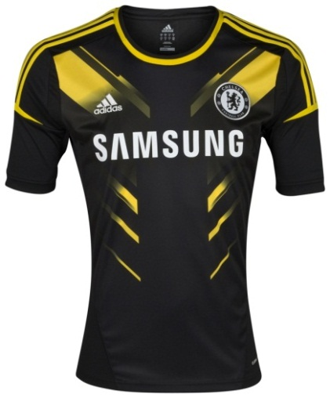
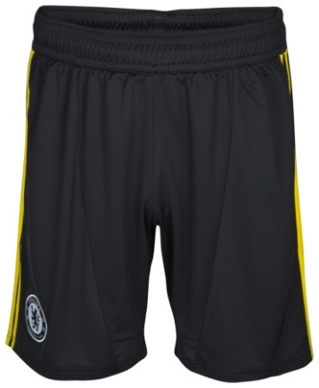

The Design

The striking sun graphic on the front of the black shirt creates a contrast in colours, giving the impression of power, while the fade in the graphic represents speed. The Chelsea badge is black and white and stands out against the sun graphic.

Technology
The 2012/13 shirt features the adidas Techfit™ technology in the playing shirt which is proven to enhance performance.

TechFit™ - The players’ kit will incorporate adidas’ cutting edge TechFit™ technology to help improve speed, increased endurance capabilities and enhanced awareness. This works by stabilising and focusing the muscles’ energy to generate explosive acceleration and deliver maximum power output.

Climacool™ -The shirts also feature adidas ClimaCool™ technology, a mixture of heat and moisture controlling materials, ventilation channels and 3D fabrics which improve air flow to the skin in the key heat zones. Sun coloured mesh panel also feature on the sleeves of the shirt for better breathability in core sweat zones.

Pre-order and purchase

The new third kit will feature during the 2012/13 season and will be available to buy on 9th August. However fans can pre-order online at www.chelseafc.com/megastore

For further information:

Gareth Mills
Senior Media Officer
Chelsea Football Club
+44 (0) 20 7957 8285 (direct)
+44 (0) 79 1228 0912 (mobile)

Stamford Bridge
Fulham Road
London SW6 1HS
www.chelseafc.com

adidas Press Office
Glen Holland
T: 0207 973 5925
E: Glen.holland@hillandknowlton.com

Harry Almond
T: 0207 413 3244
E: Harry.almond@hillandknowlton.com

