ADIDAS MICOACH ELITE SYSTEM
FACT SHEET
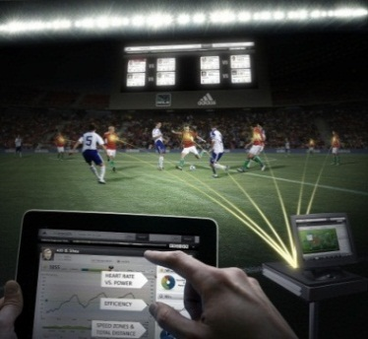

OVERVIEW | The adidas micoach Elite System is a cutting edge innovation that tracks on-field data in real time, helping teams attain and maintain peak physical performance in games and training.  Designed for professional soccer teams, micoach elite data analysis helps coaches and trainers better understand optimum level of performance, player fitness level and physical activity’s impact on the body.
HOW IT WORKS | The micoach Elite System includes a small data pod that fits into a player’s base layer in a protective pocket on the back between the shoulder blades. As the player competes or trains on the field, data is transmitted wirelessly to a central computer and instantly readable from the sideline on a coach’s iPad.
PERFORMANCE METRICS | The micoach Elite System provides coaches with real-time performance metrics including:  - Power  - Intensity of play  - Speed  - Distance covered  - Acceleration
SYSTEM COMPONENTS | The micoach Elite System includes:  - Small data pods for every player  - TECHFIT elite base layers to hold the pod to the athlete  - A base station central computer placed on the sideline  - The micoach Dash app readable on an iPad  - A secure online application for post analysis
TESTING & DEVELOPMENT | adidas collaborated with top clubs and coaches around the world to develop and test the micoach Elite System including Major League Soccer, Real Madrid, AC Milan, Ajax, Bayern Munich and multiple national teams.
ON FIELD DEBUT | The micoach Elite System will debut at the 2012 AT&T MLS All-Star Game on July 25 in Philadelphia, marking the world’s first “smart soccer” match
FOR MORE INFORMATION | Visit http://news.adidas.com/US
# # #

