PUMA PARTNER FEDERATIONS

DOMINICAN REPUBLIC

The Dominican Republic’s Olympic debut came in 1964 at the Tokyo Games, and they have featured at every Olympic Games since. The Dominican Republic has won 6 Olympic medals in total. They are most successful in athletics, with 3 of their 6 medals coming in this discipline, 2 of which were Gold medals.

The Dominican Republic’s most successful Games based on medals won are:
- London 2012: 2 medals won
- Beijing 2008: 2 medals won
- Athens 2004: 1 medal won
- Los Angeles 1984: 1 medal won
The Dominican Republic’s Olympic medalists are:
- Felix Sanchez: 2 Gold medals
- Manuel Felix Diaz: 1 Gold medal
- Yulis Gabriel Mercedes: 1 Silver medal
- Luguelin Santos: 1 Silver medal
- Pedro Nolasco: 1 Bronze medal
The Dominican Republic and PUMA have been partners since 2012.

DOMINICAN REPUBLIC OLYMPIC KIT BY PUMA

PUMA is supplying the Dominican Republic Track & Field Team with racing, training and village wear for the Olympic Games.

The Dominican Republic federation kits are designed by PUMA to highlight the expressive, bright and eclectic nature of the Dominican Republic. The Dominican athletes are lively and outgoing, but they’re also there to compete, and their kit lets people know that they’re coming to win. The red, blue and white colours were chosen to mirror the colours found on the flag of the Dominican Republic.

The kits are equipped with innovative features such as ACTV taping to which provides focused muscle support and energy return, bonded seams for ultimate comfort and are made from lightweight compression fabrics to allow for the ultimate performance. The kits are also reinforced with a 6-way stretch fine gauge warp knit fabric that assures targeted graduated advanced compression while assuring a full range of movement. The kits are designed with one goal in mind; to be forever faster.

Additional images available here: https://fastcat.puma.com/transfer/8c45d9280163f35d4c09206bba78fee7594b59d74d8ee2c564995125920460f2
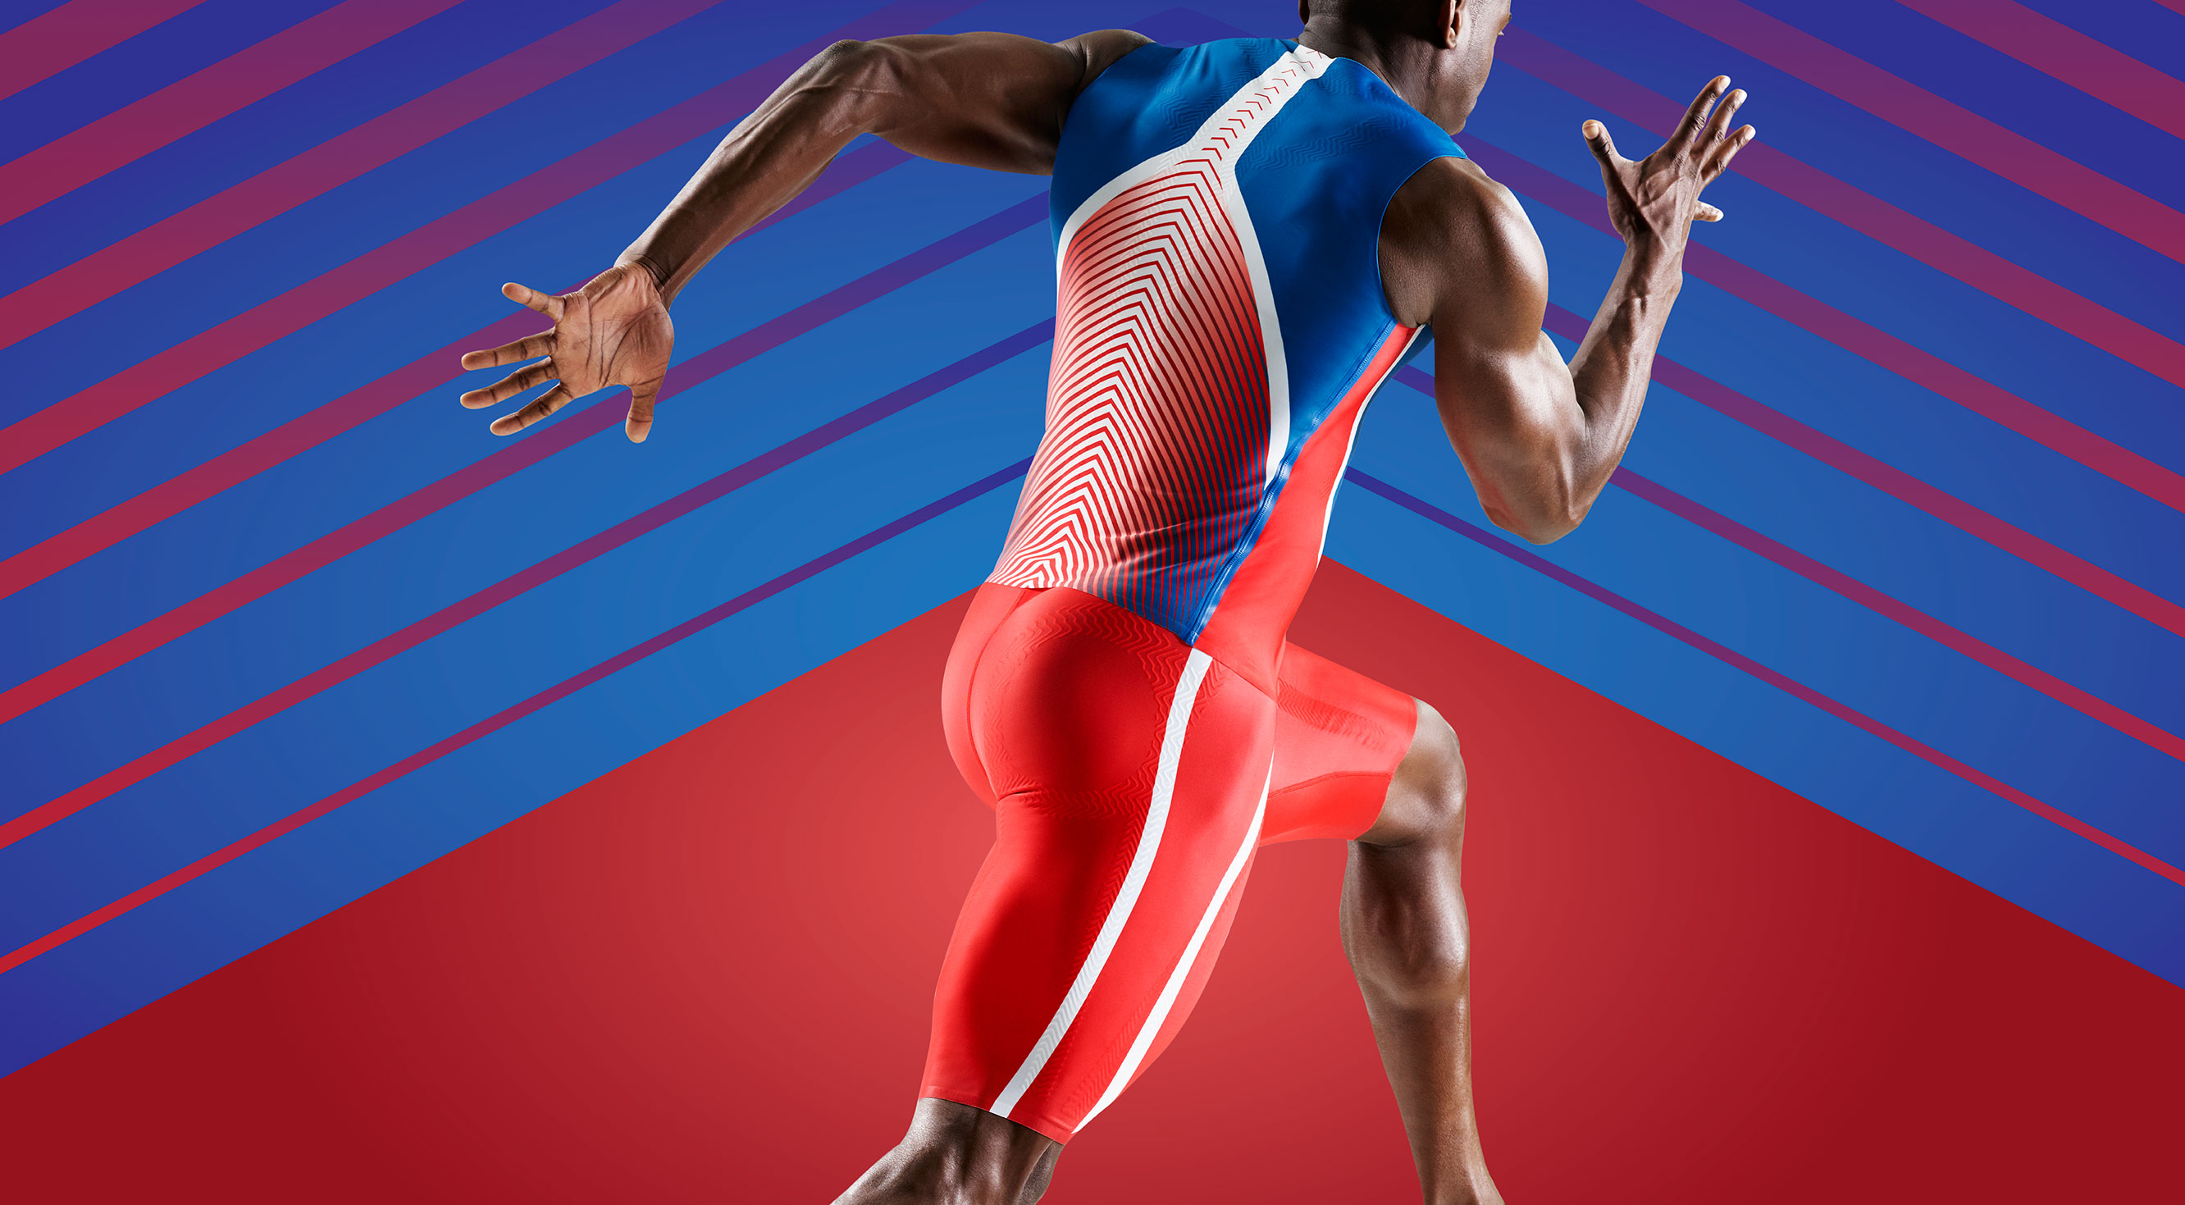

# # #

PUMA
PUMA is one of the world’s leading Sports Brands, designing, developing, selling and marketing footwear, apparel and accessories. For over 65 years, PUMA has established a history of making fast product designs for the fastest athletes on the planet. PUMA offers performance and sport-inspired lifestyle products in categories such as Football, Running and Training, Golf, and Motorsports. It engages in exciting collaborations with renowned design brands to bring innovative and fast designs to the sports world. The PUMA Group owns the brands PUMA, Cobra Golf and Dobotex. The company distributes its products in more than 120 countries, employs more than 11,000 people worldwide, and is headquartered in Herzogenaurach/Germany. For more information, please visit http://www.puma.com

