PUMA PARTNER FEDERATIONS

CUBA

Cuba first participated in the Olympic Games back in 1900 and since then has sent athletes to 19 of the 27 Summer Olympic Games. Cuban athletes have won a total of 208 medals in this time. Cuba’s most successful sport at the Olympics is Boxing, bringing 67 medals in total, 34 of which are Gold.

Cuba’s most successful games based on medals won are:
- Barcelona 1992: 31 medals
- Sydney 2000: 29 medals
- Athens 2004: 27 medals
- Atlanta 1996: 25 medals
- Beijing 2008: 24 medals
Cuba’s most successful Olympians are:
- Ramon Fonst: 4 Gold medals, 1 Silver
- Felix Savon: 3 Gold medals
- Teofilo Stevenson: 3 gold medals
- Feilberto Ascuy: 2 Gold medals
- Guillermo Rigondeaux Ortiz: 2 Gold medals
- Hector Vincent: 2 Gold medals
- Angel Herrera: 2 Gold medals
- Ariel Hernandez: 2 Gold medals
- Alberto Juantorena: 2 Gold medals
- Mijal Lopez: 2 Gold medals

PUMA and Cuba have been partners since 2013.

CUBA OLYMPIC KIT BY PUMA

PUMA is supplying the Cuba Track & Field Team with racing, training, podium, ceremony and village wear for the Olympic Games.

The Cuban federation kits are designed by PUMA to help their athletes represent the country’s lively, sociable and eclectic culture. The colours are inspired by the flag of Cuba, the flag combines blue, white and red so PUMA made a kit that would carry the country’s colours with pride.

The kits are equipped with innovative features such as ACTV taping to which provides focused muscle support and energy return, bonded seams for ultimate comfort and are made from lightweight compression fabrics to allow for the ultimate performance. The kits are also reinforced with a 6-way stretch fine gauge warp knit fabric that assures targeted graduated advanced compression while assuring a full range of movement. The kits are designed with one goal in mind; to be forever faster.
Additional images available here: https://fastcat.puma.com/transfer/8c45d9280163f35d4c09206bba78fee7594b59d74d8ee2c564995125920460f2

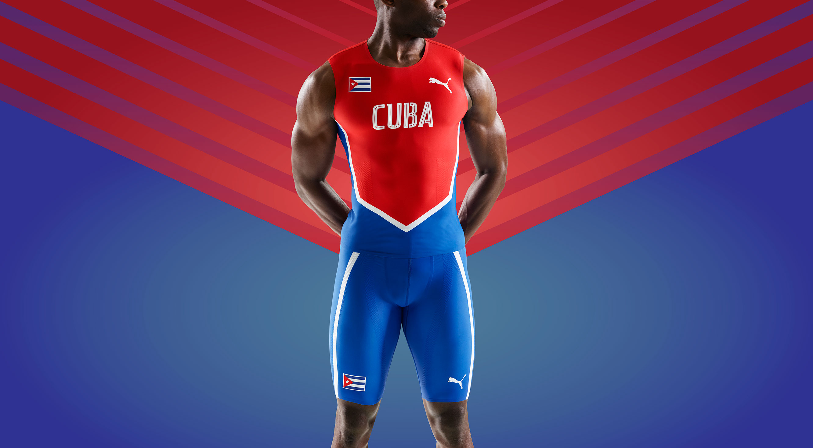
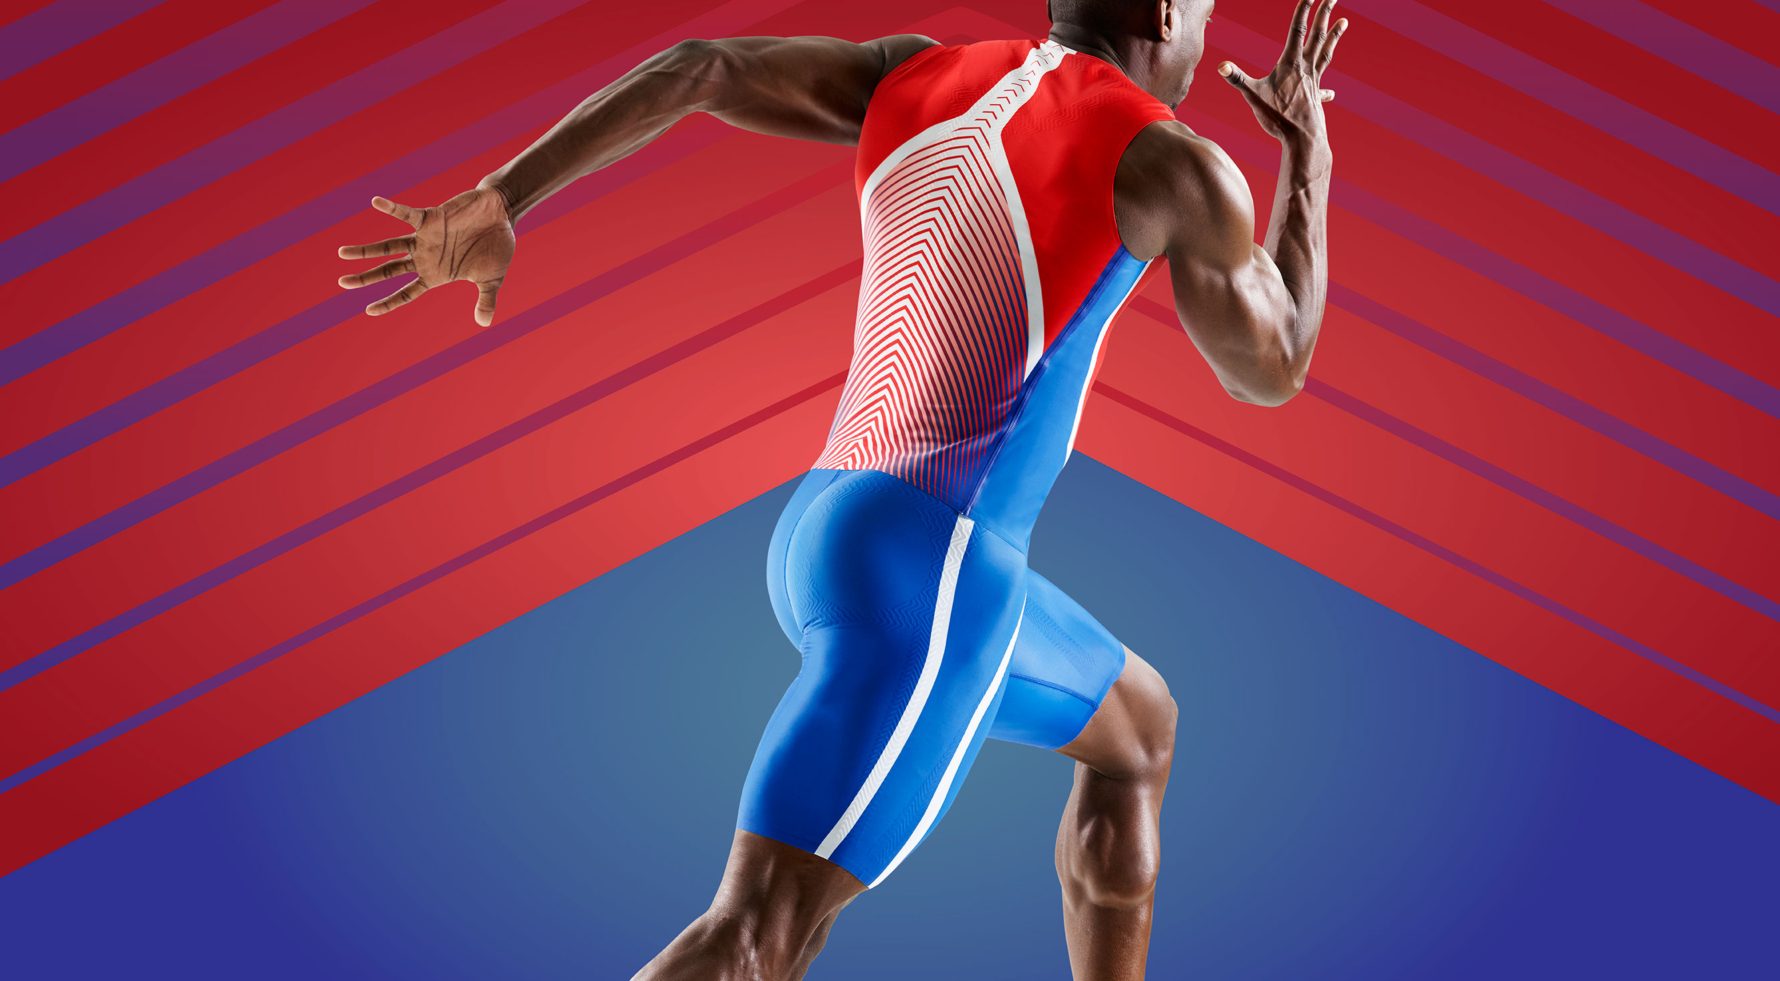

# # #

PUMA
PUMA is one of the world’s leading Sports Brands, designing, developing, selling and marketing footwear, apparel and accessories. For over 65 years, PUMA has established a history of making fast product designs for the fastest athletes on the planet. PUMA offers performance and sport-inspired lifestyle products in categories such as Football, Running and Training, Golf, and Motorsports. It engages in exciting collaborations with renowned design brands to bring innovative and fast designs to the sports world. The PUMA Group owns the brands PUMA, Cobra Golf and Dobotex. The company distributes its products in more than 120 countries, employs more than 11,000 people worldwide, and is headquartered in Herzogenaurach/Germany. For more information, please visit http://www.puma.com

