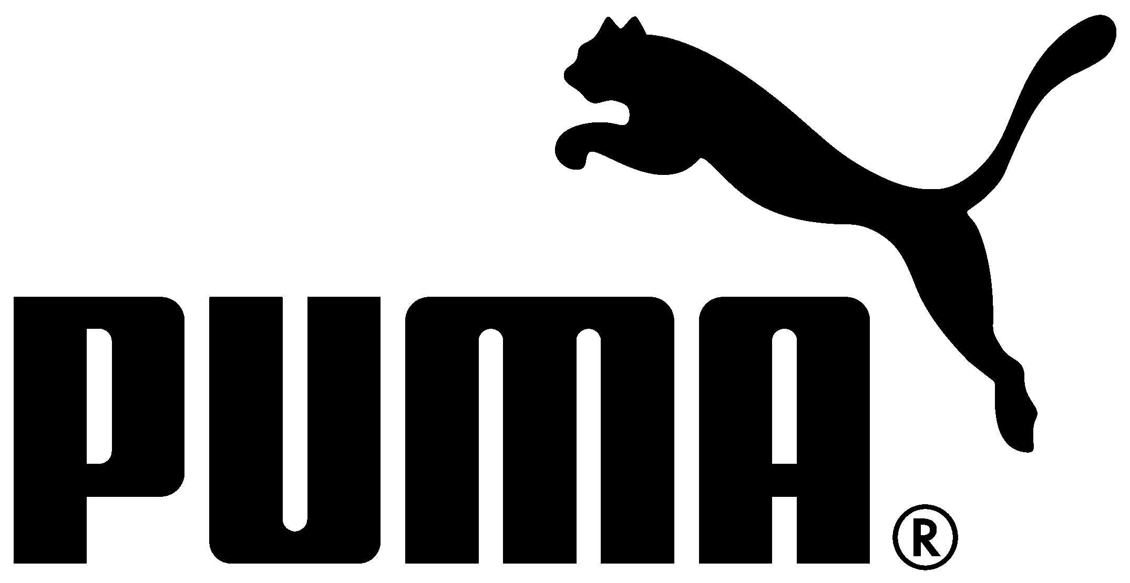
UNDER EMBARGO UNTIL 5 MARCH 2014
PRESS RELEASE

PUMA REVEALS URUGUAY’S 2014 FIFA WORLD CUP™ KITS
La Celeste to Debut New Kit against Austria Today

Herzogenaurach, Germany (5 March, 2014) – Ahead of Uruguay’s match against Austria today, PUMA has revealed the new kits that the team will wear in Brasil this year, where they will look to repeat the success of their 1950 FIFA World Cup win. La Celeste will debut the new kit on pitch tonight in their match against Austria in Klagenfurt.

The new kits feature PUMA’s new football apparel innovation PWR ACTV, a first-to-market use of both athletic taping and compression within the apparel. The ACTV tape is strategically placed within the garment to provide micro-massages on the skin, working with the human body to help maximise performance and provide players with a faster, more effective energy supply to the active muscles. This combined with the underarm mesh inserts for increased breathability and freedom of movement, will help Uruguay have a competitive advantage at this year’s World Cup.

The design of the home shirt is inspired from the Uruguay national flag and the national team’s nickname La Celeste (the sky blues). The May Sun, a national emblem and feature on the national flag, is represented as an embossed print behind the team crest, and blue and white striped inserts on the sleeves represent the stripes from the national flag. The design of the neck and collar is modeled on heritage Uruguayan football fashion.

PUMA player Diego Godín and Uruguay National Team defender said, “Brasil holds a special place in the hearts of Uruguayans as 64 years ago we won the World Cup there in the final against Brasil. We are all looking forward to the tournament this year and we hope to perform well and bring joy to our fans and country. I really like the new kit that PUMA has made for us, it fits really well and having a kit with the new PWR ACTV technology that will help us perform on the pitch will give us even more confidence to go out there and achieve great things for our country.”

A full range of replica products including home and away shirts, shorts and a full merchandise collection for each team will be available to purchase from 5 March 2014. The PUMA PWR ACTV football performance apparel collection featuring the same ACTV technology as the national playing kits is available to purchase now.

Media can download the full press kit including product imagery and player editorial images from the PUMA Press Center at http://news.puma.com/.

# # #

Media Contact:

Tim Stedman, International PR PUMA
+49 151 1474 3148
tim.stedman@puma.com

PUMA
PUMA is one of the world’s leading Sports Brands, designing, developing, selling and marketing footwear, apparel and accessories. For over 65 years, PUMA has established a history of making fast product designs for the fastest athletes on the planet. PUMA offers performance and sport-inspired lifestyle products in categories such as Football, Running, Training and Fitness, Golf, and Motorsports. It engages in exciting collaborations with renowned design brands such as Alexander McQueen and Mihara Yasuhiro to bring innovative and fast designs to the sports world. The PUMA Group owns the brands PUMA, Cobra Golf, Tretorn, Dobotex and Brandon. The company distributes its products in more than 120 countries, employs more than 10,000 people worldwide, and is headquartered in Herzogenaurach/Germany. For more information, please visit http://www.puma.com

