
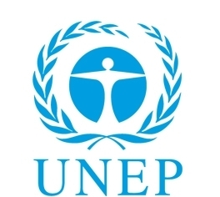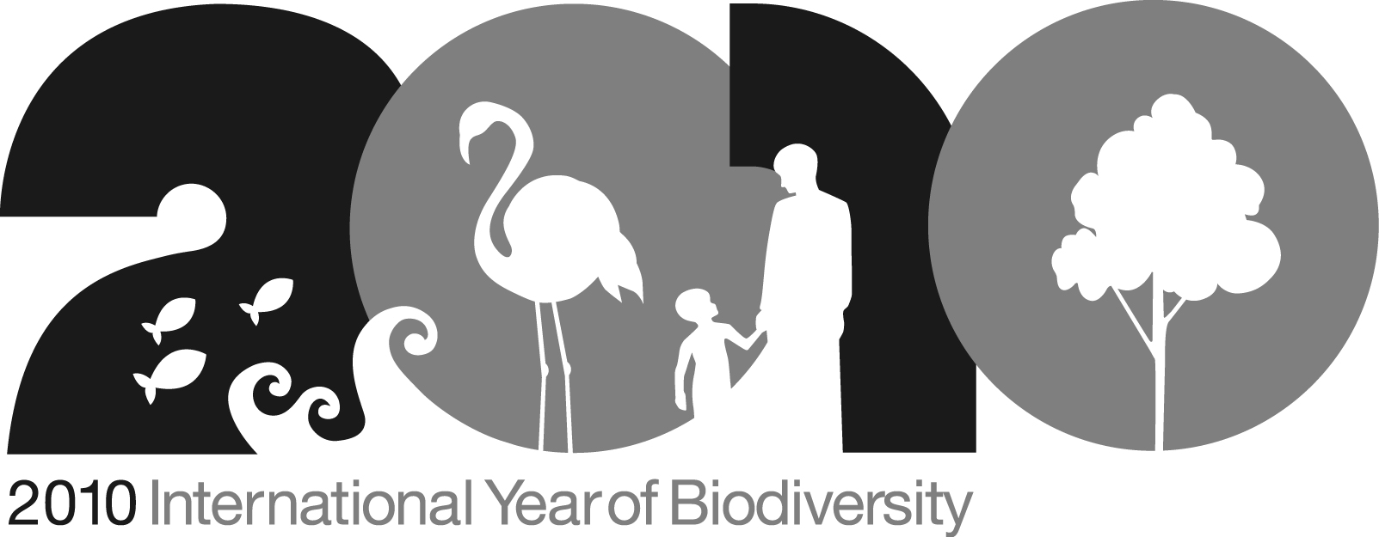

‘Play For Life’ Donation and Beneficiary Information

PUMA's 'Play for Life' campaign with the United Nations Environment Programme (UNEP) supports the 2010 International Year of Biodiversity, by raising funds and awareness about habitat and species conservation.

The ‘Play for Life’ campaign focuses on Africa, a continent that hosts exceptional biodiversity including two of the five most important wilderness areas on Earth – the Congo Basin, and Miombo-Mopane Woodlands and Savannas of Southern Africa. Nine of the planet’s 35 Biodiversity hotspots, the richest and most threatened reservoirs of plant and animal life on Earth, are also in Africa.
Proceeds from the sale of our PUMA Africa Unity Kit, Unity-Tees and Kehinde Wiley designed PUMA Lacelets will be donated to help fund conservation programs in Africa.
Fans can a play a part in determining which biodiversity programs will benefit from the sale of these products by casting their vote for their favorite cause on Facebook from May 29th – July 11th. Together PUMA and UNEP have nominated six programs to be subject to voting. Proceeds will support the three projects with the most votes.
Visit africa.puma.com for more information
To vote, visit FACEBOOK.COM/PUMA

Support for Elephants in Ivory Coast and Liberia
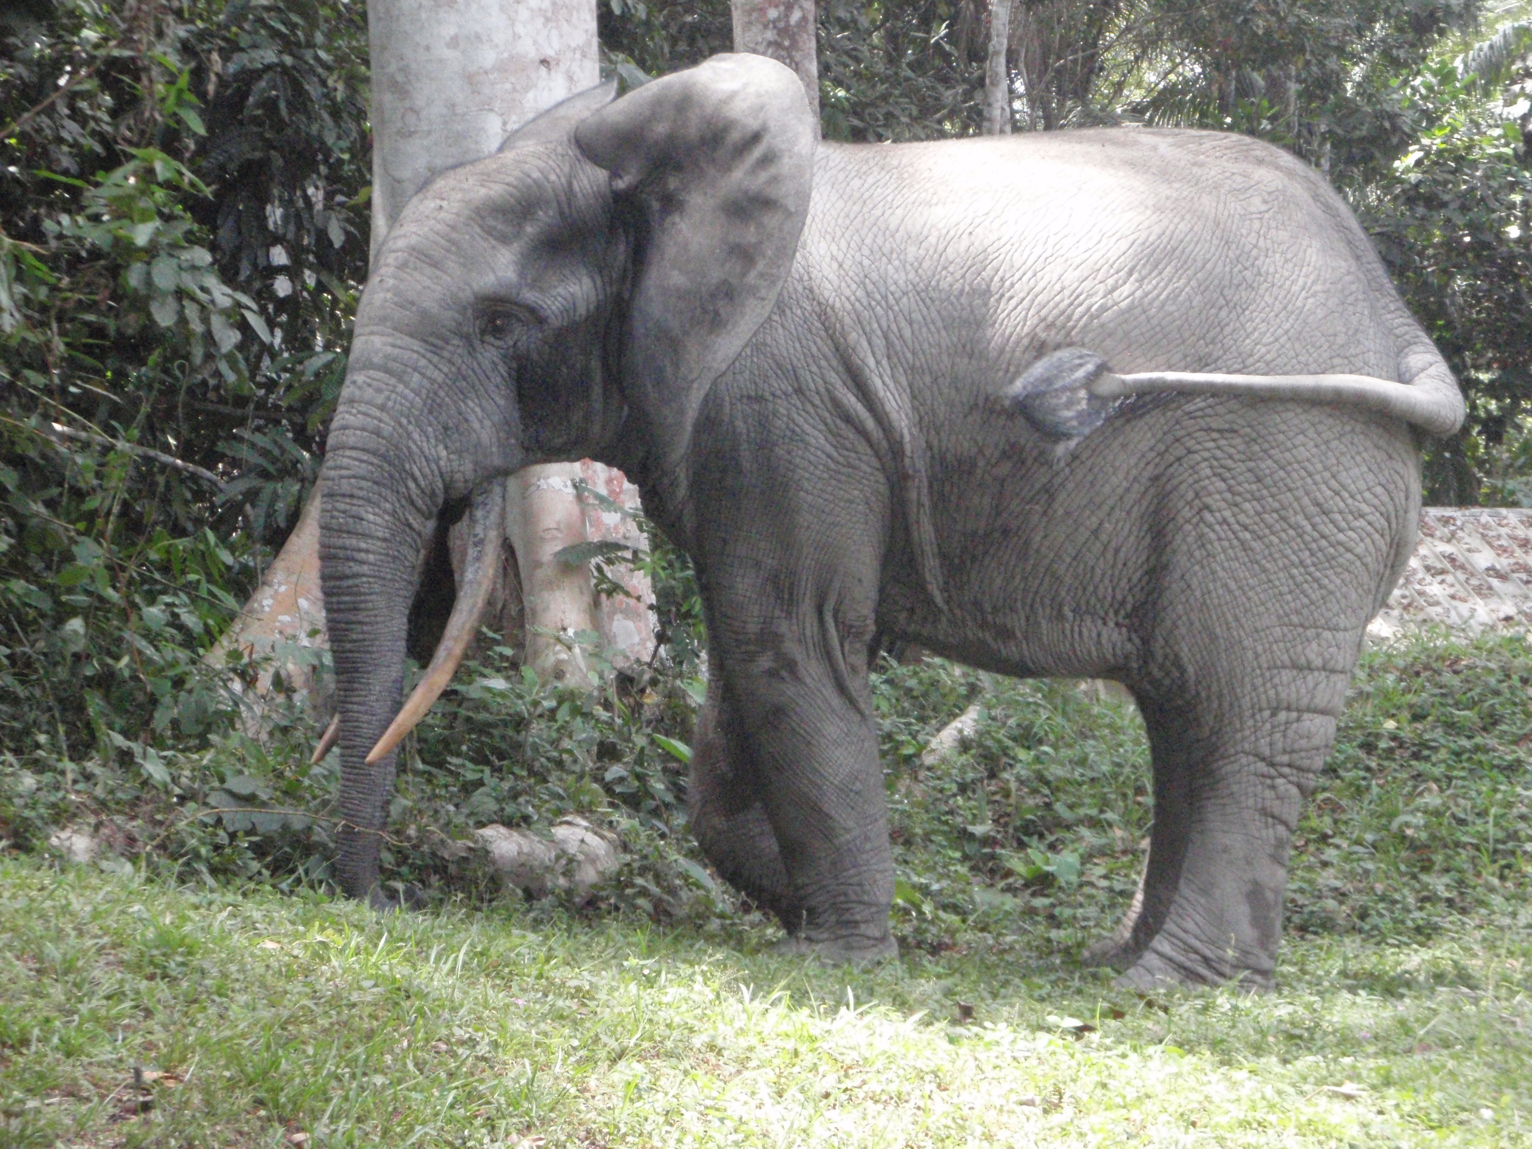
Along the Cavally River that divides Southern Ivory Coast and Liberia, remaining fragments exist of one of the most important ecosystems within the Upper Guinea Forest region. These lowland tropical forests provide habitat for more than a quarter of Africa’s mammals, including 12 species of primates, the dwindling West African chimpanzee population, the pygmy hippopotamus, and the forest elephant—the national emblem of the Ivory Coast football team. Unfortunately, these forests are threatened by non-sustainable agricultural development and timber exploitation. Elephants in this region depend on the forests for migration corridors. Without these corridors the populations would remain fragmented, preventing the genetic exchange that is vital to the elephants’ long-term survival. This project focuses on creating and preserving landscape corridors to allow these animals to migrate freely. This will help ensure the elephants’ survival and the biodiversity of area, as well as the livelihood of the local communities that depend on the forests ecosystems.

Where the money goes:
Donations to this project will fund programs to create and protect migration pathways in these forests. Activities include the development of economic alternatives to unsustainable forms of land-use, field research missions, and regional meetings between authorities.

Photo Credit: Photo by Fiona Maisels courtesy of WCS

Promoting Community Participation in Gorilla Conservation

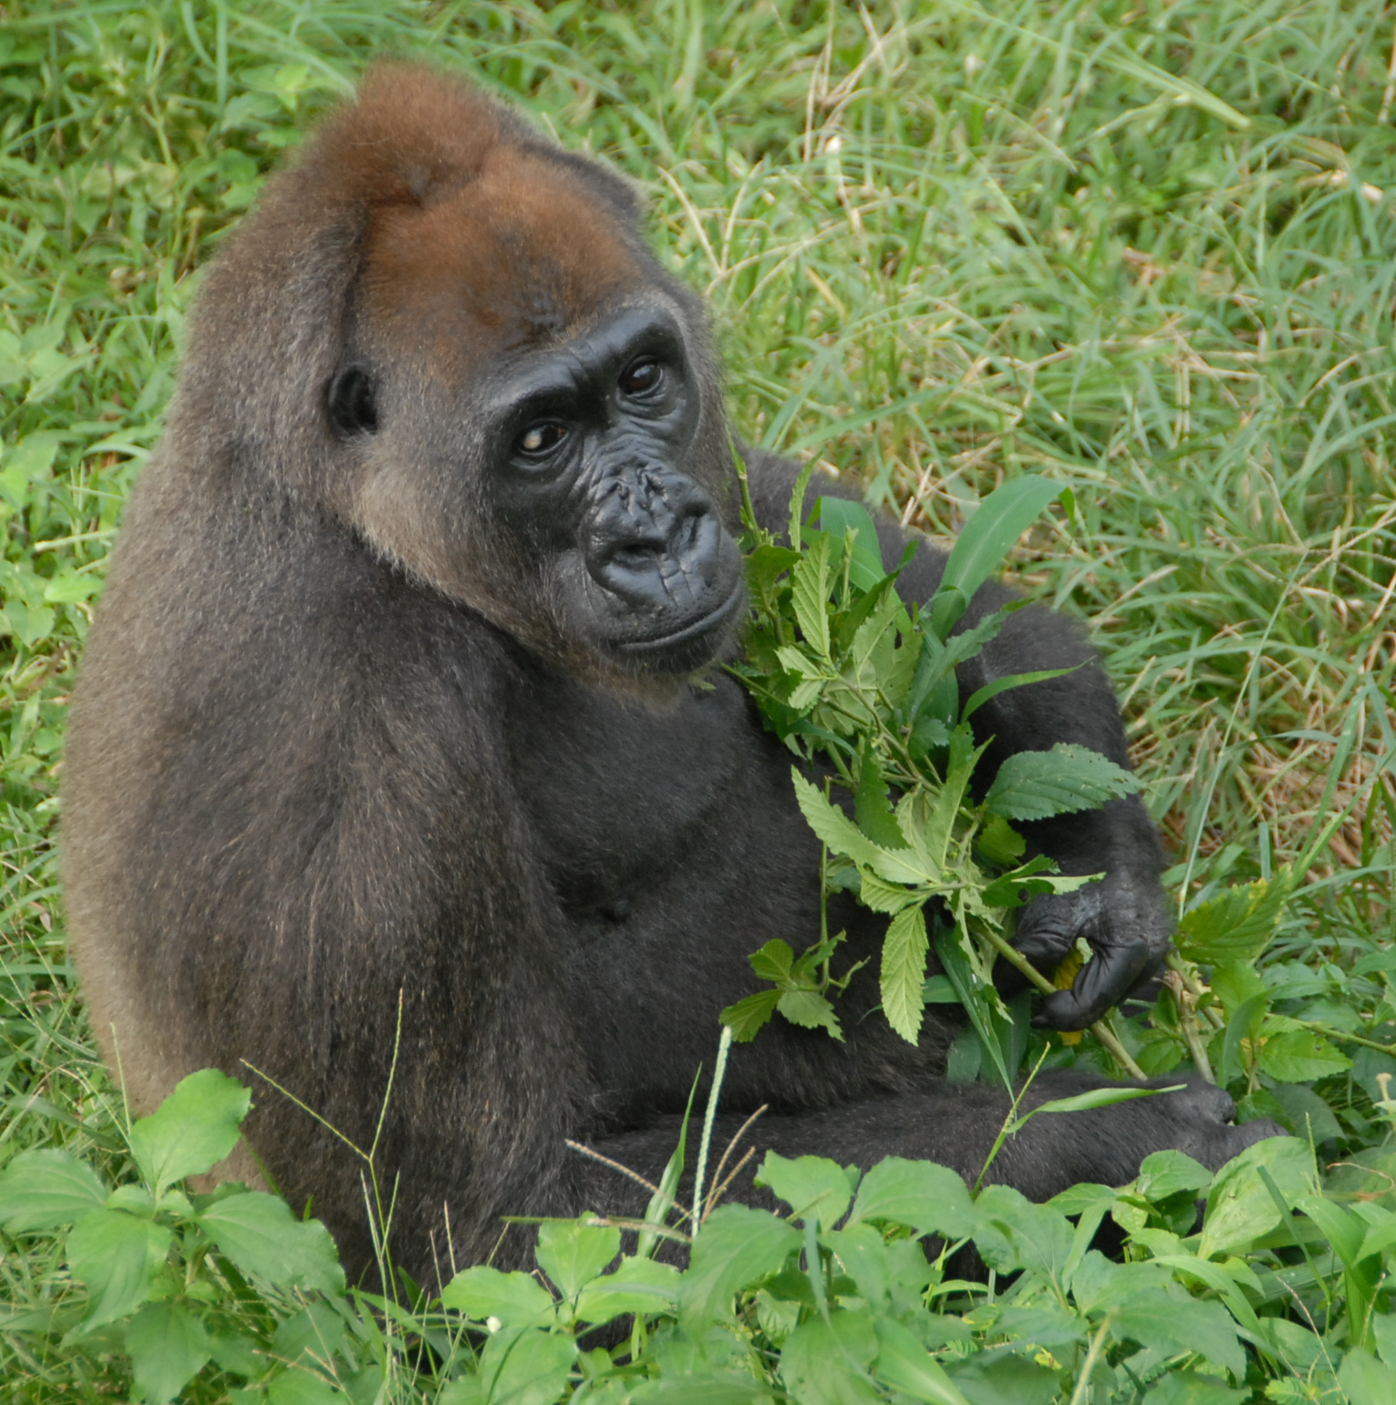
GRASP was created in 2002 in response to the crisis facing the endangered populations of Great Apes in Africa and South East Asia, and the forests which these animals and communities depend on for their existence. GRASP aims to save the Great Apes from extinction through high-level political commitment, public awareness, education and practical conservation activities. Uniting over 80 local, national and international conservation NGO’s, state governments, UN agencies, foundations and private sector interests, GRASP is an alliance that is uniquely suited to address these conservation issues.

With less than 300 remaining individuals, the Cross River Gorilla is known to occur in 11 distinct forest sites across Equatorial Africa. Unfortunately, only seven of those locales are protected by Parks, Wildlife Sanctuaries, and Forest Reserves. GRASP is working to improve the survival prospects of the gorillas by providing support to community-based conservation initiatives. Projects include the creation and support of Nigeria’s first community managed Wildlife Sanctuary in the Mbe Mountains and through the establishment of a gorilla guardian monitoring network in Mowambi and Mbulu-Mone forest areas.

Where the money goes:
Funds donated to this project will be used to support the hiring and training of ecoguards and Gorilla guardians, as well as help to develop alternative livelihoods for hunters in the Mbe Mountains.

Photo Credit: Photo by Nicky Lankester courtesy of WCS

Rhino: Back from the Brink?

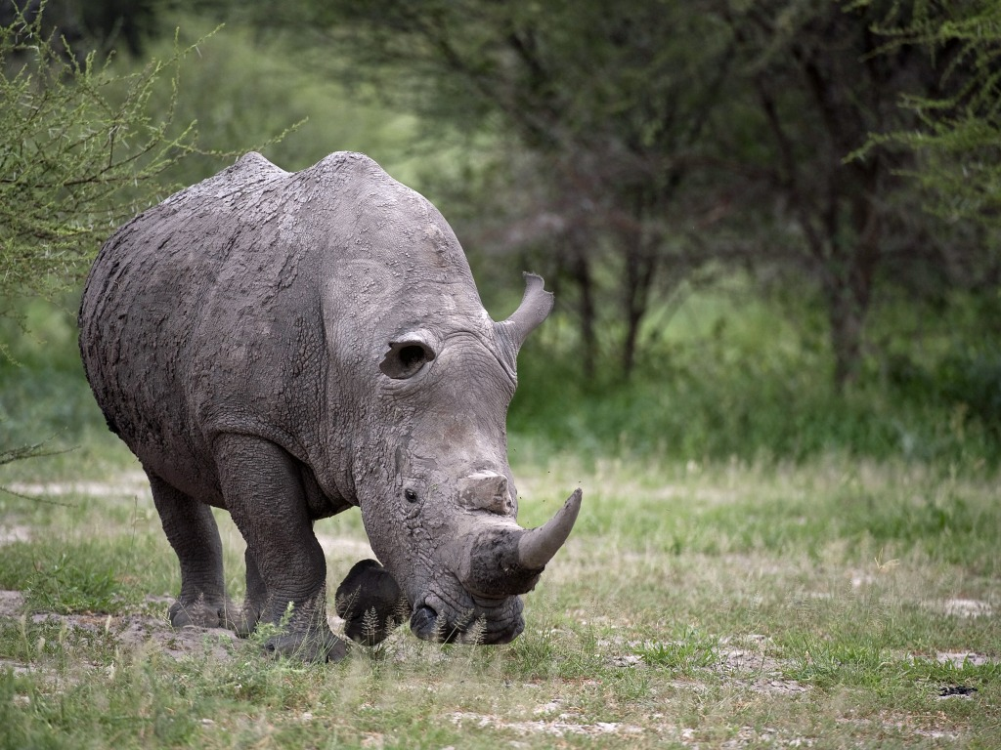
Both black and while rhinos are highly threatened in Africa with recent local extinctions in Cameroon and Democratic Republic of Congo. Since 1960 black rhinos have diminished in number from an estimated 100,000 to just 4,200. The current white rhino population is around 17,000. Rhinos are targeted for their horns; in 2008 and 2009 poaching hit the highest levels in decades.

In an effort to restore and protect the rhino population, black rhinos are being relocated from areas in Namibia to create new founder populations in adjacent areas with suitable habitat. Local communities “own” these new populations and benefit from the ecotourism revenue that these rhino herds generate. This makes the rhinos a valuable part of the local economy and encourages their protection, as they are worth more as a tourist attraction than what can be gained by killing them. Similarly, Botswana is providing a new home base for some of Zimbabwe’s black rhinos to bolster conservation and ecotourism.

Where the money goes:
Donations to this project help fund the establishment of new rhino populations, and specifically benefit the relocation process with specialized veterinarians, monitoring and security, and transportation equipment.

Photo Credit: Photo by Russel Friedman courtesy of Wilderness Safaris

The African Lion: King Without A Kingdom

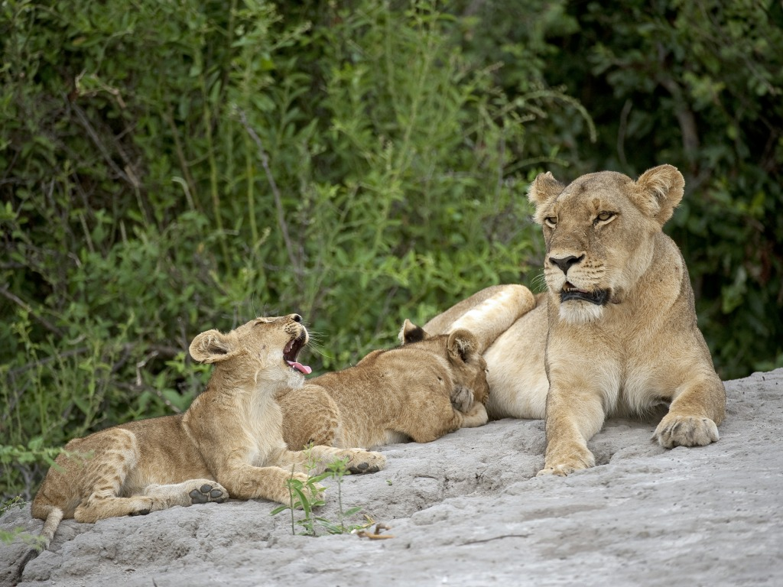
Because the lion is so visible and celebrated it is not often recognized as endangered or threatened, however the reality is dramatically different. In 1940 there was an estimated 450,000 lions in Africa - today there are just 23,000. As apex predators, lions are key indicators of the health and biodiversity of the environments in which they reside, thus making their preservation critical.

Space is at the heart of the issue: Space for human agriculture and livestock versus space for natural predator-prey ecosystems. In Africa, lions outside protected areas are indiscriminately killed in retaliation for cattle raiding or threat of their existence. To make matters worse, protected areas and lion ranges have becoming increasingly fragmented, resulting in only a handful of areas large enough for self-sustaining lion populations.

Zambia is a country that could potentially support a significant portion of the endangered lions, but lacks an accurate estimate of the current lion population and national management strategy. In Zambia a project is underway to put those needed elements in place and analyze key areas of the Human-Lion conflict.

Where the money goes:
Funds donated to this project will help secure new space for the lions by surveying Zambia’s native lion population, studying the protected and unprotected areas ecology, and developing a national management plan that can be implemented in other countries and lion ranges.

Photo Credit: Photo by Russel Friedman courtesy of Wilderness Safaris

Wildebeest and Zebra Migration Routes: Africa’s Fractured Superhighways

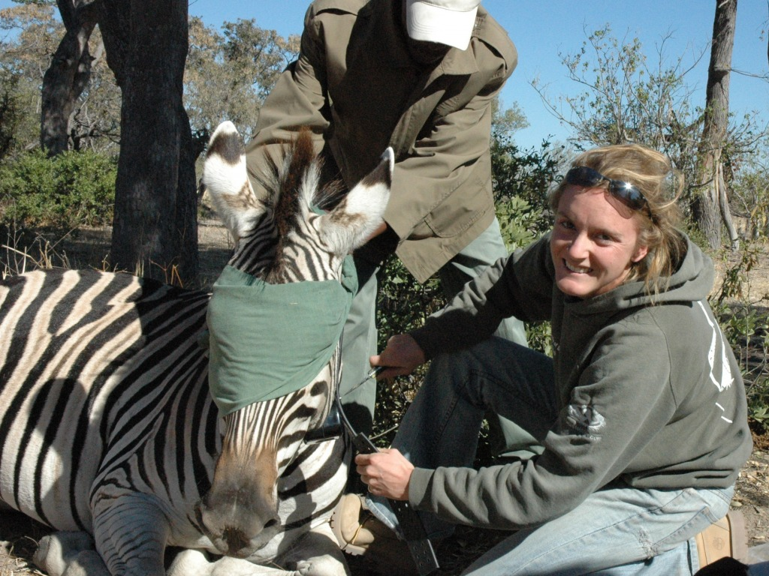
Wildebeests and zebras in Africa need room to move. Migration pathways are essential for wide-ranging migratory species conservation. Human expansion into Africa’s wilderness areas has resulted in the fragmentation of habitat and severing of migration routes for the wildebeests and zebras. Critical areas for grazing or calving are cut off and have resulted in dramatic population declines. In the mid 1980s fences severed migration pathways for wildebeests in Botswana and their populations have plummeted to negligible levels. Today, throughout Africa these animals are at risk from human development interfering with their natural migratory patterns.

However, current studies utilizing satellite technology and GPS transmitters are tracking the zebra and wildebeest movements to ultimately aid in their protection. Space utilization in relation to manmade structures and natural resources for water and grazing are being investigated. The data collected from the studies is being used to advocate for the creation of migratory routes for these animals. Insight from these studies allow for better design of protected areas and the formal establishment of migratory corridors to ensure pathways between the protected areas.

Where the money goes:
Funds donated to this project will be used to gather valuable information on the migratory habits of the wildebeest and zebras through GPS transmitter tagging, tracking, and analysis.

Photo Credit: Photo by James Bradley and Harriet Bartlam courtesy of Wilderness Safaris

Forest and Biodiversity Conservation in DRC

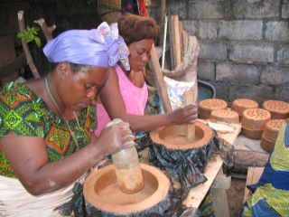
The Democratic Republic of Congo (DRC) is comprised of some of the most intact forests in the greater Congo Basin - and the world. The Virunga National Park is home to several endangered species including the forest elephant, okapi, and majestic mountain gorilla. Trespassing into the DRC’s national parks to collect firewood and charcoal is destroying the forests and threatening the survival of these animals. A new program is proving that conservation efforts in this region can be beneficial to both humans and wildlife.

By locally manufacturing and distributing fuel-efficient stoves in North Kivue Province, firewood consumption is being reduced by up to 70% and decreasing the reliance on forest resources. These stoves benefit the environment by requiring less fuel and producing less smoke, thereby improving the livelihoods and health of local inhabitants. As part of this effort, regular workshops are held to raise awareness of fuel-efficient stoves and the need for forest conservation.

Where the money goes:
Funds donated to this project will help produce and distribute more fuel-efficient stoves and fund a pilot project on bio-briquette fuel.

Photo Credit: Photo courtesy of UNEP

