

FOR IMMEDIATE RELEASE Contacts:
Yves Coulter
PUMA International PR
Yves.coulter@puma.com

Alexander McQueen PUMA®
Spring/Summer 2009

Explores the ‘Architecture of the Ribcage’ and Introduces the Seasonal Theme of Geometric Patterns
Alexander McQueen PUMA is about the juxtaposition of influences through the union of tradition and technology. Conformity and provocation coexist with a great sense of drama, always challenging the boundaries of Sports Fashion resulting in unexpected craftsmanship and revolutionary footwear shapes.

This collection focuses on the ever-prevalent study of anatomy through innovative ribcage shaped overlays and an updated take on tendon and vein aesthetics with skeletal references. Furthermore the anatomical inspiration subtly evolves, tracing a parallel between the ribcage, bone formations and the complex structure of buildings and geometric patterns. The Alexander McQueen PUMA footwear collection also takes inspiration from shapes and patterns present in Alexander McQueen’s main line.
The AMQ Ribcage and the Ribcage Sport are influenced by the human ribcage. These styles have authentic running shoe references, bringing in many elements that relate to the essence of the Alexander McQueen PUMA brand. The architectural and graphic references create subtle patterns of veins and tendons – which are overlaid by a ribcage of molded leather. Both uppers have engineered mesh and a molded translucent TPU found on the Sport version. The two key styles feature the “My left foot” 3-D insert, visible from the side profile and through the bottom of the sole. The AMQ Ribcage is available in black, white and taupe leather while the Ribcage Sport comes in electric blue and lime green.

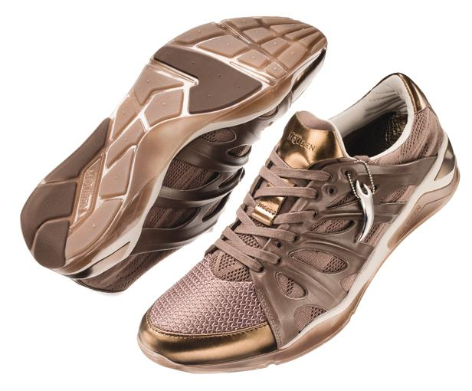
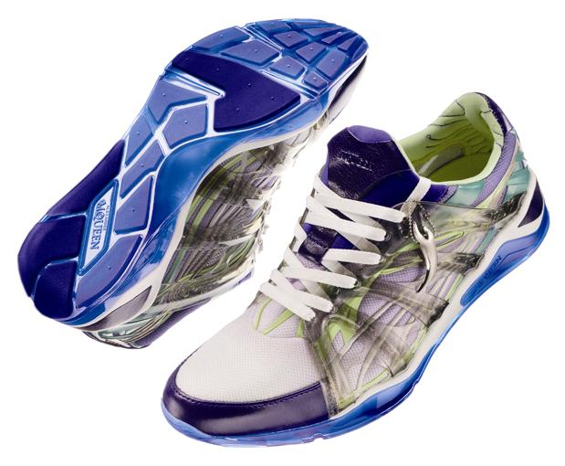

-more-
Page 2 of 2
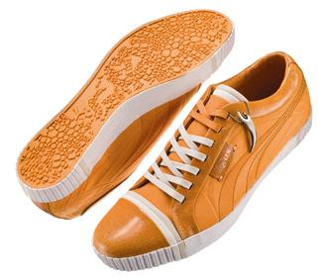
The now iconic AMQ Canvas Street Low is re-introduced for the summer season in vibrant orange. The anatomical theme is further explored through a rubber outsole with cellular graphic detail and novelty embossed canvas upper, linking directly to the engineered mesh pattern of veins and tendons of the new AMQ Ribcage. This is a light summer version of Alexander McQueen PUMA’s most loved style.

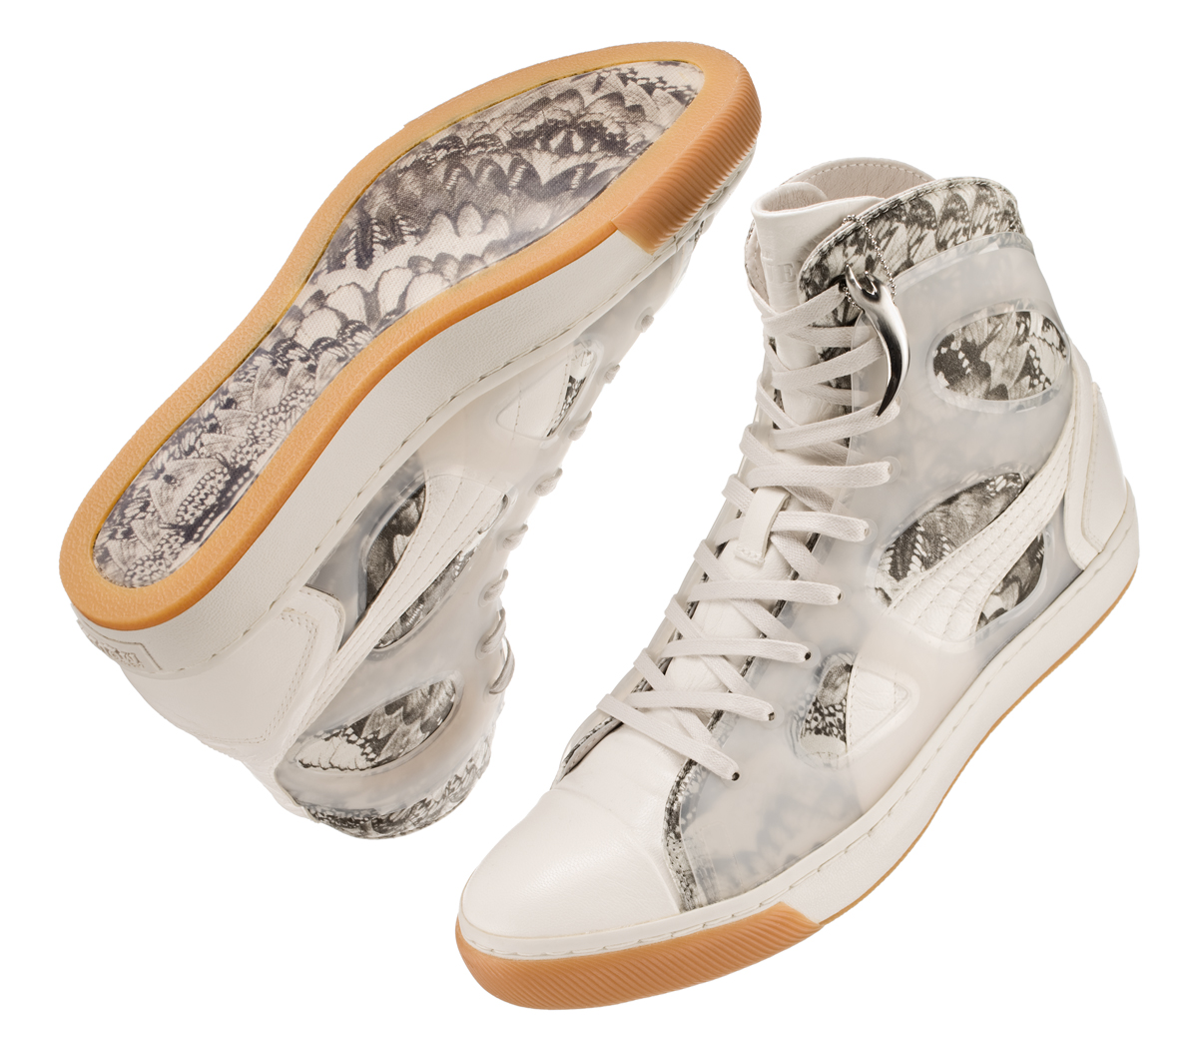
New women’s offerings include the AMQ Vulcanizo Mid in a beautiful butterfly print, which has been taken from Alexander McQueen’s mainline archive collection. The Vulcanizo is the must have style for women this season, made in rich materials, metallics, and bright colours with a cut out pattern for a light sandal-like upper that maintains its sneaker identity.

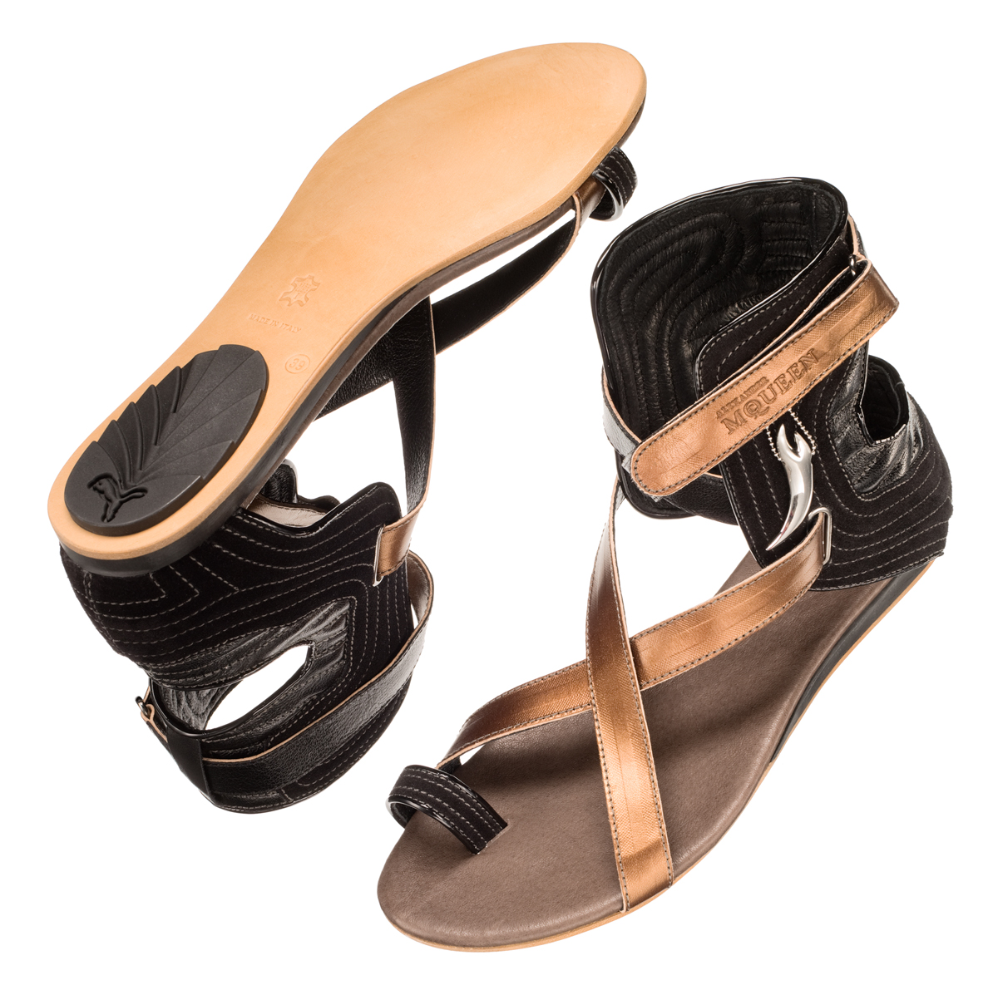
The sandal of the season is the AMQ Ankle Brace. Taking inspiration from the boots of the collection and the strong lines of architectural design. The sandal offers protection with crafted padding and strap construction. The leather foot-bed is embellished with organic stitching, demonstrating McQueen’s attention to detail and craftsmanship. This is a modern sandal focused on design as well as providing a high level of comfort and fit

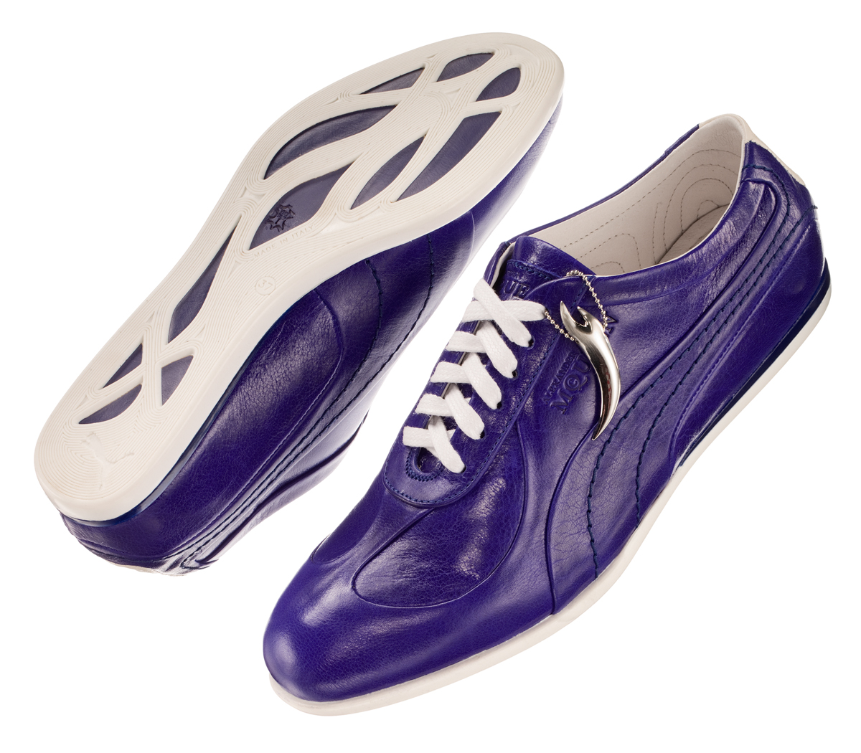
A core style for women is the AMQ Skin. This simple sleek silhouette in fine Italian leather is updated for the Spring Summer season in a vibrant electric blue to make a real statement.

###

PUMA® is the global athletic brand that successfully fuses influences from sport, lifestyle and fashion. PUMA’s unique industry perspective delivers the unexpected in athletic and lifestyle footwear, apparel and accessories, with technical innovation and
revolutionary design. Established in Herzogenaurach, Germany in 1948, PUMA distributes products in over 80 countries. For further information please visit
www.puma.com

