Press Release
Dovizioso and Stoner guests at Lamborghini Track Accademia
Automobili Lamborghini S.p.A.

Direzione Comunicazione
Gerald Kahlke
Telefono +39 051 6817711
gerald.kahlke@lamborghini.com

Ufficio Stampa – Italia e Sud Europa
Clara Magnanini
Telefono +39 051 6817711
clara.magnanini@lamborghini.com

Ufficio Stampa – Squadra Corse
Chiara Sandoni
Telefono +39 051 6817711
chiara.sandoni@lamborghini.com
Lorenzo Facchinetti
M. +39 348 8629861
extern.lorenzo.facchinetti@lamborghini.com

Ufficio Stampa – Eventi e
Collezione Automobili Lamborghini
Rita Passerini
Telefono +39 051 6817711
rita.passerini@lamborghini.com

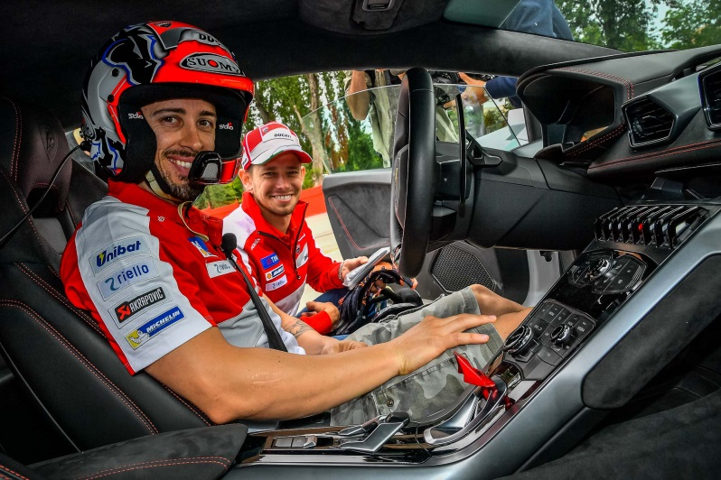
- Training day at Imola for the two Ducati Corse riders with Lamborghini Squadra Corse
- Next “Track Intensivo” program scheduled for June 20/22
Sant’Agata Bolognese/Imola, May 25, 2016 – MotoGP Legend, two-time world champion and current Ducati tester Casey Stoner, and the Ducati Team’s official MotoGP rider Andrea Dovizioso, were two exceptional guests at the first 2016 Lamborghini Track Academy. The two Ducati riders accepted Lamborghini Squadra Corse’s invitation to attend the first European ‘Accademia’ event: the “Intensivo” program held at Autodromo di Imola on 24 May. Coming direct to Imola from Sunday’s Italian MotoGP event at Mugello, Stoner and Dovizioso, who has just renewed his Ducati contract until 2018, spent a training day on track: for once not with two wheels, but with the Lamborghini Huracán’s four wheels.
Stoner and Dovizioso took part in the same Intensivo program as the Accademia clients, followed by a dedicated instructor who accompanied them step by step throughout the training day. To familiarize themselves with the Lamborghini, the riders started the day with power oversteer exercises in the Huracán LP 580-2, particularly enjoying the driving fun of the two-wheel drive. Various track lap sessions followed, allowing the participants to fully understand the handling limits of the Huracán LP 610-4.
"It was an extraordinary experience - Andrea Dovizioso said - honestly I did not expect to have such a "competitive" car in my hands. Despite the Huracán being a road car, I was able to push really hard, getting better and better after each session. The engine is amazing, the sound of the V10 is stunning, but I was impressed especially by stability and braking: compared to the bike, you can continue to brake hard into the apex making the most of deceleration, that's the big difference."
Casey Stoner was fascinated by the experience, especially as the Australian rider had never raced or ridden on the Imola track before. "Lamborghini cars have been special for me since I was a child. Now being able to drive one is really extraordinary. The most interesting aspect is that the Huracán could seem tricky to drive, because it has the appearance of a race car. But actually it allows you to do pretty much anything you want: it’s ok for everyday use, but when you go on track it becomes an animal! Compared to MotoGP - Casey continues - driving to the limit is completely different: with the Huracán you’re able to accelerate well in advance and continue to push flat out during the turns.”
The Track Accademia of Imola was also an opportunity for an informal meeting between the two Italian brands’ motorsport managers who come from the same Group: Giorgio Sanna, Head of Lamborghini Motorsport; Paolo Ciabatti, Ducati Corse Sporting Director; and Davide Tardozzi, Team Manager of the Ducati Team.
The next Lamborghini Track Accademia event is scheduled for June 20/22, once again at Autodromo of Imola. The Intensivo program is comprised of a day on track with car control exercises, full track laps with individual coaching, telemetry and video analysis and “hot laps” with the Accademia instructors, the professional drivers coming from the Youngster programs of Lamborghini Squadra Corse.

Lamborghini Accademia 2016 Calendar
- May: Track Accademia - Shanghai (China)
- June: Track Accademia - Imola (Italy)
- September: Track Accademia - Nürburgring (Germany)
- October: Track Accademia - Las Vegas (USA)
- October: Pilota Lamborghini - Las Vegas (USA)
- November: Track Accademia - Valencia (Spain)

For more information about Lamborghini Accademia:
http://squadracorse.lamborghini.com/en/accademia/overview/

