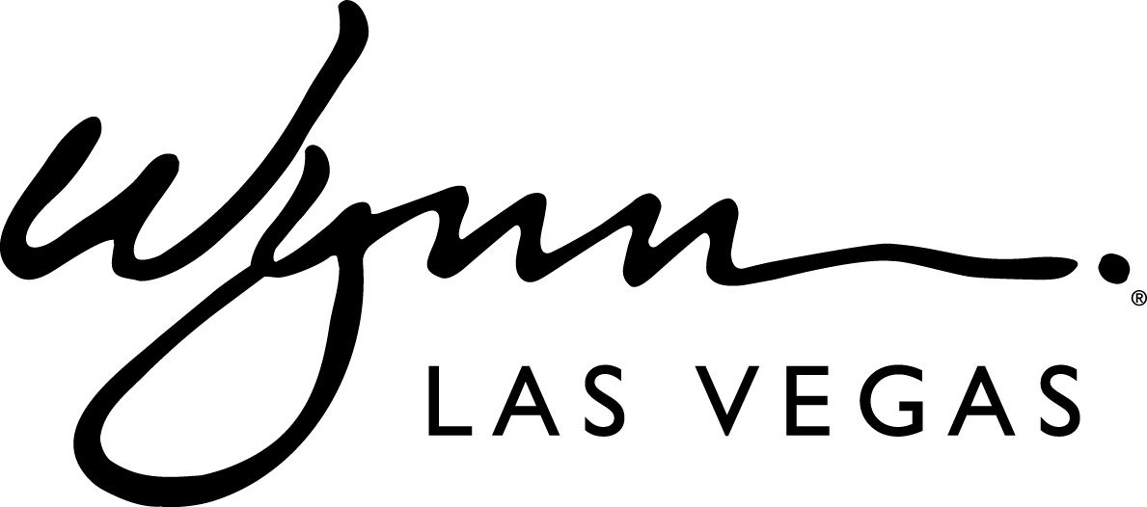 FOR IMMEDIATE RELEASE
Dec. 18, 2013

Wynn Las Vegas Honored at Best of Silver State Restaurants & Lounges Awards

Andrea’s, The Buffet at Wynn, The Country Club and XS Nightclub among Award Winners

LAS VEGAS — (Dec. 18, 2013) –Wynn Las Vegas received top honors in several categories at the Best of Silver State Restaurants & Lounges Awards, held on Friday, Dec. 13. Andrea’s at Encore for Best Interior Design, Restaurant; The Buffet at Wynn, Best Buffet; The Country Club, Best Sunday Brunch; XS, Best Nightclub; and Alex Stokes, Director of Food and Health at Wynn Las Vegas, was recognized with the Industry Champion Award.

“It is an honor to be recognized by voters as the best in a variety of categories at the Silver State Awards,” said Steve Weitman, senior vice president of food and beverage for Wynn Las Vegas and Encore. “We pride ourselves in providing our guests with memorable dining experiences, highlighted by exceptional service, unique food and beverage offerings all in unparalleled dining environments. It is great to see our food and beverage professionals recognized for the incredible effort they make every day.”

More than 13,000 votes were cast by the public to determine the winners of each category. Proceeds from the night benefited the Nevada Restaurant Association Educational Foundation which funds programs such as ProStart, a national high school culinary and restaurant management program that teaches students the skills and knowledge needed to enter the workforce or to continue to post-secondary education.

About Andrea’s
With interiors designed by Todd Avery Lenahan of TAL Studio, Andrea’s at Encore melds modern and feminine décor elements. The restaurant’s interiors are accented in cream, cognac, pearl and gold hues and feature luxurious finishes. Additionally, guests can lounge in velvet sofas in the step-up dining area under the glow of 1,000 champagne tinted Venetian glass teardrops. The main focal point of the room, a 16-foot LED screen featuring the eyes of the restaurant’s namesake, Andrea Wynn, overlooks the bar and lounge.

About The Buffet
Consistently regarded as one of the best buffets in Las Vegas, The Buffet at Wynn features 15-live action cooking stations with highlights including Alaskan Opilio crab legs, wagyu beef lasagna, a variety of hand and cut sushi rolls, roasted prime rib, and a delectable array of miniatures desserts.

About Jazz Brunch
Jazz Brunch at The Country Club, boasts a Big Easy-inspired menu, Sundays from 10 a.m. to 2 p.m. James Beard Award nominated Chef Carlos Guía pays homage to the great American steakhouse in this inviting setting, complete with gorgeous views of Wynn Golf Club fairways and 18th hole waterfall. The Jazz Brunch menu features New Orleans favorites such as shrimp and grits and authentic French Quarter beignets.

About XS
XS remains one of the most celebrated nightlife venues in the world today. In 2013, it was named the #1 nightclub in the country by Nightclub & Bar as well as the top club in Las Vegas by USA Today. Dubbed “Las Vegas dance music mecca” by MTV, it is known for an impressive roster of exclusive electronic dance music residencies. Open Friday through Monday from 10 p.m. to 4 a.m., reservations are highly recommended (XS: 702-770-0097).

About Alex Stokes
Alex Stokes brings more than 35 years of public health experience to his role as Director of Health and Food Safety at Wynn Las Vegas. In this position, he is responsible for conducting in house inspections of food and beverage facilities to ensure compliance with federal, state and Southern Nevada Health District (SNHD) regulatory requirements. Additionally, Stokes conducts food safety training classes, reviews requirements for food and beverage facilities and serves as the point of contact for SNHD when conducting inspections on property. Stokes moved to Las Vegas in 1997 and began working with Wynn prior to the resort’s opening in 2005.

For more information on Wynn Las Vegas, please visit www.wynnlasvegas.com or call 702-770-7000.

For more information about the Nevada Restaurant Association, please visit www.nvrestaurants.com.

###

Media Contact:
Rosie Abrams, Public Relations Manager
702-770-3626
Rosie.Abrams@WynnLasVegas.com

