[dd-mm-year]
Reduce CO₂-emissions with a VELUX roof window
Analysis show that a VELUX roof window saves more CO₂ than it costs to produce and dispose of - mainly due to the free solar energy entering through the window. Consequently, installing a VELUX roof window will help meet the increased demand for energy-savings as well as the overall wish to reduce CO₂–emissions and stop global warming.

As the effects of climate change are felt across the globe, both governments, industry and private homeowners are taking steps to address the challenges and lower CO₂-emissions. Tougher energy-requirements and financial incentives for building green are being introduced. All the while increasing energy demands and scarce fossil fuel-resources raise energy-prizes and further encourage private home-owners to choose climate friendly home improvements.
Now, a new Life Cycle Assessments (LCA) show, that a VELUX roof window can help overcome these issues by saving more CO₂ in its lifetime than it costs to produce and dispose of.
Reduce CO₂ by up to 500 kg.
Installing a VELUX roof window is effectively accommodating both consumers’ and legislators’ need for energy- and CO₂-savings by reducing total CO₂ –emissions. In fact, throughout the lifetime of the window, total CO₂-emissions are reduced by 4-500 kg.

Free solar energy leads to energy savings
The reduction of CO₂ is mainly thanks to the free solar thermal energy gained through the window. It reduces the demand for heating in the winter months. But a roof window can also lower costs for air conditioning during summer. Replacing and old roof window with a new one, can increase room temperature during the winter by up to 2 degrees C and reduce it during the summer by up to 5 degrees C. The energy contribution of a roof window can be further optimised by adding blinds and shutters to avoid overheating in the summer and improve insulation in the winter. On top of that, the free daylight also reduces energy consumption by cutting costs for electrical light during the day.
Energy balance and the environment
To fit the need of consumers and to contribute positively to the environment, VELUX product development focusses on creating and optimal balance between the energy gains from free solar energy entering the home and the amount of energy that escapes through the window.
“Bearing in mind that buildings account for 40% of energy consumption, it is important to us that our products contribute to a healthier and more sustainable way of designing buildings. Now, we are proud to have achieved a level of energy balance where the roof window is a positive contributor to the energy efficiency of the building. One VELUX roof window leaves a positive environmental footprint reducing total CO₂ emissions by 4-500 kg from cradle to grave. And on top of that there are the additional benefits of a healthier and more comfortable living environment with daylight and fresh air through the roof,” says Jacob Schambye.

Jacob Schambye talks more about sustainable products and LCA: https://www.youtube.com/watch?v=FKV32VN2ZPY

Life Cycle Assessments
When the environmental impact is calculated, all stages of the windows life are assessed - from raw material extraction through materials processing, manufacture, distribution, use, maintenance, and disposal or recycling. Calculations show that the impact of production and disposal is very minimal compared to the potential energy gains or losses during the lifetime of the window in the building.

As the figure below shows, after approx. ten years a VELUX roof window will have saved more CO₂ than were generated - having a net positive CO₂ footprint throughout its lifetime of approx. 40 years.

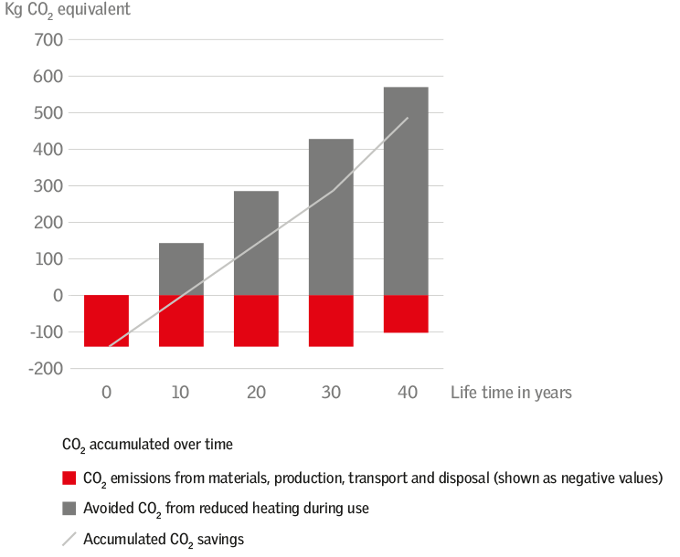

Red column: Accumulated year-to-date CO₂ emissions. Grey column: Avoided CO₂ emissions in the use phase (accumulated year to date). Grey line: Accumulated CO₂ savings calculated as the difference between the red and the grey column.

Product LCAs are the first step towards Environmental Product Declaration or Energy Labelling of windows and accessories.

More about how The VELUX Group works with corporate responsibility: http://crreport.velux.com/products-services.html
Press material at VELUX Media Centre
See and download our news videos, photos and press materiel on VELUX Media Centre at press.velux.com. Follow us on twitter.com/velux and facebook.com/velux

About the VELUX Group
The VELUX Group creates better living environments with daylight and fresh air through the roof. The VELUX product programme contains a wide range of roof windows and skylights, along with solutions for flat roofs. The Group also supplies many types of decoration and sun screening, roller shutters, installation products and products for remote control. The VELUX Group, which has manufacturing companies in 11 countries and sales companies in just under 40 countries, represents one of the strongest brands in the global building materials sector and its products are sold in most parts of the world. The VELUX Group has about 10,000 employees and is owned by VKR Holding A/S, a limited company wholly owned by foundations and family. For more details, visit www.velux.com.

Contact
Pernille Franch Pedersen, Media Relations Manager
Pernille.franch@velux.com, Mob: +45 23 81 56 47

