UEFA EURO 2020 Logo Launch – Press Kit

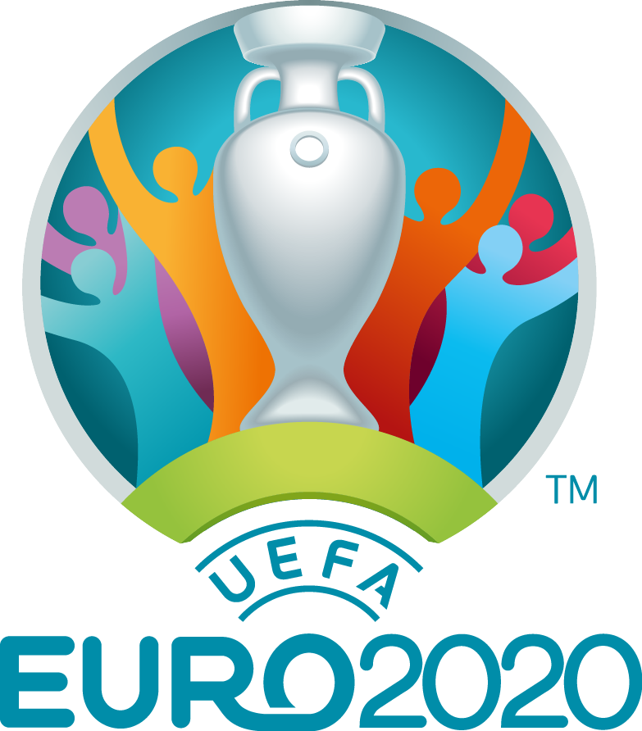

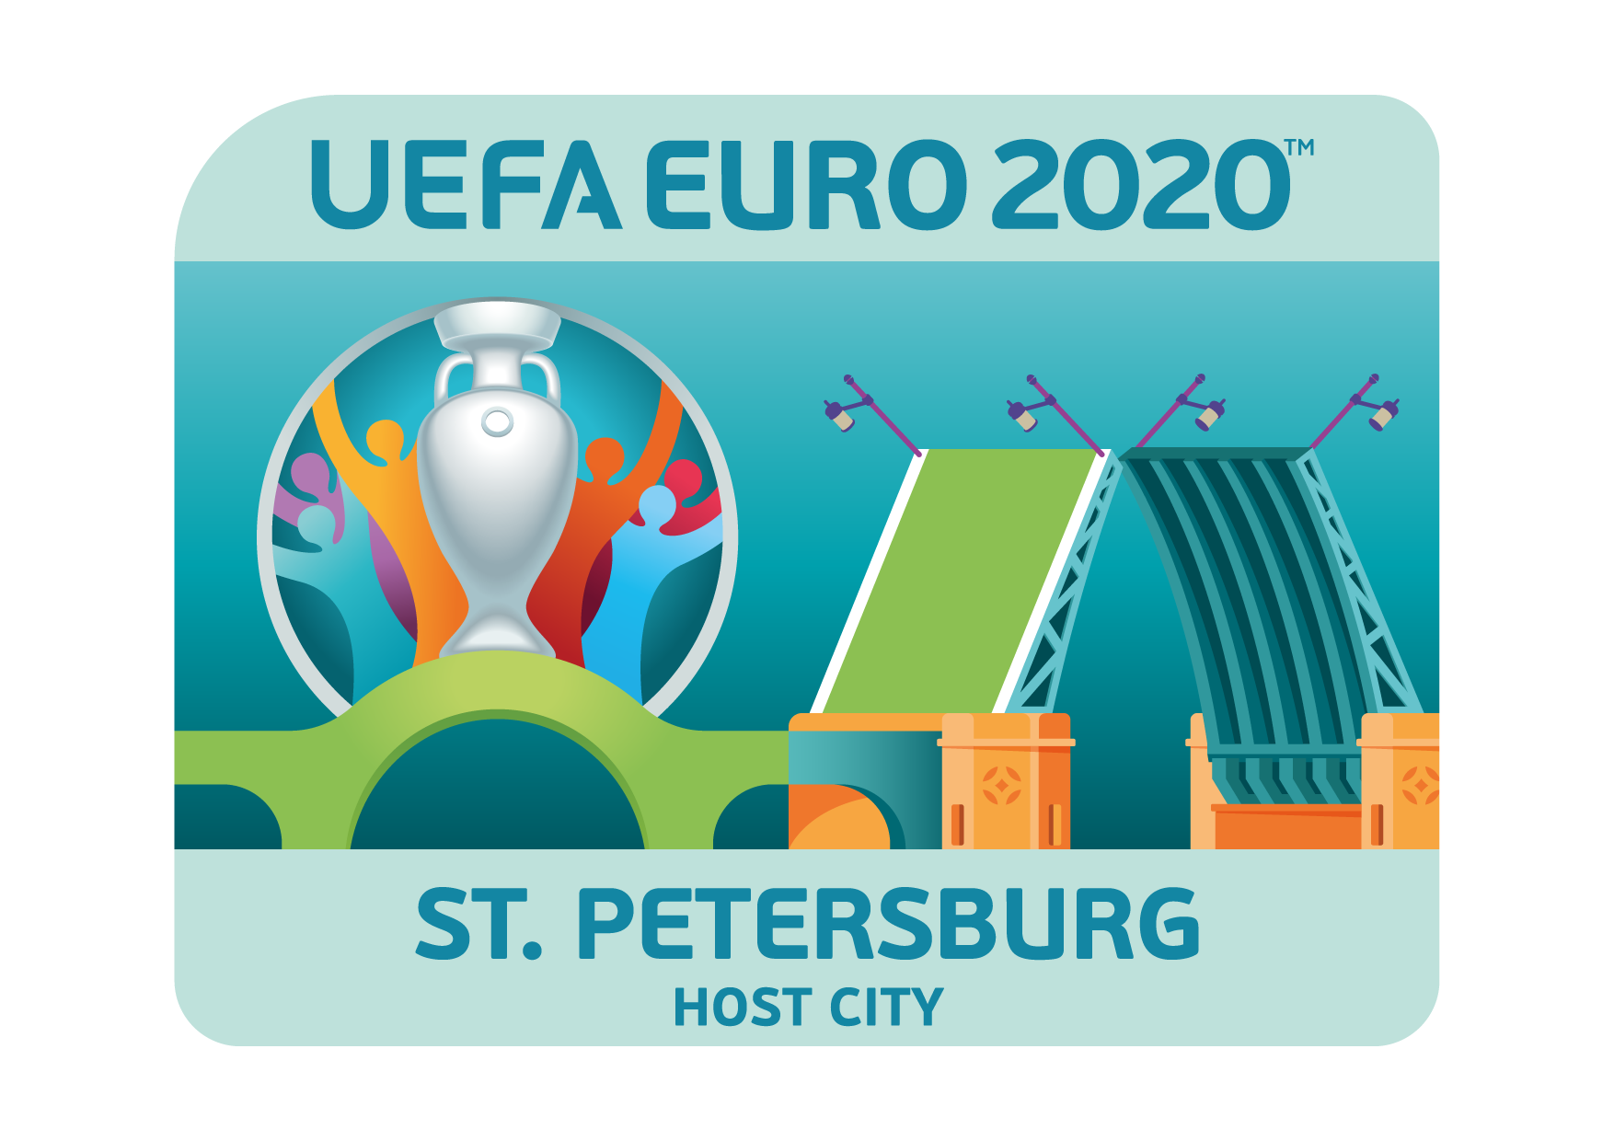

The Brand Inspiration

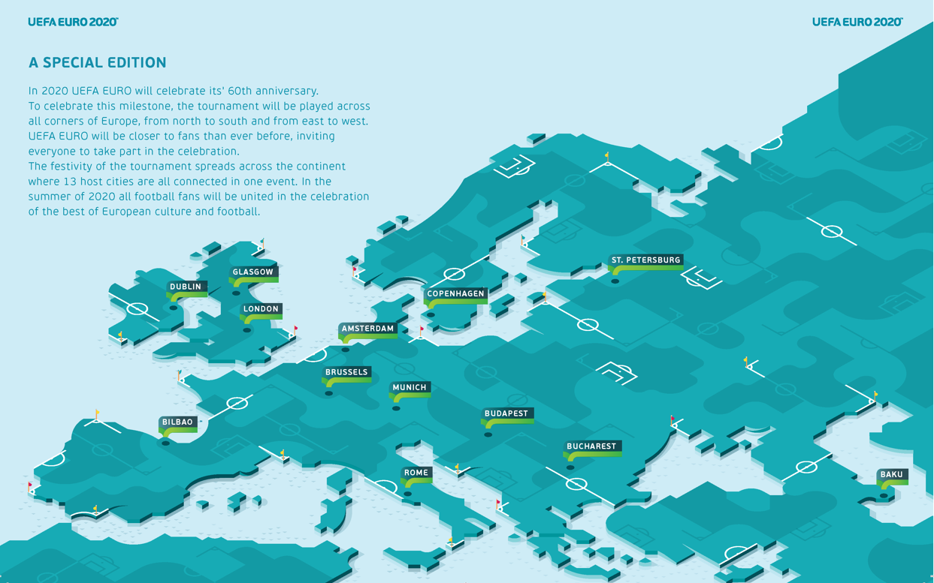

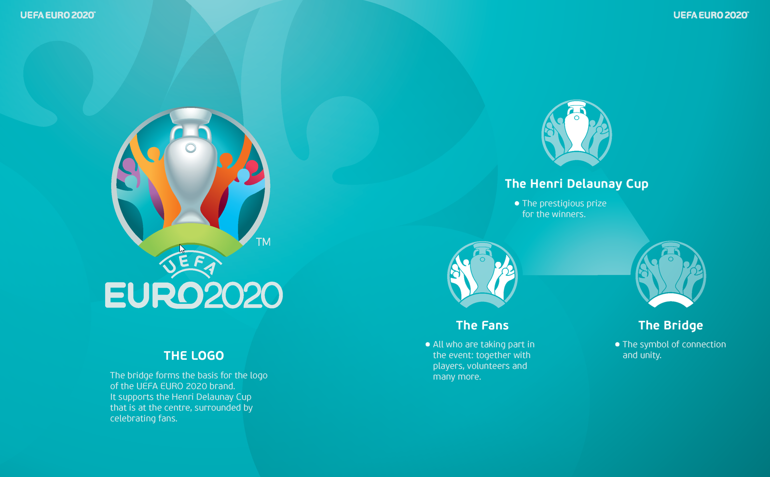

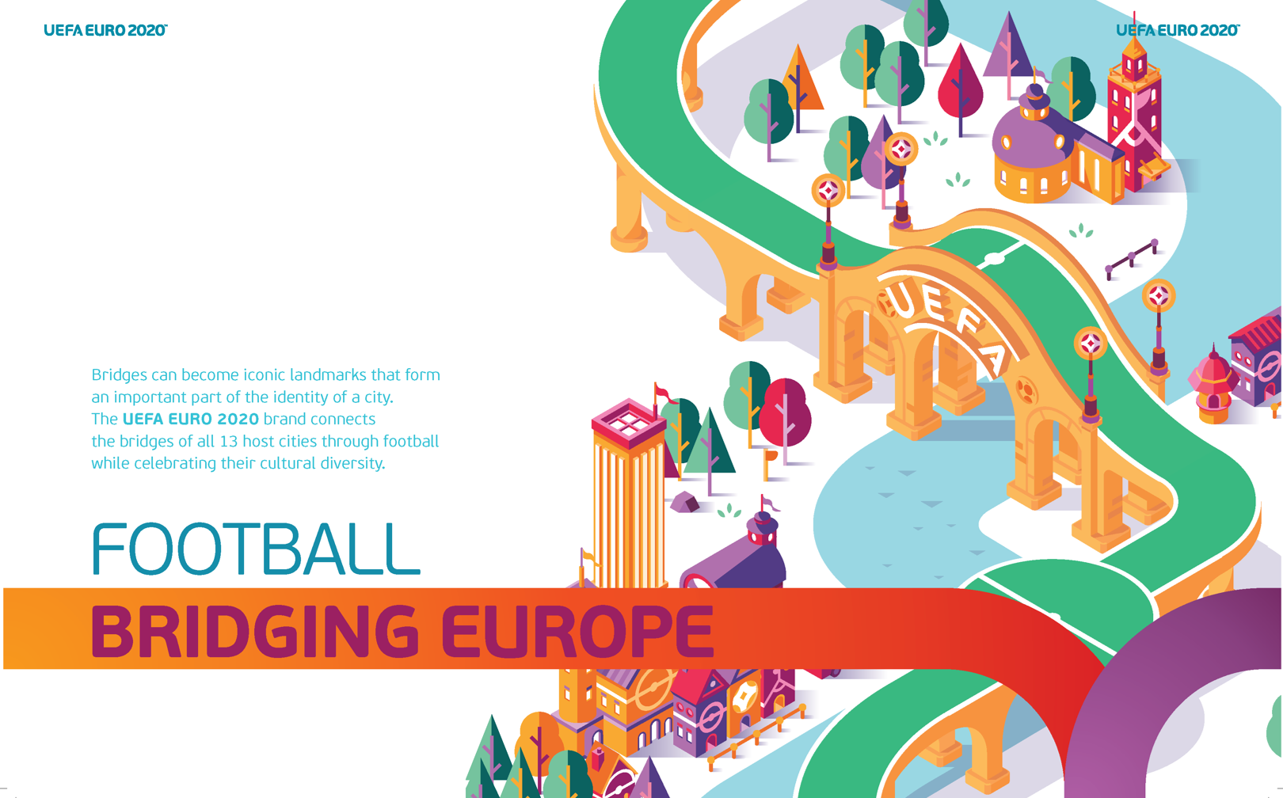

All you need to know about UEFA EURO 2020

Which cities will host games?

- Semi-finals and Final
  - London (England), Wembley Stadium

- Three group matches and a quarter-final
  - Baku (Azerbaijan), Olimpiya Stadionu
  - Munich (Germany), Fußball Arena München
  - Rome (Italy), Stadio Olimpico
  - St. Petersburg (Russia), Saint Petersburg Stadion

- Three group matches and a round of 16 match
  - Amsterdam (Netherlands), Amsterdam ArenA
  - Bilbao (Spain), Estadio de San Mamés
  - Brussels (Belgium), Eurostadium
  - Bucharest (Romania), Arena Națională
  - Budapest (Hungary), Puskás Ferenc Stadion
  - Copenhagen (Denmark), Parken (Stadium)
  - Dublin (Republic of Ireland), Dublin Arena
  - Glasgow (Scotland), Hampden Park

How many teams will qualify?

The success of the first 24-team UEFA European Championship – UEFA EURO 2016 – vindicated UEFA's decision to broaden the net for the final tournament, and 24 sides will be involved again at UEFA EURO 2020. There will be no automatic qualifiers, however, with all the nations with host cities required to earn their place at the finals.

The European Qualifiers – running from March to November 2019 – will send 20 competitors to the tournament, namely the top two teams in each of the ten qualifying groups. Four more countries will qualify via the new UEFA Nations League, with the decisive play-offs to be staged in March 2020.

A EURO with 13 host cities
The EURO final tournament in 2020 will be brought to all four corners of the continent, as a one-off celebration of its 60th anniversary.
UEFA did not pursue this innovative idea alone. It conducted a comprehensive consultation process, especially with its member associations, and the feedback received was extremely welcoming. The outcome was the presentation of a concrete proposal to UEFA’s Executive Committee in December 2012 and the idea of a pan-European EURO 2020 became a reality.

To be a true European experience, it was essential for the tournament to be staged from North to South, and East to West. Following a bidding and selection process, thirteen cities from each part of the continent – from St Petersburg to Bilbao, from Dublin to Baku – are now all looking forward to playing host to the tournament in four years’ time.

Eight of these thirteen host cities will be savouring something they had never done before, and will have the chance to stage matches in a European Championship final tournament.

With 13 cities hosting final tournament matches, it will give fans in all such countries a wonderful opportunity to share the EURO experience on their home soil.

Dates for host city logo unveiling relay

- London – 21/09/2016
- Rome – 22/09/2016
- Baku – 30/09/2016
- Bucharest – 15/10/2016
- Glasgow – 25/10/2016
- Munich – 27/10/2016
- Copenhagen – 01/11/2016
- Budapest – 16/11/2016
- Dublin – 24/11/2016
- Brussels – 14/12/2016
- Bilbao – 15/12/2016
- Amsterdam – 16/12/2016
- St. Petersburg – 19/01/2017

VIDEOS / PICTURES / DOCUMENTS

- The UEFA EURO 2020 logo and all UEFA EURO 2020 host city logos will be made available on UEFA.org once they have been unveiled:
http://www.uefa.org/mediaservices/mediadownload/index.html

- Pictures of all logo launch events in the thirteen host cities will be made available here after the logo revealing in the respective cities: https://photolibrary.uefa.ch/Go/drXRyDNw

- Brand Story Video: https://uefa.box.com/s/b8517cgd9wxjslatizmr967xnrko15o3

- UEFA Nations League / UEFA EURO 2020 qualifying format: http://uefa.to/1mI1USJ

- News about UEFA EURO 2020: http://www.uefa.com/uefaeuro-2020/news/index.html

- Bridge on the logo: Palace Bridge

The Palace Bridge
Despite being a relatively new edition to St. Petersburg, the Palace Bridge has established itself as one of the most iconic sites in the city. Linking downtown St. Petersburg to Vasilevskiy Ostrov, the bridge passes some of the city’s most historic buildings, such as the Winter Palace and the Hermitage Museum.
Construction of the bridge started in 1912, while its height was strictly limited so that it would not obstruct the view of famous buildings and monuments in the vicinity. The central span of the bridge splits into two wings, which can be raised to allow ships to pass along the Neva River. The bridge attracts numerous tourists in summer during the White Nights when it opens in the early hours of the morning to allow boats to pass.
The Palace Bridge has undergone renovations on a number of occasions, the latest of which took place in 1997. The bridge is an important transport artery in St. Petersburg and carries in excess of 30,000 cars per day.

