Awards and Accolades

August 2014
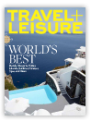

The Peninsula Hotels has won the following awards in August 2014：

Travel + Leisure (USA)
2014 World’s Best Awards
Top 100 Hotels Overall
The Peninsula Bangkok – No 13 (Score: 95.47)
The Peninsula Hong Kong – No 37 (Score: 94.34)
The Peninsula Shanghai – No 42 (Score: 94.09)
The Peninsula Chicago – No 58 (Score: 93.52)

Top Hotel Brands
The Peninsula Hotels – No 7 (Score: 92.06)

Top City Hotels in Asia
The Peninsula Bangkok – No 2 (Score: 95.47)
The Peninsula Hong Kong – No 3 (Score: 94.34)
The Peninsula Shanghai – No 4 (Score: 94.09)
The Peninsula Manila – No 11 (Score: 92.53)
The Peninsula Beijing – No 22 (Score: 89.95)

Top Large City Hotels in the Continental U.S.
The Peninsula Chicago – No 4 (Score: 93.52)
The Peninsula Beverly Hills – No 6 (Score: 92.51)

Top Hotel Spas Overall
The Peninsula Bangkok – No 2 (Score: 97.08)

Top 5 Hotel Spas, Asia
The Peninsula Bangkok – No 1 (Score: 97.08)

May 2014


The Peninsula Hotels has won the following awards in May 2014:

City Weekend (China)
2014 Readers' Choice Dining and Nightlife Awards
The Best Afternoon Tea
The Lobby – The Peninsula Shanghai

City Weekend (China)
2014 Readers' Choice Dining and Nightlife Awards
The Best Hotel Dining
Sir Elly’s – The Peninsula Shanghai

Travel Weekly China (China)
2014 China Travel & Meetings Industry Awards
Best Luxury Hotel of the Year
The Peninsula Shanghai

April 2014

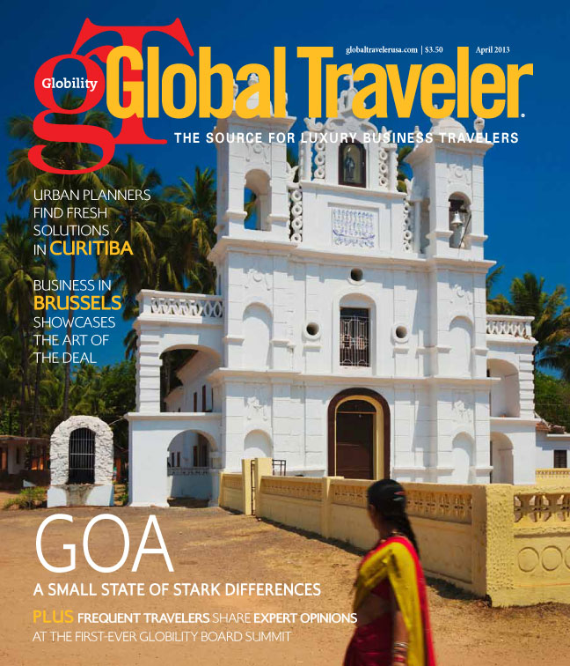
The Peninsula Hotels has won the following awards in April 2014:

Global Traveler (USA)
Leisure Travel Awards
Best Spa
The Peninsula New York

Shangliu Tatler (China)
Shangliu Tatler Best Restaurant 2014
Best Restaurant in Shanghai
The Peninsula Shanghai – Sir Elly’s and Yi Long Court

China Master Bartender Competition (China)
Hovan Lam – Salon de Ning
The Peninsula Hong Kong

March 2014

The Peninsula Hotels has won the following awards in March 2014:

Environmental Protection Department (Hong Kong)
Indoor Air Quality Certificate Award 2013
Premises Awarded with “Good Class” Certificate
The Peninsula Hong Kong

Luxury Travel Advisor (USA)
2013 Awards of Excellence
Most Anticipated New Hotel Opening
The Peninsula Paris

DININGCITY (China)
China Restaurant Week - Best Service Restaurant in Beijing
The Peninsula Beijing

World Luxury Hotel Awards (South Africa)
2014 World Luxury Spa Awards
Best Luxury Hotel Spa - Country Winner for Japan
The Peninsula Tokyo

Best Spa Manager - Country Winner for Japan
The Peninsula Tokyo

Best Luxury Hotel Spa - Country Winner for Hong Kong
The Peninsula Hong Kong

World Spa & Travel Magazine (Singapore)
100 List 2014 – City Hotels
The Peninsula Bangkok

February 2014

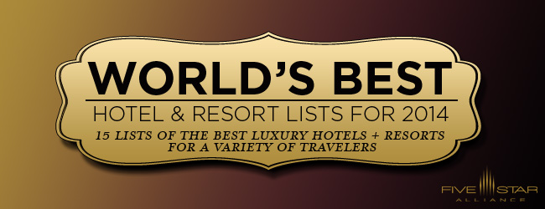

The Peninsula Hotels has won the following awards in February 2014:

Five Star Alliance (USA)
World’s Best Hotels 2014
Best Business Hotel
The Peninsula Shanghai

January 2014

The Peninsula Hotels has won the following awards in January 2014:

American Automobile Association (USA)
AAA Five Diamond Award 2014
Rated Five Diamond
The Peninsula Chicago

Forbes Travel Guide 2014 (USA)
Forbes Travel Guide 2014 Star Award
Forbes Five-Star Hotel
The Peninsula Shanghai
The Peninsula Beverly Hills
The Peninsula Chicago
The Peninsula New York
The Peninsula Hong Kong
The Peninsula Beijing

Forbes Five-Star Spa
The Peninsula Shanghai
The Peninsula New York
The Peninsula Hong Kong

Forbes Four-Star Spa
The Peninsula Beverly Hills
The Peninsula Chicago
The Peninsula Beijing

Forbes Four-Star Restaurant
The Peninsula Beverly Hills - The Belvedere
The Peninsula Chicago - Shanghai Terrace

Recommended Rating Awards
The Peninsula Shanghai – Sir Elly’s Restaurant

Travel + Leisure (China)
2013 Travel & Leisure Annual Travel Awards
The Top 10 Luxury Hotels
The Peninsula Hong Kong
The Peninsula Shanghai
The Peninsula Beijing

Best Spa
The Peninsula Shanghai

FinanceAsia (Hong Kong)
FinanceAsia Business Travel Poll
Best Hotels in Tokyo
The Peninsula Tokyo – No. 1

Best Hotels in Manila
The Peninsula Manila – No. 2

Best Hotels in Shanghai
The Peninsula Shanghai – No. 3

Institutional Investor (USA)
The World's Best Hotels 2013
The Peninsula Chicago – No. 5 (94.2) - No 3 in Americas; No 1 in Chicago
The Peninsula New York – No. 6 (94.2) - No 4 in Americas
The Peninsula Hong Kong – No. 7 (94.1) - No 2 in Asia; No 1 in Hong Kong
The Peninsula Beverly Hills – No. 38 (89.1) - No 20 in Americas

COSMO Bride (China)
2013 COSMO Bride Wedding Awards of The Year
Best Wedding Venue
The Peninsula Shanghai

Hong Kong Hereditary Breast Cancer Family Registry
2013 Pink Desserts for a Cause Award
Top Fund Raised Pink Restaurant
The Peninsula Hong Kong

