10 November 2011

STATION-TO-STATION AT JING
New EXECUTIVE CHEF TO UNVEIL BUFFET WITH GLOBAL APPEAL

The new Executive Chef at The Peninsula Beijing, Chef Xu Chi Ping, and his team of award-winning chefs unveil “Station-to-Station at JING” - a culinary tour de force that takes guests on a global gastronomic adventure with an extravagant buffet.

Along with his expert team, Chef Ping will set up a spectacular Station-to-Station buffet that will feature 16 gourmet stations where chefs will prepare foie gras, carved meats, rotisserie, salads and chocolate desserts among other exquisite options, all of which will be prepared with the freshest and most authentic ingredients. The global buffet will allow the chefs at The Peninsula Beijing to showcase their secret recipes and world-class skills at each of the 16 stations, creating a dining experience that is truly memorable.

Garden green station: Provides a selection of the freshest organic field greens and vegetables. Most of them are transported in the morning directly from an organic farm on the outskirts of Beijing. Six home-made vinaigrettes and sauces are available.
Foie gras station: Foie gras cornets and foie gras terrine are served. Accompanied by five types of spiced plum, glazed apple, port wine figs, home-made truffle brioche and sesame baguette.
Seafood station: Jumbo cocktail shrimps, Alaskan king crab legs, snow crab claws with traditional cocktail sauce, pink peppercorn mignonette, Thai aioli, Tabasco and lemon wedges.
Sushi & Sashimi station: An assortment of sashimi, Nigiri sushi and Maki, tuna, salmon, snapper, octopus, scallops and eels are served with traditional Japanese condiments.
Antipasto station: An abundant display of Italian favorites such as Prosciutto, smoked sausages, Genoa salami, imported cheeses, marinated olives and grilled vegetables.
Soup station: Two soups are served everyday, one Chinese style and the other Western, both using healthy ingredients. A selection of home-baked breads and rolls are also available at this station.

- more -
STATION-TO-STATION AT JING
NEW EXECUTIVE CHEF TO UNVEIL BUFFET WITH GLOBAL APPEAL- 2

Carving and rotisserie station: Thyme and salt crusted prime rib, horseradish sauce shallot red wine jus, garlic bread pudding; rotisserie spice crusted leg of lamb, saffron ratatouille, herb roasted baby potatoes, apricot chutney, pepper relish and parsley mint pesto.
Pasta and noodle station: A variety of pasta and noodles are available for you to choose and our chefs are at the service station to cook them for you either Western or Chinese style.
Western and Chinese hot dishes station: Attentively prepared dishes are available to pamper your taste buds. Recommendations include pan-fried horseradish crusted crab cakes; roasted sea bass with leeks, lardoons, mushrooms and wok-fried spare ribs with XO sauce. Chinese-Fresh noodles and wontons with supreme chicken broth and abalone jus as well as Chef’s choice of 8 traditional noodle toppings are also available.
Chinese barbecue station: Cantonese roasted duck, sliced barbecued pork with malt sugar, barbecued suckling pig, chicken marinated with dark soy sauce and other traditional Chinese condiments
Dim Sum station: Prepared by our Hong Kong chef in authentic Cantonese style are an assortment of steamed, fried and grilled dim sum. Ingredients include chicken, beef pork, shrimp and vegetables. Served with dipping soy sauce, garlic chili sauce, ginger vinegar and XO sauce
Artisan Cheese station: Assorted imported cheeses, toasted walnuts, fresh and dried fruits, assorted chutneys and honey, baked camembert “En Croute”, walnut raisin bread, French baguette and cheese crackers
Dessert station: Chef Victor's creations will never disappoint you.
Crepe station: Traditional French crepes served with butter, sugar and Cointreau, berry compote, Chantilly cream, roasted almonds and liquid ganache.
Gelato(ice cream) station: Eight home-made Gelato flavours are served with crispy waffle cones, assorted condiments, crunchy nuts, fruit coulis and toppings.

- more -
STATION-TO-STATION AT JING
NEW EXECUTIVE CHEF TO UNVEIL BUFFET WITH GLOBAL APPEAL- 3

JING offers an elegant, inviting atmosphere, a semi-private dining area and the Peninsula’s legendary service is renowned throughout the world. JING’s modern-meets-Asia ambience is ideal for both business entertaining or a relaxing dinner with family or friends. Available daily for dinner from 6pm – 10pm. Priced at RMB348 per person and half price for children under 12. Prices are subject to 15% surcharge, including unlimited chilled juices, soft drinks and local mineral water.

###
Incorporated in 1866 and listed on The Stock Exchange of Hong Kong (00045), HSH is the holding company of a Group which is engaged in the ownership, development and management of prestigious hotel, commercial and residential properties in key locations in Asia, the United States and Europe, as well as the provision of transport, club management and other services. The hotel portfolio of the Group comprises The Peninsula Hotels in Hong Kong, Shanghai, Beijing, New York, Chicago, Beverly Hills, Tokyo, Bangkok, Manila and Paris (opening in 2013). The property portfolio of the Group includes The Repulse Bay Complex, The Peak Tower and The Peak Tramways, St. John’s Building, The Landmark in Ho Chi Minh City, Vietnam and the Thai Country Club in Bangkok, Thailand.

For further information, please contact:
Ms. Cathie Yang  Director of Public Relations  The Peninsula Beijing  Telephone: (86-10) 8516 2888-6627  Fax: (86-10) 6510 6308  E-mail: cathieyang@peninsula.com  Website: peninsula.com  Digital Photo Library: www.peninsula.com/pdl  Broadcast Video Library:  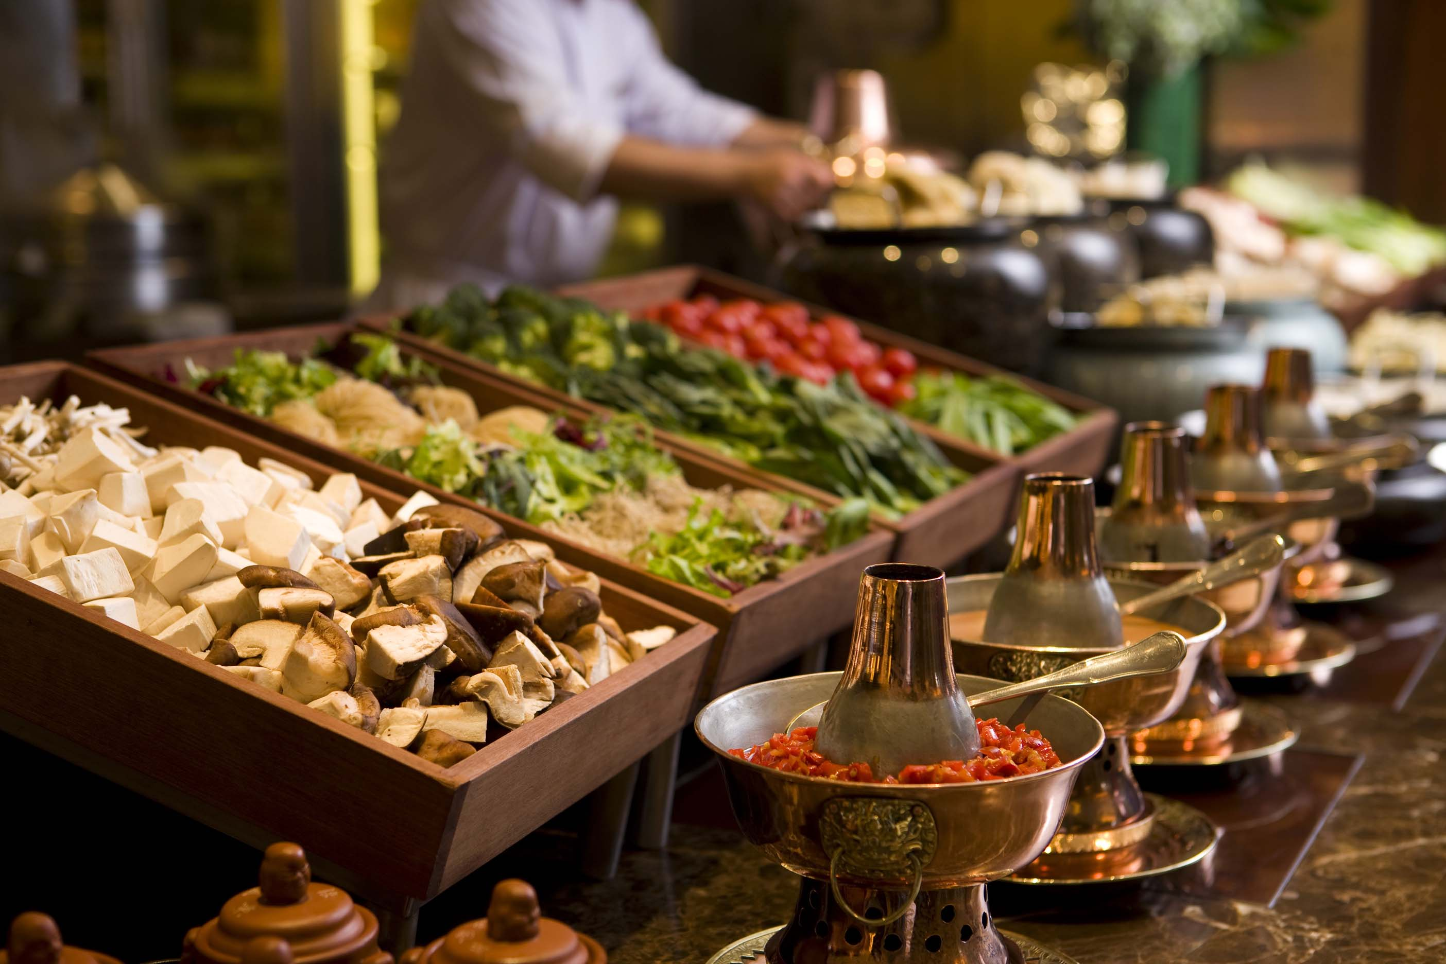  www.thenewsmarket.com/thepeninsulahotels | Ms. Cindy Wang  Assistant Public Relations Manager  The Peninsula Beijing  Telephone: (86-10) 8516 2888-6614  Fax: (86-10) 6510 6308  E-mail: cindywang@peninsula.com

