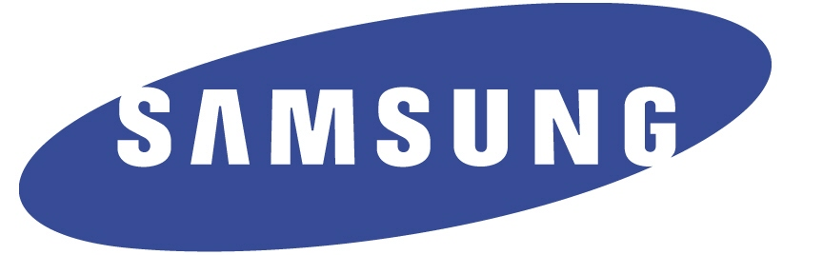

Reuben Staines
Samsung Electronics America
Enterprise Business Division
201-329-7415
rstaines@sea.samsung.com
@SamsungBizUSA

Molly Luby
Allison & Partners for
Samsung Electronics America
Enterprise Business Division
646-428-0611
molly@allisonpr.com

SBE & Samsung Set New Benchmark for Premium In-Room Guest
Experience at SLS Las Vegas Hotel & Casino

Opening August 23, new property leverages Samsung hospitality TVs and commercial displays to help create a legendary entertainment experience for guests

LAS VEGAS, NV – August 21, 2014 – Samsung Electronics America has partnered with Stockbridge/SBE Holdings, LLC d/b/a SLS Las Vegas (“SLS Las Vegas”) to bring its industry-leading hospitality technology solutions to the SLS Las Vegas, scheduled to open on August 23. The SLS Las Vegas selected Samsung to outfit its newest property with a number of technology solutions, including smart hospitality TVs and video wall displays, creating a legendary guest experience worthy of the iconic Las Vegas property.

- Download b-roll footage here.

“We’re thrilled to be working with the SLS Las Vegas to outfit this luxury property that epitomizes Samsung’s passion for creating new possibilities in entertainment and pushing the boundaries of what can be achieved with technology, from the lobby to the guest room and beyond,” said Jonas Tanenbaum, vice president of hospitality at Samsung Electronics America. “With this partnership, we are furthering our commitment to delivering technologies that meet the changing needs and expectations of guests, as well as solutions that help make managing these technologies more seamless for hotel management.”

More than 2,000 Samsung Smart TVs will outfit the property, with immersive Curved TVs in the presidential suites, Samsung’s 55-inch 690 Series Smart Hospitality TV in all standard guest rooms, and various other models in public areas including bars, restaurants and pool cabanas.

Utilizing Allin Interactive’s DigiHD ITV solution integrated with Samsung’s H-Browser platform, the SLS Las Vegas will deliver guests a rich and interactive Smart TV experience, all without the need for a set-top box. Guests will have access to premium on-demand content provided by Cox Business/Hospitality Network, delivered safely encrypted through Samsung’s LYNK DRM solution.

With the touch of a few buttons on their remote control, SLS Las Vegas guests can also request resort amenities such as laundry pick-up or valet service, access up-to-date restaurant menus and resort activity schedules, check messages, review their account and check out.

“The SLS Las Vegas is truly a legendary property, as we designed every detail with the guest in mind to meet the needs of visitors that crave a unique aesthetic, superior amenities and a memorable hospitality experience,” said Sam Bakhshandehpour, President, sbe. “Samsung, together with Allin Interactive and Cox Business/Hospitality Network, have allowed us to deliver guests an in-room experience that caters to the high expectations of today’s tech-savvy travelers.”

Beyond the guest room, a massive video wall comprised of 26 Samsung UD Series commercial displays positioned behind the front desk will create a striking visual impact for guests upon arrival. To streamline and enhance the guest check-in process, the SLS Las Vegas will also be utilizing Galaxy Tab S devices that will leverage a third-party Android-based app to remotely check in guests.

For more information about Samsung’s Hospitality TV solutions, please visit samsung.com/hospitality or call 1-866-SAM-4BIZ.

About Samsung Electronics America Enterprise Business Division
As a global leader in Information Technology, Samsung’s Enterprise Business Division (EBD) is committed to introducing new business experiences across a diverse spectrum of industries from retail to healthcare, hospitality to sales. We believe technology brings business and customers together — to better share, collaborate and discover new opportunities. With a market-oriented approach to innovation, EBD is a division of Samsung Electronics America, Inc. (SEA), a U.S. subsidiary of Samsung Electronics Company, Ltd. (SEC). For more information, please visit samsung.com/business., call 1-866-SAM-4BIZ or follow Samsung EBD via Twitter: @SamsungBizUSA.

About Samsung Electronics Co., Ltd.
Samsung Electronics Co., Ltd. is a global leader in technology, opening new possibilities for people everywhere. Through relentless innovation and discovery, we are transforming the worlds of TVs, smartphones, tablets, PCs, cameras, home appliances, printers, LTE systems, medical devices, semiconductors and LED solutions. We employ 286,000 people across 80 countries with annual sales of US$216.7 billion. To discover more, please visit www.samsung.com.

About SLS Las Vegas:
SLS Las Vegas is an all-encompassing resort and casino with more than 1,600 guest rooms and suites in three distinctive towers, 80,000 square feet of flexible meeting space and a collection of sbe’s acclaimed restaurant and nightlife brands. Opening Aug. 23, SLS Las Vegas provides an approachable experience featuring multiple unparalleled nightlife offerings including Hollywood favorite, The Sayers Club, the edgy and sophisticated nightclub, Foxtail and mega-club, LiFE. Additionally, SLS Las Vegas offers an impressive selection of dining concepts including Bazaar Meat by José Andrés; Katsuya by Starck; Cleo; Umami Burger, Beer Garden & Sports Book; Ku Noodle; 800 Degrees Neapolitan Pizzeria; The Griddle Cafe; The SLS Buffet and The Perq. The property also hosts a 10,000-square-foot Fred Segal retail experience, the intimate and luxurious Ciel Spa and a sports book operated by global gaming leader, William Hill. For more information about SLS Las Vegas, please visit slsvegas.com and stay connected on Facebook, Twitter, and Instagram.

About sbe:
sbe is a global hospitality and real estate company that develops, manages and operates award-winning hotels, casinos, residences, restaurants and nightlife around the world. Through exclusive partnerships with cultural visionaries, sbe is dedicated to delivering the best in design, culinary and entertainment. Already a proven leader in the hospitality and real estate industries, sbe has over 80 properties currently operating or in development, and has expanded several of its flagship brands including SLS Hotels, Katsuya by Starck, The Bazaar by José Andrés and Hyde Lounge nationally and internationally. Founded in 2002 by Chairman and CEO Sam Nazarian, sbe is a privately held company. More information about sbe can be obtained at www.sbe.com, or by downloading the sbe App here.
###

