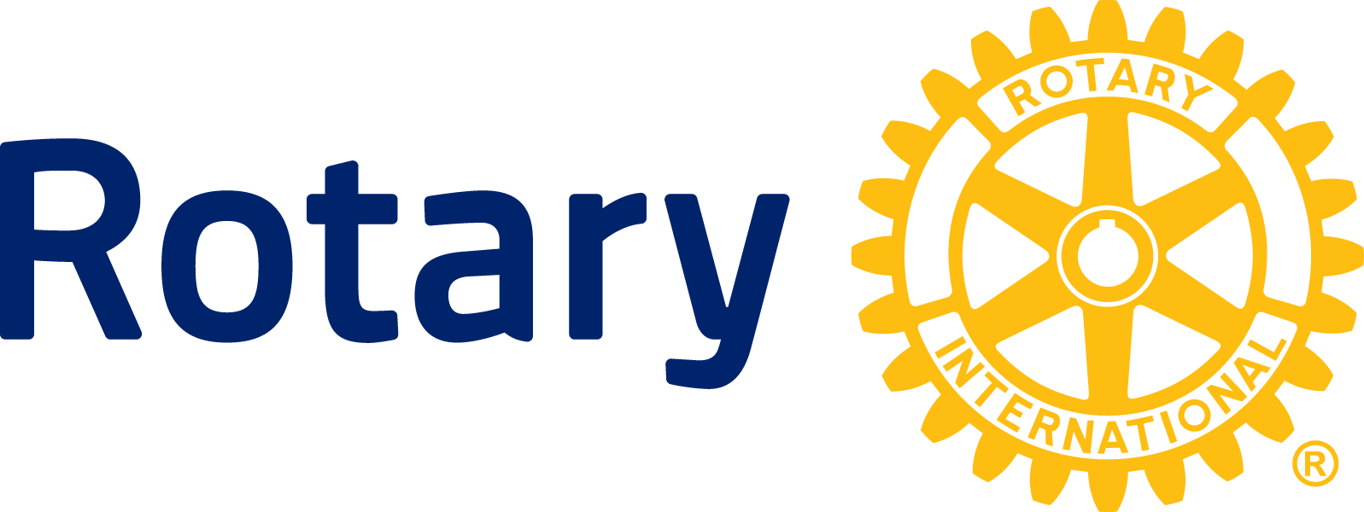

NEWS RELEASE

Rotary brings free health services into underserved communities

Rotary clubs of South Africa, Swaziland, Lesotho, Nigeria, Uganda and Ghana team up with NGOs, businesses and governments for Rotary Family Health Days

EVANSTON, Ill. (March 28, 2014) — Rotary Family Health Days – an innovative international campaign providing free health-care services to underserved families -- launches its fourth edition in April 2014, aiming to reach 350,000 people in Uganda, Nigeria, Ghana, South Africa, Swaziland and Lesotho.

Rotary Family Health Days (RFHD) promotes healthy living and disease prevention by providing free, comprehensive health-care services to tens of thousands of people in underprivileged communities. The program, led by Rotary’s mobilizing arm - Rotarians for Family Health & AIDS Prevention - addresses Africa’s most pressing health challenges, including HIV/AIDS, tuberculosis, malaria and reproductive health, as well as conditions such as diabetes and hypertension. An important component is immunizing children against polio, measles and other vaccine-preventable diseases.

The Rotary-led program is sponsored by The Coca-Cola Africa Foundation, the South Africa Department of Health, the Centers for Disease Control and Prevention CDC, USAID, the SABC and Caxton as primary media partners as well as YFM, Media 24 news and Independent Newspapers in the Western Cape.

RFHD launched in 2011 at 160 sites in Uganda and Kenya and immediately exceeded organizers’ expectations by drawing 38,000 people to the one-day event. In 2012, Nigeria signed on and the program expanded to three days. By 2013, RFHD operated 368 sites in Uganda, Nigeria and South Africa, reaching over 275,000 people. More than 5,500 Rotary members from 362 clubs participated.

“We believe we have achieved ‘proof of concept’ and identified the power of our health campaign,” said Marion Bunch, director and managing partner of RFHD and a Rotary club member from Georgia, USA, who became active in the fight against HIV/AIDS in Africa after losing a son to the disease, and has since expanded the scope of her efforts to address other health issues. “We have learned that when a campaign delivers several interventions at once, the benefits rise exponentially for families and communities.”

According to the World Health Organization (WHO), every year millions of Africans die from diseases that are preventable and treatable. The region faces many challenges including weak and fragmented health systems, inadequate resources for delivering proven interventions, limited access to health-services and extreme poverty. Rotary Family Health Days addresses these challenges by bringing life-saving health services into the communities most at risk.

Rotary Family Health Days 2014

South Africa, Swaziland, Lesotho | April 2 - 4 160 sites
Ghana | April 10 - 12 30 sites
Uganda | April 10 - 12 120 sites
Nigeria | April 24 - 26 150 sites

About Rotary

Rotary brings together a global network of volunteer leaders dedicated to tackling the world’s most pressing humanitarian challenges. Rotary connects 1.2 million members of more than 34,000 Rotary clubs in over 200 countries and geographical areas. Their work improves lives at both the local and international levels, from helping families in need in their own communities to working toward a polio-free world. For more information, visit Rotary.org.

Note to journalists:

Video and still images will be available on the Rotary Media Center.

SABC will air a 24-minute documentary about Rotary Family Health Days on Sunday, 30 March 2014. To view the trailer, click here.

###

Contact: Rotary: Stéphanie Tobler, +41 44 387 714 16, stephanie.tobler@rotary.org

S. Africa, Lesotho and Swaziland: Annemarie Mostert, 0824574558, annemarie@rfha.org

Uganda: Fred Massade, 0753 670020, fmasadde@moreuganda.com

Ghana: Willie Keteku (Accra), 020 201 2348, williekay@gmail.com

Nigeria: Olugbemiga Olowu (Ikeja), 234-802-323-8561,
lutaynigeria@yahoo.com

