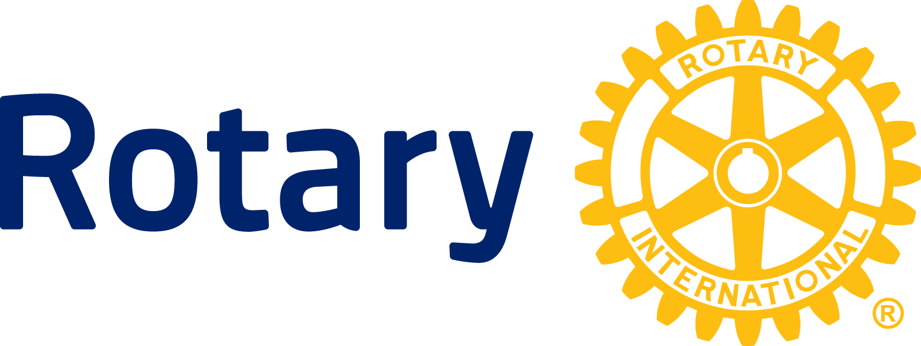

NEWS RELEASE

Rotary releases US$35.9 million to fight polio in Africa and Asia

EVANSTON, Ill. (18 Feb. 2014) — The continued fight to eliminate polio gets an additional $36 million boost from Rotary in support of polio immunization activities and research to be carried out by the Global Polio Eradication Initiative, which aims to end the disabling viral disease worldwide by 2018.

The funding commitment comes at a critical time as the eradication initiative focuses on stopping polio in the three countries where the virus remains endemic: Afghanistan, Nigeria, and Pakistan. Stopping polio in those countries is crucial in order to halt the recent spate of outbreaks in countries where the disease had previously been beaten and where mass immunizations of children via the oral polio vaccine must continue until global eradication is achieved.

The Rotary grants include $6.8 million for Afghanistan, $7.7 million for Nigeria and $926,000 for Pakistan. Grant amounts are based on requests from eradication initiative partners UNICEF and the World Health Organization, which work with the governments of polio-affected countries to plan and carry out immunization activities.

UNICEF will use a grant of $2.73 million to bolster vaccination activities throughout the Horn of Africa as part of an on-going response to an outbreak that began in 2013 and has now infected more than 200 children. The so-called “imported” cases are linked to the strain of polio endemic to Nigeria, underscoring the need to stop the virus in the endemic countries.

“Now it is of critical importance to get as many children as possible immunized through routine immunization, especially in areas within the Horn of Africa that are not doing so well in that regard,” says Joel Lehmann, a Rotary member from Nairobi, Kenya. “As Rotary, we want to find effective ways to eradicate polio worldwide and at the same time, to improve child health in general,” Lehmann adds.

The other countries where Rotary funds will be used to fight polio are Burkina Faso, $2.1 million; Cameroon, $3.4 million; Democratic Republic of Congo, $3.9 million; Niger, $2.3 million; Somalia, $1.3 million; South Sudan, $2.6 million; and Sudan, $1.2 million.

WHO also received $934,000 to study the impact of introducing injectable, inactivated polio vaccine into the immunization program as part of the initiative’s endgame plan, as the goal of global eradication nears.

Unrelated to this round of grants, Rotary released $500,000 in December 2013 as an emergency response to the polio outbreak in strife-torn Syria, which had not reported polio since 1999. Through Jan. 31, there were 23 confirmed cases in Syria since October 2013, all traceable to the polio strain circulating in Pakistan.

Rotary launched its polio immunization program PolioPlus in 1985 and in 1988 became a spearheading partner in the Global Polio Eradication Initiative with the WHO, UNICEF, and the U.S. Centers for Disease Control and Prevention. Since the initiative launched in 1988, the incidence of polio has plummeted by more than 99 percent, from about 350,000 cases a year to 369 confirmed so far for 2013.

Rotary’s main responsibilities within the initiative are fundraising, advocacy, and social mobilization. To date, Rotary has contributed more than $1.2 billion and countless volunteer hours to fight polio. Through 2018, every new dollar Rotary commits to polio eradication will be matched two-to-one by the Bill & Melinda Gates Foundation up to $35 million a year.

About Rotary

Rotary brings together a global network of volunteer leaders dedicated to tackling the world’s most pressing humanitarian challenges. Rotary connects 1.2 million members of more than 34,000 Rotary clubs in over 200 countries and geographical areas. Their work improves lives at both the local and international levels, from helping families in need in their own communities to working toward a polio-free world. For more information, visit Rotary.org.

###

Contact: Petina Dixon-Jenkins (847) 866-3054
petina.dixon-Jenkins@rotary.org

