FOR IMMEDIATE RELEASE

REEBOK NAMED AS CES INNOVATIONS 2014 DESIGN AND ENGINEERING
AWARD HONOREE

Brand’s Groundbreaking Sports Activity Impact Indicator, the Reebok CHECKLIGHT™ Honored in the Health & Fitness Category

New York, NY, November 12, 2013 - Reebok today announced that it has been named an International CES Innovations 2014 Design and Engineering Awards Honoree for the Reebok CHECKLIGHT™. Products entered in this prestigious program are judged by a preeminent panel of independent industrial designers, independent engineers and members of the trade media to honor outstanding design and engineering in cutting edge consumer electronics products across 29 product categories.

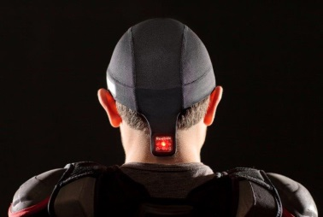
Reebok CHECKLIGHT™ is a groundbreaking sports activity impact indicator designed for athletes of all ages and skill-levels. The CHECKLIGHT™ skullcap is for use in all helmeted and non-helmeted contact sports and activities. CHECKLIGHT™ uses multiple motion sensors to provide actionable impact data to help assess an athlete before continuing to play. An easy-to-read display of red and yellow lights indicate the level of impact. The Reebok CHECKLIGHT™ is the first impact indicator that comfortably fits wearable electronics directly on the athlete, not on the athlete’s protective equipment. Embedding flexible electronics into a closely fitting skullcap helps to accurately measure direct accelerations in real-time.

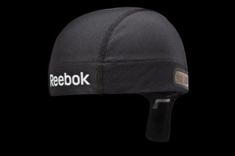
“At Reebok, we are committed to technological and engineering innovations that will help people be fit for life,” said Paul Litchfield, Reebok’s Head of Advanced Concepts. “The more we learn about head injuries, the more we understand the long-term ramifications and we want to do our part to help ensure people can participate, compete and enjoy their favorite fitness activities throughout their lives.”
“There is still much to be learned in this area, but we believe technology can play a significant role in improving the athletic experience. We’re proud that a product we designed to help people stay fit for life is also being recognized by CES, who are a trusted authority on tech and innovation,” said Litchfield.
More than three years of lab and multi-sport field-testing with hundreds of athletes ranging from youth to professional have served in the development and validation of Reebok CHECKLIGHT™, which utilizes the award-winning conformal electronics technology platform developed by Cambridge, MA electronics company MC10 to help ensure the product is comfortable and non-distracting to the athlete. During the creation of CHECKLIGHT™, Reebok has worked with head trauma experts in the medical and academic fields and professional athletes, including NFL quarterback Matt Hasselbeck.
The Reebok CHECKLIGHT™ is the first consumer electronics product launched at Reebok as part of an advanced research and development initiative to introduce wearable fitness technologies that will help people reach their fitness goals and stretch the limits of the fitness industry through technology.
The prestigious Innovations Design and Engineering Awards are sponsored by the Consumer Electronics Association (CEA)®, the producer of the International CES, the global gathering place for all who thrive on the business of consumer technology, and have been recognizing achievements in product design and engineering since 1976.
Reebok CHECKLIGHT™ will be displayed in The Venetian at the 2014 International CES, which runs January 7-10, 2014 in Las Vegas, Nevada. Honorees will also be displayed at CES Unveiled: The Official Media Event of the International CES from 4-7 p.m. on Sunday, January 5 in South Seas Ballroom C at Mandalay Bay.

The Innovations entries are judged based on the following criteria:

- Engineering qualities, based on technical specs and materials used
- Aesthetic and design qualities, using photos provided
- The product’s intended use/function and user value
- Why the product deserves the Innovations award, including specifics regarding its unique/novel features and features that consumers would find attractive
- How the design and innovation of this product directly compare to other products in the market place
Products chosen as an Innovations honoree reflect innovative design and engineering of the entries. Examples may include the first time various technologies are combined in a single product or dramatic enhancements to previous product designs.

Innovations 2014 Design and Engineering honoree products are featured on CESweb.org/Innovations, which lists product categories, as well as each product name, manufacturer information, designer, description, photo and URL.

To download image above please go to http://news.reebok.com/

For more information about the Reebok CHECKLIGHT™ go to: http://shop.reebok.com/us/content/CHECKLIGHT

About Reebok
Reebok International Ltd., headquartered in Canton, MA, USA, is a leading worldwide designer, marketer and distributor of sports, fitness and casual footwear, apparel and equipment. An American-inspired global brand, Reebok is a pioneer in the sporting goods industry with a rich and storied heritage in running, training and fitness. A subsidiary of the adidas Group, Reebok operates under the multiple divisions of the Reebok brand, Reebok-CCM Hockey and the Sports Licensed Division. Reebok is the exclusive outfitter of CrossFit and the Reebok CrossFit Games and main event partner and official apparel and footwear supplier for the 2013 Red Bull X-Alps. For more information, visit Reebok at www.reebok.com. Or, discover Reebok at the following locations: http://reesha.re/plus; http://facebook.com/reebok; http://twitter.com/reebok; and http://youtube.com/reebok
*The Reebok CHECKLIGHT™™ is not a concussion diagnostic tool – it provides an objective measure of impact force and is designed to lead athletes on a pathway to assessment.

Contact: Sandra Carreon-John
M&C Saatchi PR for Reebok Phone: (646) 619-2811 sandra.carreon-john@mcsaatchi.com

Dan Sarro
Reebok
Phone: (781) 401-4443
Daniel.sarro@reebok.com

