Press Release

Date | 16 August 2016
Contact | Nicholas Braude, PwC  Tel: (617) 530-5435  e-mail: nicholas.braude@pwc.com
Pages | 3

PwC’s 25 Fastest Growing Cloud Companies
signal software climate change

First-time ranking shows opportunities and obstacles facing software vendors

Tuesday, 16 August 2016 – With cloud computing rapidly reshaping the software industry, PwC has ranked the 25 Fastest Growing Cloud Companies to help understand what drives success when vendors move to the cloud.

Released as part of PwC’s Global 100 Software Leaders research report, this first-time cloud-specific ranking suggests that no one type of company has the secret formula for success in the cloud.

The ranking includes a diverse mix of companies, from startups to high-profile companies whose business models rely on the cloud to companies with a tight focus on specific areas such as expense management, mid-market ERP and accounting.

SaaS having biggest impact on vendors
“Companies are becoming increasingly dependent on software as a service (SaaS), and this area really exemplifies the cloud’s growth,” says Mark McCaffrey, PwC Global Software Leader. “Software vendors who’ve made the transition to SaaS are well on their way to restructuring their operations to the new realities of lower average sales prices and margins.”
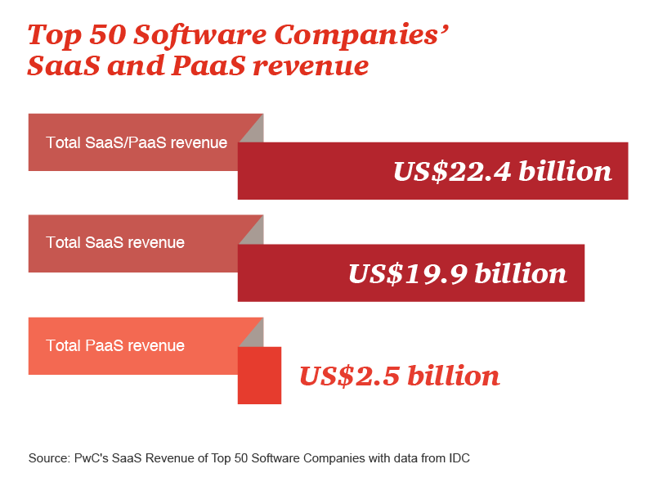
At least one third of the 25 Fastest Growing Cloud Companies are established firms that flourished for years from selling on-premises software licenses. It’s critical to remember that while cloud applications are less expensive to deploy, their switching costs are also lower—meaning that subscription revenue can dry up if vendors don’t think more carefully about customer service—service that spans from the user interface to product support.

The data and trends do illustrate several key themes:
- Customers are increasingly accepting the cloud in spite of its foibles.
- Cloud migration presents both technical and business challenges for vendors.
- The cloud gives software vendors a greater opportunity for customer engagement.
- The success in cloud demands faster product cycles from software vendors.
“Not all software companies will get it right immediately,” cautions Raman Chitkara, PwC’s Global Technology Leader. “Among the top half of our Global 100 Software Leaders ranking, six companies also appear on our Fastest Growing Cloud Companies list. We still have a relatively long way to go before the leaders and laggards in cloud are well established.”

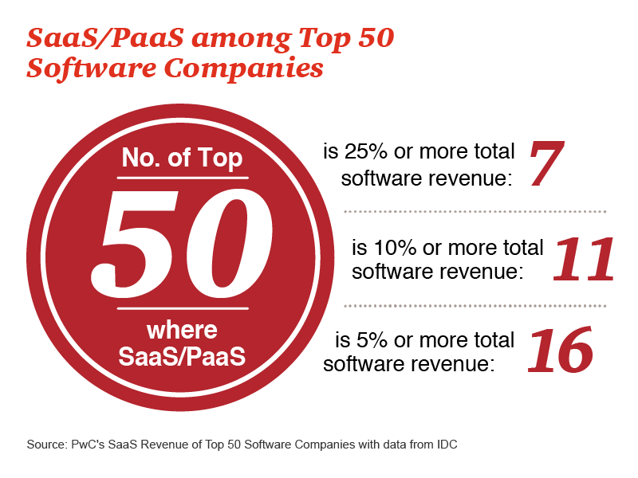

What are the operational considerations?
With the cloud model affecting nearly every aspect of a vendor’s business, PwC identifies several operational considerations for software companies transitioning to the cloud. Pivoting to the cloud involves significant changes to a company’s business, both internal and external, including product development, marketing and sales, customer service and support, and revenue.

The impact of cloud computing is vast, with business issues, technical issues, cultural issues and customer issues to tackle. The cloud is indeed a new paradigm, and software vendors need to stray from their comfort zones to successfully transition all phases of the company.

For more information and to download the Top 25 Fastest Growing Cloud Companies report, click here.

About PwC’s 25 Fastest Growing Cloud Companies and the Global 100 Software Leaders
The PwC 25 Fastest Growing Cloud Companies list is based on corporate financial statements (GAAP-based where applicable), other public sources and estimates for privately held companies. The ranking is based on year-to-year growth rate in Public Cloud revenue from 2013 to 2014, the most recent year for which complete data was available. Due to variances in fiscal years, the results were ‘calendarised’ for both years.

PwC recently launched the fourth edition of its Global 100 Software Leaders ranking since 2010. The current edition continues our tradition of monitoring and analysing the leading companies and trends in the industry. Our goal is to help our clients understand both the obvious and the underlying forces influencing the software industry.

The new PwC Global 100 Software Leaders list is based on corporate financial statements (GAAP-based where applicable), other public sources and estimates for privately held companies, as compiled for PwC by the Global Software Business Strategies Group at IDC. Learn more about the report’s methodology here.

About PwC
At PwC, our purpose is to build trust in society and solve important problems. We’re a network of firms in 157 countries with more than 208,000 people who are committed to delivering quality in assurance, advisory and tax services. Find out more and tell us what matters to you by visiting us at www.pwc.com.

©2016 PricewaterhouseCoopers. All rights reserved. PwC refers to the PwC network and/or one or more of its member firms, each of which is a separate legal entity. Please see www.pwc.com/structure for further details.

