News release

Date | 5 August 2014
Contact | Mike Davies, PwC  +44 207 804 2378  e-mail: mike.davies@uk.pwc.com

Africa: Growth is on the horizon but where should you look?

CEOs around the world are increasingly recognising the untapped potential of Sub-Saharan Africa (SSA). This is driven by Africa’s unparalleled demographic edge as, by 2040, it is expected to have the biggest labour force in the world and be experiencing faster economic growth than any other region, according to a new PwC report.

The projections are contained in the latest PwC Global Economy Watch, which puts the spotlight on the largest cities in SSA.

Most major corporations are already active in at least one of the three largest cities in SSA – Lagos, Kinshasa and Johannesburg.

But PwC economists believe it’s the ‘Next 10’ biggest cities in SSA that should also be exciting foreign investors. The population of these cities is projected to almost double by 2030, growing by around 32 million people. In fact, latest UN projections show that by 2030 two of the ‘Next 10’ – Dar es Salaam and Luanda – could have bigger populations than London has now.

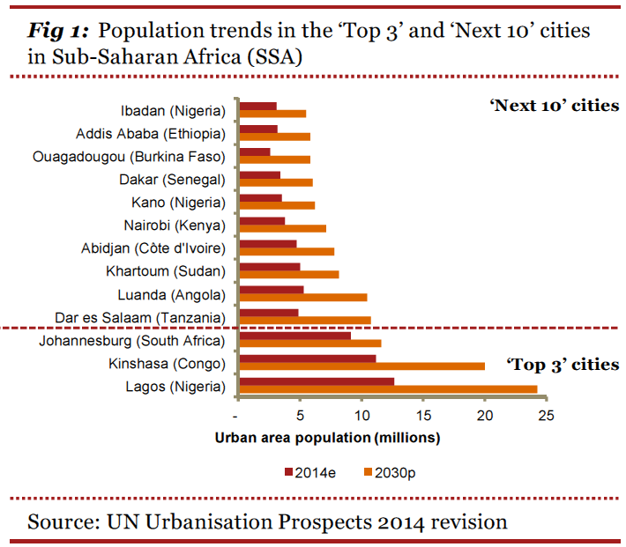
Cities are the typical entry points for businesses trying to expand into new overseas markets, because they enable closer interaction with customers in a relatively small geographic space, which in turn helps contain distribution costs.

Says PwC senior economist Richard Boxshall: “We estimate that economic activity in the ‘Next 10’ cities could grow by around $140 billion by 2030. This is roughly equivalent to the current annual output of Hungary.”

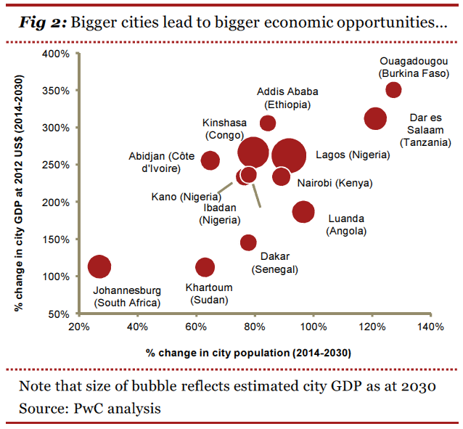

However, there are three problems that could slow the pace at which the ‘Next 10’ grow. These are issues that most SSA countries have been trying to tackle for many decades with limited success:

- Low quality of ‘hard’ infrastructure like roads and railways
- Inadequate ‘soft’ infrastructure like schools and universities, and
- Growing pains arising from political, legal and regulatory institutions struggling to deal with a bigger and more complicated economy.
“The challenge that policymakers face is to convert Africa’s demographic dividend into economic reality by overcoming these hurdles. History suggests this will not be a quick or easy process. However investors should form their own plans to mitigate these problems by supporting infrastructure skills and development programmes,” says Richard Boxshall.

Ends

Notes:
The estimates of population growth and economic activity are based on the following key assumptions:
- National GDP growth rates follow those projected by the IMF in its latest World Economic Outlook report (which do not take into account the latest Nigerian GDP rebasing)
- City GDP per capita grows in line with the rest of the country (which may be a conservative assumption)
- Constant real exchange rates, which could also be a relatively conservative assumption given that real exchange rates might be expected to rise in the long run in dollar terms for emerging economies with relatively rapid productivity growth.
The report on Sub-Saharan Africa in the August edition of PwC’s Global Economy Watch can be found at www.pwc.com/gew

About PwC
PwC helps organisations and individuals create the value they’re looking for. We’re a network of firms in 157 countries with more than 184,000 people who are committed to delivering quality in assurance, tax and advisory services. Tell us what matters to you and find out more by visiting us at www.pwc.com.
PwC refers to the PwC network and/or one or more of its member firms, each of which is a separate legal entity. Please see www.pwc.com/structure for further details.
©2014 PricewaterhouseCoopers. All rights reserved.

