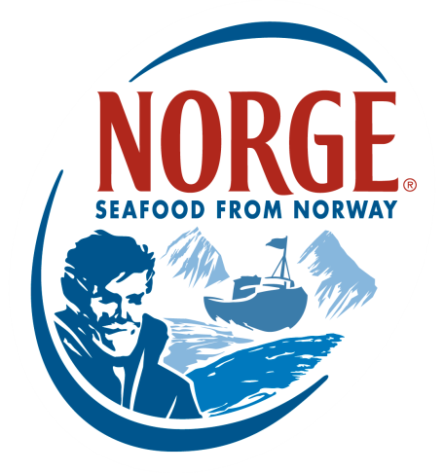
CONTACT:
Jessica Butera
The Food Group
212-329-6273
Jessica.butera@thefoodgroup.com

NORWEGIAN MACKEREL

Norwegian Mackerel has long been favored around the world, especially in Asian countries, for its flavorful, firm meat and high amounts of omega-3 fatty acids. Norwegian Mackerel are fast-swimming pelagic fish that are often identified by their sharp, vivid “tiger stripes.” They can be found in large coastal shoals as well as in the Skagerrak, the North Sea and the South Norwegian Sea. Mackerel caught in the autumn (the premium catch period) have an abundance of healthy fat content, a distinguishing characteristic that results in a tastier, more-succulent product. This is when mackerel are at their best.

Immense care is taken to ensure Norwegian Mackerel is of the highest quality. In order to be caught, the mackerel must be mature (older than 3 years). Immediately after being caught, mackerel are pumped straight into refrigerated holding tanks onboard the fishing vessels, avoiding contamination from the outdoor air. In the fishing vessels, the catch is stored in seawater at temperatures of between 0˚C and 1˚C to maintain freshness. They are then delivered directly to processing plants by automated systems without the fish ever being touched. This careful attention makes Norwegian Mackerel highly sought-after around the world.

NORWEGIAN MACKEREL KEY INFORMATION
- Norwegian Mackerel is a type of wild pelagic fish that slowly grow in the cold, clear waters of Norway.
- They are rich in healthy fatty acids, which give Norwegian Mackerel a moist, firm texture and rich flavor.
- Mackerel are typically 15–25 inches long and weigh approximately 6.5 pounds.
- Norwegian Mackerel can be distinguished by their sharp and vivid stripes, referred to as tiger stripes.
- There are two types of Norwegian Mackerel: Spring Mackerel and Autumn Mackerel.
- After Mackerel spawn, they become known as Autumn Mackerel and have a higher fat content (up to 30%), which gives them more flavor and more-succulent meat. This also means they are higher in omega-3 fatty acids.
- Spring Mackerel has a low fat content (3%).
- Though mackerel season is April to November, the Autumn Mackerel is preferred for its high fat content.
- Fishing takes place during the summer and fall months. Vessel sizes vary from small boats that use nets and trolling lines on the coast, to large, seagoing boats that rely on purse seine nets.

INTERESTING FACTS
- Mackerel is also referred to as saba.
- About 50% of restaurants that serve mackerel in the US specialize in Asian cuisine, with 65% of it being featured in sushi preparation (sushi, sashimi, nigiri and hosomaki).
- Mackerel provides a great deal of nutritional value, including protein, calcium, potassium, iron and other minerals. The American Heart Association recommends eating at least two servings of fish—particularly fatty fish like mackerel—weekly, as it provides heart health benefits.
- Today, Japanese fishermen catch far more mackerel than their Norwegian counterparts, but Japanese connoisseurs continue to prefer the taste of Norwegian Mackerel. This is due to the high fat content, which creates a more flavorful product. At its peak, Norwegian Mackerel contains twice as much healthy fat as mackerel that is caught off the coast of Japan.
- Approximately 100,000 tons of Mackerel are exported from Norway to Japan every year.

About the Norwegian Seafood Council
Founded in 1991 by the Ministry of Fisheries, the Norwegian Seafood Council (NSC) builds awareness of and educates the public on seafood from Norway. Headquartered in Tromsø, Norway, with a U.S. branch in Boston, Mass., the NSC carries out Norwegian Seafood promotional, media, marketing and public relations campaigns and is a resource for market information in more than 20 different markets. Its efforts are financed by the Norwegian seafood industry itself. As the world’s second-largest exporter of seafood, Norway provides quality, nutrient-rich seafood to over 150 different countries and is the world's largest joint marketer of seafood. For more information on the NSC, visit www.salmonfromnorway.com.

