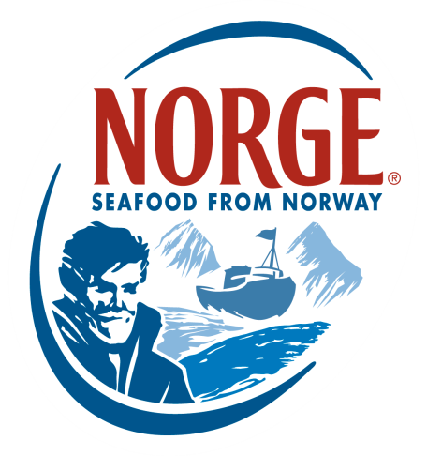
CONTACT:
Jessica Butera
The Food Group
212-329-6273
Jessica.butera@thefoodgroup.com

Global Sushi Challenge:
US Preliminary Participants and What Inspires Them

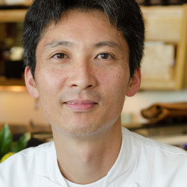

TAKATOSHI TOSHI – 1st Place /US Country challenger
Executive Sushi Chef
Sushi Ran (2006 – Present)
Sausalito, CA
9 years experience

"I am thrilled to share Japanese traditions and culture, as well as some of the newer technologies in the Japanese sushi industry."

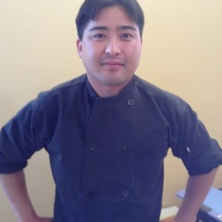
BRENT HAJIME KOSHU – 2nd place
Sushi Chef
Sushi Koshu
Diamond Bar, CA
10 years experience

"I want to meet chefs from around the country and see how chefs from around the world create amazing dishes."

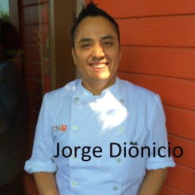
JORGE L. DIONICIO – 3rd place
Sushi Chef
O Ya (2015-Present)
New York, NY
15 years experience

"I love sushi, challenges and learning something new every day."

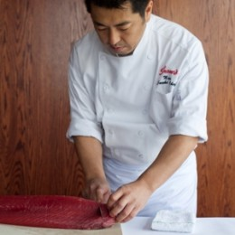

NAOKI NAKASHIMA
Sushi Chef
Shaw's Crab House (2013-Present)
Chicago, IL
15 years experience

"I originally became a sushi chef because I enjoy the happiness guests experience after dining on one of my dishes."

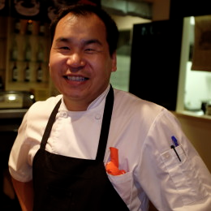
ENKHBILEG “BILLY” TSERENBAT
Owner/Chef
Sushi Fix (2012 – present)
Wayzata, MN
14 years experience
"I think this is a tremendous opportunity for everyday sushi chefs to challenge ourselves."

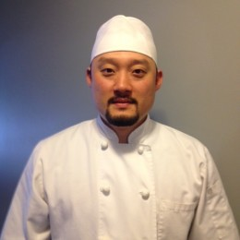
SANG HYUN LEE
Head Sushi Chef
O Sushi (October 2013 - February 2014)
Boston, MA
13 years experience

“This challenge presents an opportunity to combine ideas and traditions that exemplify the passion it takes to create award winning sushi. I look forward to meeting other talented chefs and comparing my skills with theirs, which will also provide the ability to learn more about my craft and take this knowledge with me as I pursue the honor of being recognized for my individual and contributions.”

TAKUYA MATSUDA
Executive Sushi Chef
Kamei Royale (July 2012 – present)
Richmond, B.C. Canada
15 years experience

"I always strive to expand my knowledge and experience in Japanese cuisine."
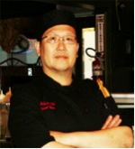
DESMOND YU WAI CHOW
Sushi Chef
Fusion Kitchen (1998 – Present)
Taunton, MA
42 years experience

"I hope to learn from other chefs...and improve my technique and sushi skills"

JOSEPH “BERNIE” MARTINEZ
Sushi Chef
Makoto Japanese Restaurant (2015-present)
Eugene, OR
20 years experience; 8 as a sushi chef

"I always want to learn more, teach whenever possible and create dishes that have never been seen before."

