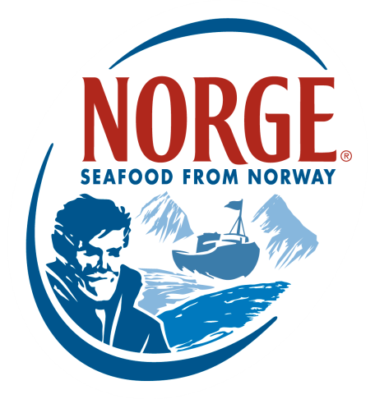
CONTACT:
Jessica Butera
The Food Group
212-329-6273
Jessica.butera@thefoodgroup.com

Norwegian Salmon - The Original Sushi Salmon

Today, Norwegian ocean-farmed salmon is the preferred salmon used in sushi restaurants worldwide, with approximately 50% of Norwegian exports consumed raw. However, it wasn’t always this way. Japanese have long-standing traditions for serving raw fish, but the consumption of raw salmon was unthinkable in the early 1980s. Pacific Salmon was never popular as sushi due to its inferior size and quality, as well a high incidence of parasites, which caused it to be considered by many to be inedible.

For a long time, tuna dominated the sushi market while salmon was sold grilled, fried or smoked at relatively low margins. Suppliers of tuna, a more expensive commodity, dominated the higher margin segments of raw fish served as sushi and sashimi.

It wasn’t until 1974, when Thor Listau visited Japan and witnessed the extensive consumption of low-quality salmon and immediately recognized an opportunity for Norwegian Salmon exporters. At the time, Listau was a member of the Norwegian Parliamentary Committee for Shipping and Fisheries. A few years later in 1980, fish farmer Thor Mowinkel became the first Norwegian Salmon exporter to focus on the Japanese market. He noticed his product was being served fried, while sushi and sashimi made up a high-end segment of approximately one million tonnes.

While the Japanese food industry denounced Norwegian Salmon as not being red enough, having inferior-sized heads and smelling like “river fish,” Norwegian Salmon advocates were determined that their fish belonged in the high-end market. Norwegian Salmon were large and contained more healthy fat than the Pacific Salmon, making it much tastier and more desirable in its raw state. Not to mention the fact that it was free of parasites and therefore perfectly suited for raw preparation.

As one of the most selective fish markets in the world, Japan finally became accessible when a Norwegian delegation realized what it was going to take to increase salmon consumption. In 1985, the Norwegian government launched Project Japan, a trade initiative developed to expand Norwegian fish and seafood exports to Japan. Thor Listau, now Norwegian Minister of Fisheries, led a delegation of 20 people to Japan. Armed with premium raw salmon, their goal was to triple Norwegian Salmon exports to Japan. Salmon played a key part in this strategy and focus was on obtaining the attention of chefs and influencers within foodservice industry. The visit was a success and Project Japan would become largely responsible for increasing global consumption of raw salmon.

During the 1970s and 1980s, Japan became a thriving place of business and cultural hot spot, leading to an increased interest in Japanese cuisine. This interest coincided with the increasing demand for healthy food and environmental awareness in the 1990s and 2000s. Around the world, fish suppliers recognized the potential of the sushi trend to drive demand for high-quality, high-margin products, and therefore began advocating sushi as a great addition to the national diet. As the early suppliers of salmon for raw consumption, Norwegian Salmon farmers were already very familiar with Japanese quality requirements for sashimi-grade products. They continued to expand their marketing efforts while leveraging the growing popularity of sushi across the globe.

Today, Norway is the world’s leading country for salmon farming and exports to more than 100 countries. Norwegian Salmon farmers produce more than one million tonnes of salmon each year. For more information on Norwegian Salmon, visit SalmonFromNorway.com.

###
About the Norwegian Seafood Council
Founded in 1991 by the Ministry of Fisheries, the Norwegian Seafood Council (NSC) builds awareness of and educates the public on seafood from Norway. Headquartered in Tromsø, Norway, with a U.S. branch in Boston, Mass., the NSC carries out Norwegian Seafood promotional, media, marketing and public relations campaigns and is a resource for market information in more than 20 different markets. Its efforts are financed by the Norwegian seafood industry itself. As the world’s second-largest exporter of seafood, Norway provides quality, nutrient-rich seafood to over 150 different countries and is the world's largest joint marketer of seafood.

