Neal Fraser
Owner/Chef at BLD, Fritzi Dog, Neal Fraser & Co. at Vibiana, Redbird at Vibiana (Los Angeles, CA)

Known for his take on New American cuisine, Chef Neal Fraser has garnered critical praise, showcasing ambitious flavors and artfully composed dishes. Fraser started as a line cook at Wolfgang Puck’s Eureka Brewery and Restaurant before enrolling at the Culinary Institute of America. During his tenure at the CIA, Chef Fraser worked with Thomas Keller and David Burke. He returned to LA and officially opened his first restaurant, Grace, with his wife and business partner in 2003. Since then he has opened his casual three-meal-a-day café, BLD, and a fast casual healthy hotdog concept called Fritzi Dog. The Frasers closed Grace in 2010 to focus their sites on Vibiana and the forthcoming Redbird. Also in the works is a BLD at LAX and ICDC, an ice cream, donut, coffee shop created in partnership with his longtime pastry chef Mariah Swan. Chef Fraser was the first California chef to win “Iron Chef America” and was a contestant on “Top Chef Masters” in 2013.

Tim Graham
Chef at Travelle (Chicago, IL)

Having earned three stars from the Chicago Tribune and a Michelin star while running Chicago’s TRU restaurant, Tim Graham is an acknowledged rising star in America’s culinary landscape. At Travelle, Chef Graham’s contemporary Mediterranean cuisine takes diners on a journey that explores the region’s renowned flavors— from the shores of Southern France to the spice markets in Turkey. After graduating the New England Culinary Institute in Burlington, VT, he steadily climbed TRU’s ranks, holding the position of chef de cuisine before eventually being named executive chef of the Mobil Four Star and AAA Five Diamond restaurant. In early 2010, LEYE founder Rich Melman asked Graham to join forces with internationally-acclaimed French Chef Joho as an executive chef to the bistro-style French restaurant Brasserie Jo. Later he helped develop and open Paris Club. In April 2014, Chef Graham won the Cochon 555 Chicago competition.

Greg Hozinsky
Executive Chef at The Strand House (Manhattan Beach, CA)

Chef Greg Hozinsky is the executive chef of The Strand House where he uses seasonally-inspired and locally grown ingredients to compliment his fresh and rustic culinary approach. Hozinsky graduated from California Culinary Academy in San Francisco in 2003, and began working under Michael Mina at Aqua in San Francisco. He then returned to his native Southern California for externships at the House of Blues Foundation Room and Valentino’s in Santa Monica. He worked at Avenue in Manhattan Beach and was promoted to sous chef at the age of 21. From there, Hozinsky became chef de cuisine at Frascati in Palos Verdes, then the executive chef at Shade Hotel in Manhattan Beach, at just 22. Hozinsky then moved to another Zislis Group property, The Strand House, in 2012. Recently, Hozinsky had the honor of cooking at The James Beard House in New York City. In 2012 he was named one of Zagat’s “30 Under 30: LA’s Hottest-Up-and-Comers.”

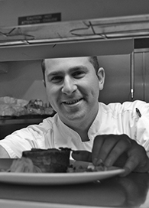
David Seigal
Executive Chef at Cull & Pistol (New York, NY)

Chef David Seigal passed up a formal culinary education to begin his career under Chef Charlie Palmer at Metrazur restaurant in New York City’s Grand Central Terminal. He continued honing his skills in some of the world’s top kitchens including New York Times four-star Jean-Georges, as well as Café Gray and Bouley. After his professional stages abroad, David returned to NYC in 2006, where he took his first Executive Chef position opening Catalan tapas restaurant Mercat. David’s cooking earned acclaim from The New York Times Food Critic Frank Bruni who named his Fideos Negros at Mercat one of the top 10 dishes of 2007. Most recently David worked as Executive Chef at award-winning Mediterranean wine bar, The Tangled Vine. Under David’s Culinary leadership, Time Out New York voted The Tangled Vine “Best New Local Bar” of 2011. After over a decade of fine-dining experience, David returns to his roots as Executive Chef of Cull & Pistol, the seafood restaurant from The Lobster Place. To David, there are few experiences equal to that of tasting the freshest and finest quality fish and seafood.

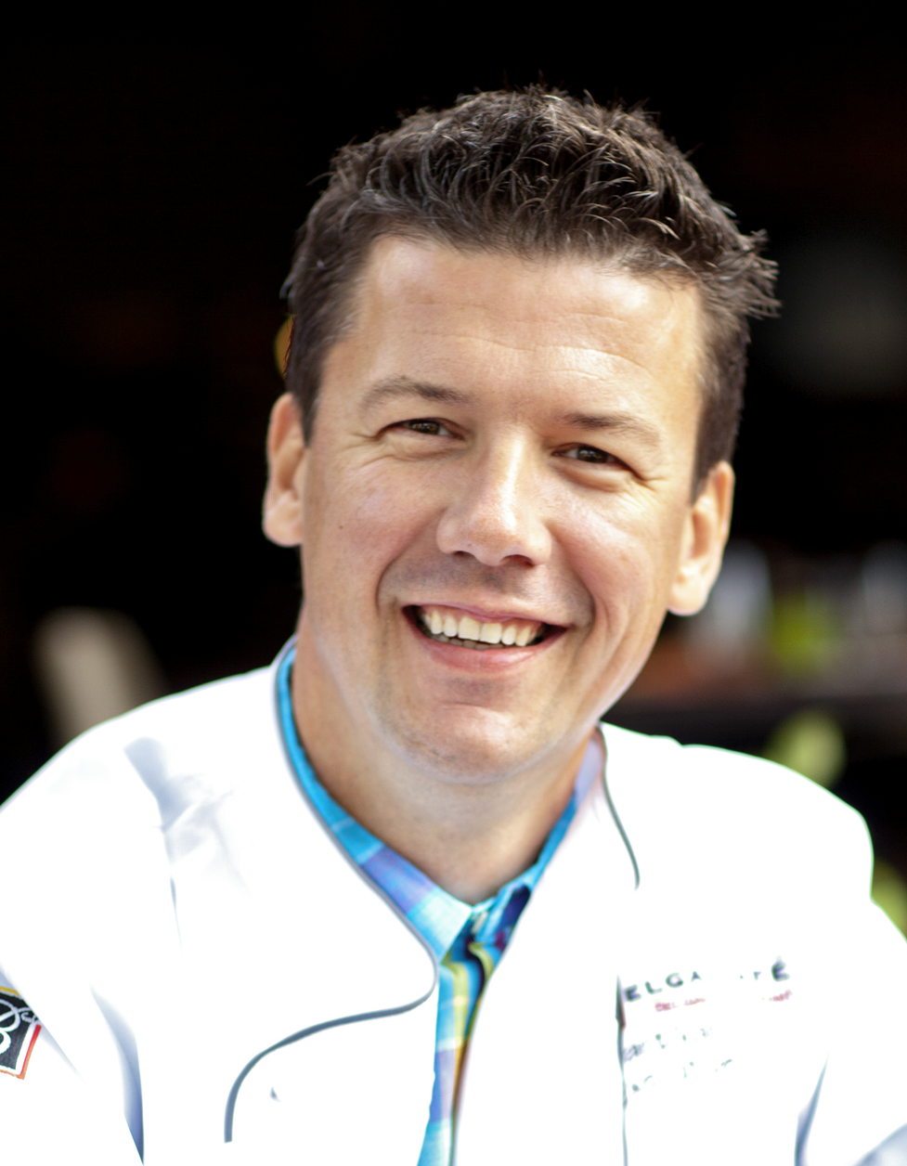
Bart Vandaele
Owner/Executive Chef at Belga Café and B Too (Washington, DC)

Chef Bart Vandaele not only wields a mastery of traditional and contemporary Belgian cuisine—he is knighted in the order of Leopold II; currently serves as brand ambassador for Belgian beer Stella Artois, Hoegaarden, Leffe Blond, and Leffe Brown; was recently honored by the Master Cooks of Belgium; and was a contestant on Bravo’s 10th season of “Top Chef.” Born in Roeselare, Belgium, Chef Vandaele began culinary school at age 12. He moved on to work at renowned Belgian restaurants including one star Michelin restaurant, Piet Huysentruyt, and two star Michelin restaurant, Scholteshof. In 1997 he moved to DC to serve as executive chef to the Head of the Delegation of the European Union to the United States. In 2004, he opened Belga Café on DC’s famed Barrack’s Row in Southeast. He recently opened his second location, B Too.

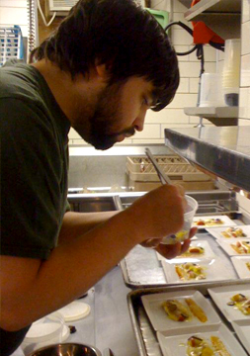
Paul Backer
Chef de Cuisine at Tilia (Minneapolis, MN)

Chef Paul Backer joined the Tilia team shortly after the restaurant opened. By consistently showing his willingness to go above and beyond, he quickly rose from prep cook, to sous chef, and now chef de cuisine. He started his career at the age of 18 in a Chaska diner called MIX. After moving to the city, he worked under Tyge Nelson at the recently opened Barrio in lowertown. Paul was then on the opening staff of Nelson’s The Inn in downtown Minneapolis, while, at the same time helping open Pizzeria Lola.

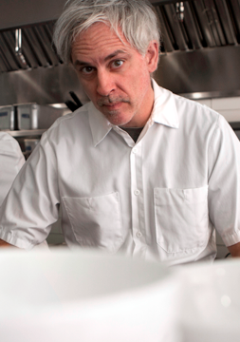
Steven Brown
Partner/Executive Culinary Director at Tilia (Minneapolis, MN)

Steven Brown has been called “one of the biggest cooking talents this town has ever produced” by James Beard-award winning food critic Dara Moskowitz Grumdahl. Minneapolis food scribe and Travel Channel host Andrew Zimmern has said Brown “makes the best food in town, dish-for-dish, pound-for-pound.” With Tilia, Brown adds the title of restaurateur to his estimable resume, which includes stints as executive chef at Levain and Porter & Frye. His experience also includes stints in New York City, Modena, Italy and the Yucatan peninsula of Mexico.

